Images from Southwick RoH
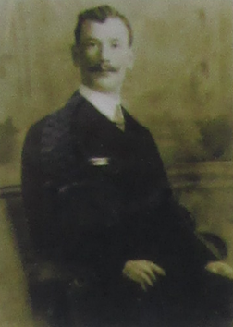
Guardsman Walter Darcey Thompson of the Coldstream Guards was killed in action on 16th September 1914 aged 31. He left his widow, Martha who was seven months pregnant, and two young children at 5, John Street (now Darwin Street). Six months later Martha died leaving three orphans. Neighbours adopted two of the children and Captain Smith and his wife Eva of the Salvation Army adopted the third child.
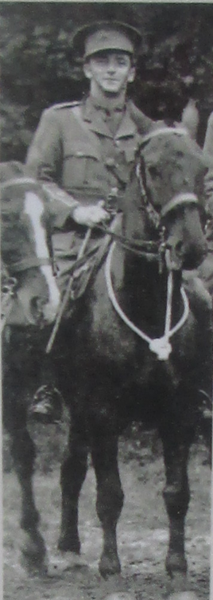

Paul Heptinstall (1895-1980) of 3, Abbay Street joined the Royal Engineers at the beginning of the war. He rose through the ranks for consistent good work in the field to become an officer. 2nd Lieutenant Heptinstall was awarded the Military Cross for gallant conduct on the night of 28th/29th November 1917. He was wounded in March 1918 and taken prisoner.

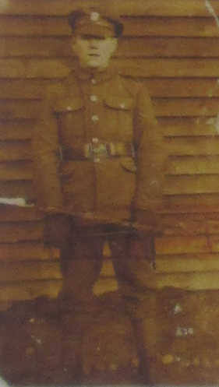
18-year-old J.J. Lay of 24, Dryden Street was called up in April 1918. After a few weeks training her was sent to France with the Northumberland Fusiliers. On 27th May 1918 he was posted missing believed killed in action. His body was never found.
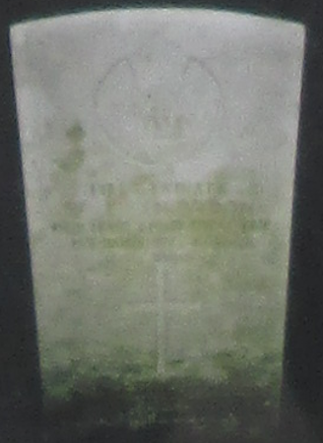

A LETTER FROM THE FRONT
From Private Willliam Snowdon of then Durham Light Infantry to his mother at 22, Cowper Street (now Kismet Street) in October 1915.
“I have seen a lot of Sunderland and Southwick boys belonging to the Sunderland Terriers out here, including J. Nairn and Ted Langham. They were pleased to see me. I had a talk with Fred Plumpton of Ven. Bede’s. I may have to go into the trenches tomorrow but does it matter? J. Nairn and the other chaps reckon it is a pantomime – in fact, some of the fellows who came out last night say they would rather be in the trenches than out back here. I saw Bob Kirton this morning, and he looked well. As usual he was eating. I am quite content.”
Private Snowdon was killed in action on the first day of the Battle of the Somme on 1st July 1916 aged 23. Two of the soldiers that he mentioned in his letter lost their lives in the war too – Ted Langham, aged 22, on 10th June 1918, and Bob Kirton, aged 22, on 18th September 1916.

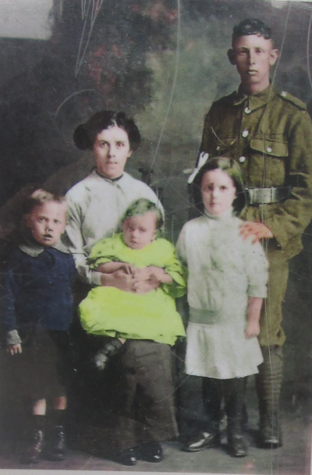
Adam Gibson (1885-1932) is pictured with his family shortly after he joined up with the Northumberland Fusiliers in 1915. During the Battle of the Somme in July 1916 Private Gibson was buried by the explosion of an enemy shell and he received shrapnel wounds to the neck and hand. In June 1917 he was called home from the war to 3, Ogle Terrace, Low Southwick to attend the funeral of his four-year-old daughter Sarah, pictured sitting on her mother’s knee. Private Gibson returned to the trenches where he was exposed to mustard gas and he was subsequently honourably discharged in October 1917 being no longer physically fit for war service. Like many other Southwick men, war wounds cut Adam Gibson’s life sort [sic.] when he died in 1932 aged 47.

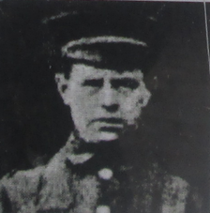
Private Luke Burlinson Farrar of the Durham Light Infantry was killed in action in the front line “somewhere in France” on 6th February 1916, aged 31. He left a widow and four children at 4, Stoney Lane.

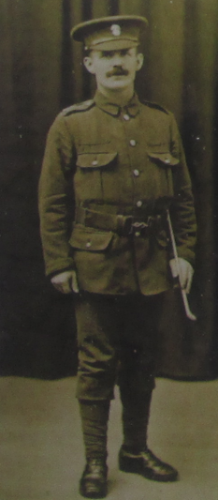
Private James Joshua Lay of the Northumberland Fusiliers was killed in action on 18th July 1916 during the Battle of the Somme. He was a miner before the war.

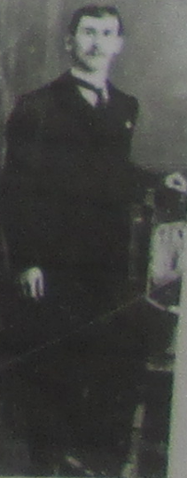

Private Reuben James of the Royal Inniskilling Fusiliers was wounded and taken prisoner during a major German offensive on 27th May 1918. On 10th June he died in captivity, aged 29, wile undergoing an operation. He left his wife, Rosetta, and five children at 3, Ogle Terrace, Low Southwick.

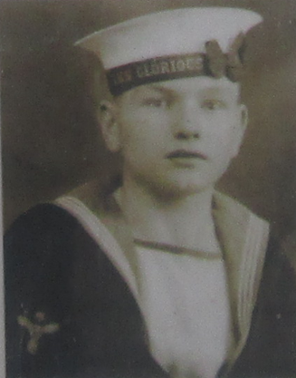
Harry Meadows Langley of 11 Barrie Square was lost at sea in June 1940, aged 22, when HMS Glorious was attacked and sunk by two German battle cruisers. Only 43 men were saved from the ship’s company of 1,200 men.

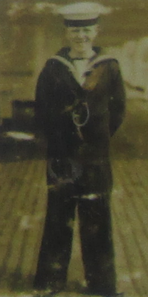
On 22nd May 1941 during the Battle of Crete HMS Warspite was bombed by the Luftwaffe, 18-year-old Signalman Norman Warne of 7, Beechwood Crescent was badly burned in the attack. He died in hospital in Alexandria on 3rd June 1941.

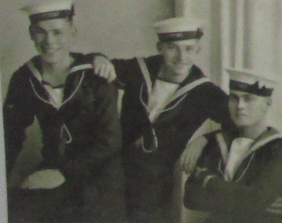
Three Suddick lads who served in the Second World War pictured in about 1936. From the left Harry Howe, Billy Tate and Tommy Thompson. Billy Tate died of burns on 27th October 1939 he received when HMS Ryal Oak was torpedoed in Scapa Flow by a German U-Boat on 14th October 1939. He was 21-years-old.

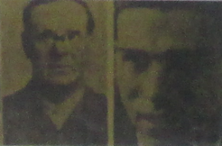
Robert Gregory aged 59 and his 21-year-old son Fred, both from 49 Cato Street, were lost at sea when their merchant ship was sunk in August 1940.

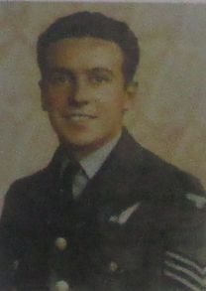
Sergeant James E. Foster, Air Gunner, of Hawthorn Street, Carley Place, aged 23, was killed in a collision of aircraft in December 1944.

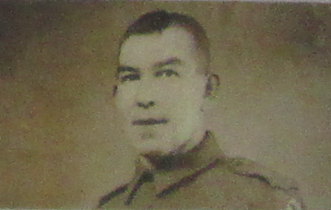
Corporal Herbert Schonewald – Pioneer Corps – of Maplewood Avenue was mentio9ned in a despatch for bravery for emptying an ammunition dump whilst under fire from the enemy in March 1945.

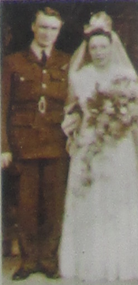
Flight Sergeant Tom Robinson married Nancy in Holy Trinity Church, Southwick during the summer of 1942. In November of 1942 28-year-old Tom was killed in action and his body washed up on an African beach.

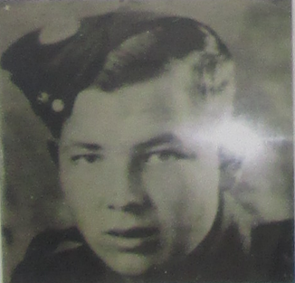

Sapper Albert Holden Thompson of the Royal Engineers, whose home was at the south side of Southwick Green, was killed on active service by a V2 rocket in Belgium on 16th December 1944. He was 20 years old.

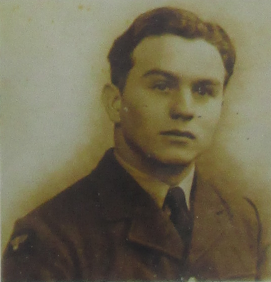

Flying Officer William W. Thwaites of 9, John Street (now Darwin Street) was posted missing presumed killed in action over some Greek Islands on 15th November 1943. His body wasn’t recovered.

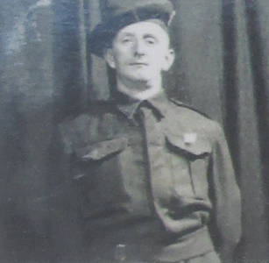

Sergeant James Murphy Loughlin from 23 Pembrooke Street, Carley Place was killed in action in October 1944, aged 31.

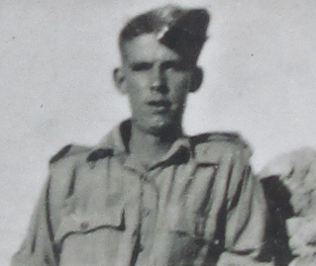

Lance Corporal Joseph Lockwood of the Queen’s Royal Regiment lost his life on 8th December 1944, aged 26.

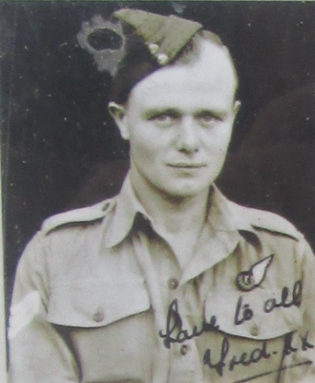
Flight Sergeant Fred Davis of 18, Tennyson Street was killed on active service on 12th June 1945 when his plane crashed near Calcutta. His wife was pregnant with their second child.

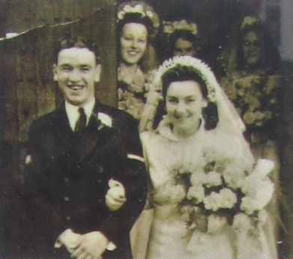

Royal Navy Leading Steward Frankie Bland from Maplewood Avenue was killed in action on a mine sweeper in the North Sea on 10th June 1941, aged 25. His wife was pregnant with their son.

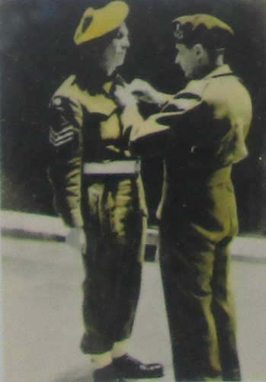
Lance Sergeant Norman Wilkinson (1920-1978) of the Royal Scots Fusiliers was awarded the Military Medal for bravery in the field. On 29th April 1945 L/Sgt Wilkinson having crossed the River Elbe led his section to the top of a quarry where he himself silenced the LMG post taking all the post prisoner. The Citation records “…The 20mm gun had still to be overcome. After a quick reconnaissance L/Sgt Wilkinson again led his section in a bold and courageous attack around the flank onto the enemy position. With complete disregard to his own personal safety, he led the assault can captured the 20mm gun intact with all its crew…” Norman’s bravery allowed following troops to cross the river without the risk of casualties.
Field Marshall Bernard Montgomery is pictured pinning the Military Medal to Norman’s chest.

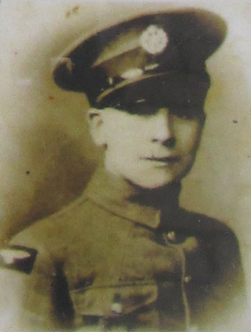

RAF Sergeant James Dobson of 1, Hawthorn Street, Carley Place was taken prisoner by the Italians when his plane was brought down in North Africa in 1940. He was a POW for over three years until the armistice with Italy was signed. Later 24-year-old Sgt Dobson was stationed in India where he was murdered and robbed by locals.

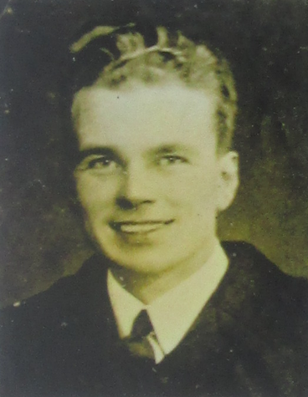

Second Officer (MN) George Taylor (1914-1984) of Grange Crescent was awarded the MBE, GM and Lloyds War Medal for heroism and courageous leadership at sea when his ships were torpedoed and sunk in October 1941 and June 1943.

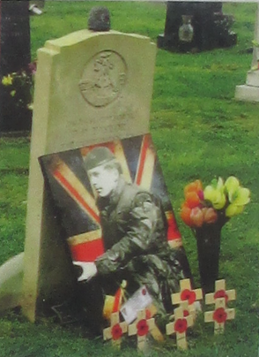

Corporal Tommy “Tucker” Taylor of The Light Infantry was killed on active service in Northern Ireland on 13th May 1973, aged 26. Tucker left a widow and two children. He is buried at Southwick Cemetery.

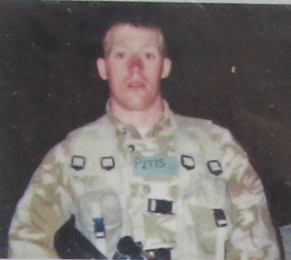

Private William Pemberton of The Light Infantry served in Northern Ireland, Afghanistan and Iraq. He suffered from P.T.S.D. which took his life on 2nd October 2012, aged 28. Rest in peace young Billy.

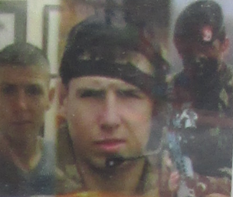
Private Michael Tench of The Light Infantry was killed on active service in Iraq on 21st January 2007. He was 18 years old.

