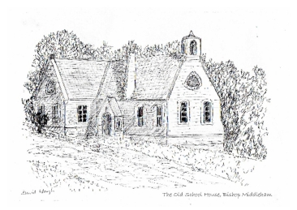
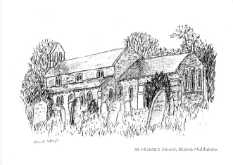
BISHOP MIDDLEHAM and MAINSFORTH
World War 1 Commemoration 2014

INTRODUCTION
The War Memorial in St Michael’s Churchyard commemorates those who died in both
World Wars. When research for this book began it was decided to focus on the men who
laid down their lives in World War 1, and to consider the experience for those left at
home. There is much more to be discovered about those who lost their lives in World
War 2.
The research for this book started with
the North East War Memorials Project.
(including the photograph on the front
cover).
Entries from Bishop Middleham School’s
Log provided invaluable information.
The 1911 Census Records recorded some
details of the families and where they
lived.
At Durham County Records Office we
found a wealth of information about

Bishop Middleham and several Church
Magazine Newsletters of that period,
The Old School : David Waugh

which we have included in their entirety, providing a vivid snapshot of the impact of
world events upon the Parish of Bishop Middleham and Mainsforth, including the deaths
of some of the young men, and the momentous news of women finally getting the vote.
Reproduced by permission of Bishop Middleham Parish and Durham County Record Office.

The discovery of Spencer Wade’s autobiography Both Hands Before the Fire was the jewel
in the crown. Spencer Wade was the Vicar of our Parish during the latter part of World
War 1 and he guided our village through those dark times.

EXTRACT from Both Hands Before the Fire
SPENCER WADE:
‘In 1916 Sis and I took over the vicarage
at Bishop Middleham. It was a large house,
so there was plenty of room to store our
furniture. There was an extensive garden,
which thrilled Sis, who was a life long
horticulturalist.
We both loved the small, transitional gothic
church, dating from 1146 AD; and there
was a Day School, destined to occupy much

St Michael’s Church: David Waugh
of my time.’

MANY THANKS to Nathan Brimm, David Waugh, Michele MacCallam, Eric Potts and
Julie Hall, Richard Hirst and Gill Seymour, Major Chris Lawton Rtd., Fernie Boorman and
Greta Nelson and Michael Thompson who led us to Tony Wade, who gave us permission
to use his grandfather’s work.
Also thanks to the Parish Council, St Michael’s Church, St Michael’s School and Bishop
Middleham Village Hall for their support.
Written and researched by L. Johnston and H. Boorman

1

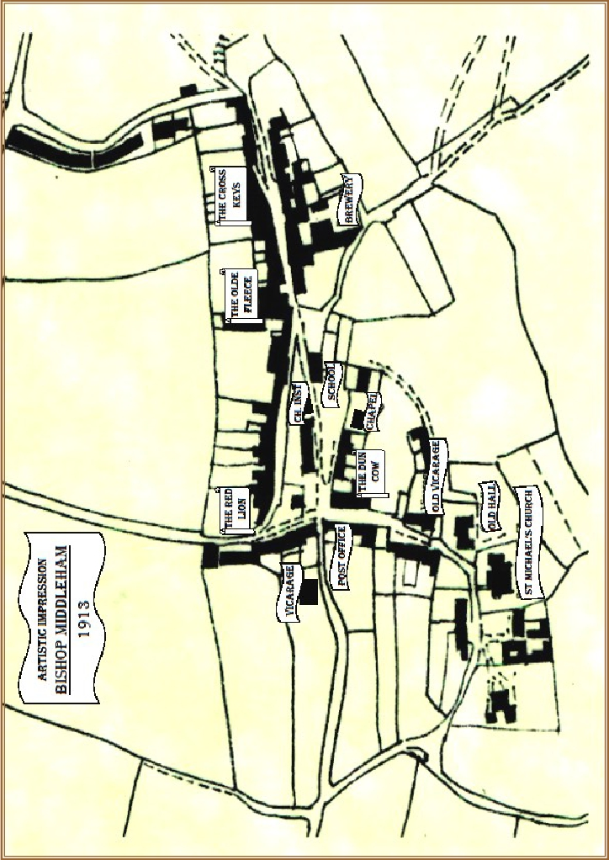
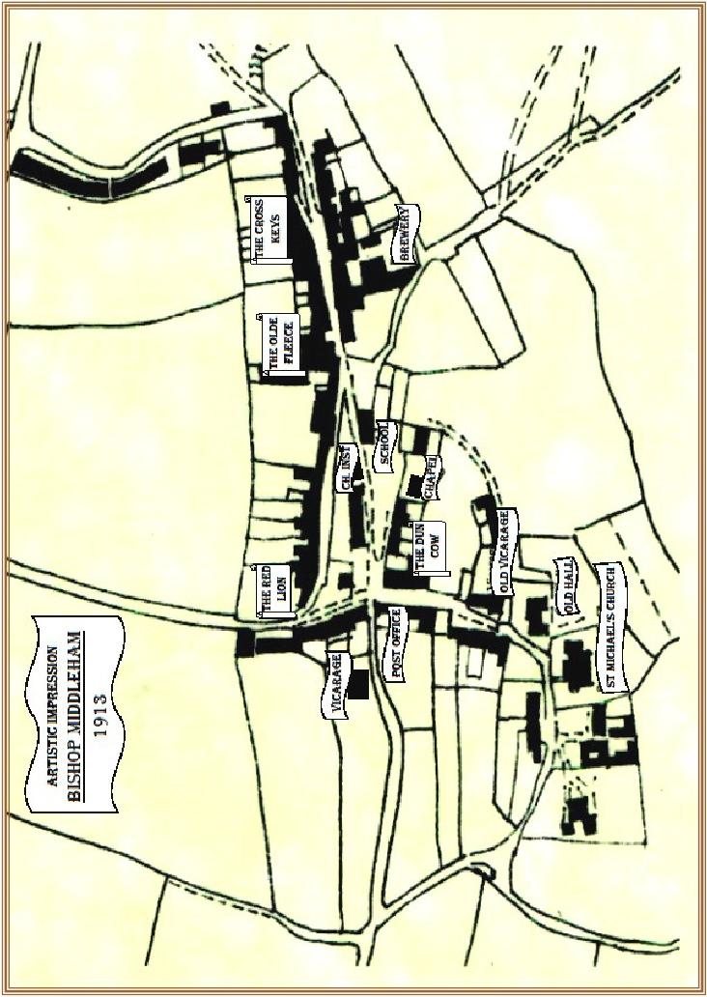
2


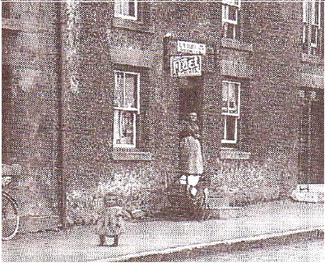
THE PARISH
So what was the Parish of Bishop Middleham and Mainsforth like on the eve of the first World
War? What had these brave young men left behind?

EXTRACT from Both Hands Before the Fire:

‘The population consisted of miners, farmers and workers at the Sedgefield Asylum
(as it was known in those days), some 3 miles away. Quite a number of my new
flock were warders there.’

In Bishop Middleham at this time there was no electricity and there were no telephones. Insula
Cottages, The Green, Woodstock Terrace and Westfield Terrace did not exist, nor did Bishops
Garth, Kiln Crescent or The Park, and estates like Stoneybeck and Broadoaks were a distant
dream. Ivy Cottages were the original 17th century buildings and livestock could still be seen
grazing on the village green. Thus, in 1914 there were just over 100 houses compared with nearly
600 today.

However, Kelly’s Directory of 1914 reveals a thriving community. Then, as now, there were
Doves, Davisons, and Hirsts farming around the village. Probably these young men would have
helped with the harvest at one time or another.

They would have had a choice of Public Houses
in which to quench their thirst, be it with Thomas
Iceton, landlord of the Red Lion, or with Edith
Legg at the Dun Cow, or at William Raine’s
Cross Keys, or even the Fleece under the tenure
of Mrs Ann Ross. The beer was unlikely to run
dry with the Brewery of Matthew Forster being
so close at hand in the village.

Had they wanted something to
eat, they had a choice of butcher
between John Gibson or John
Tinkler. For groceries they could
choose between Thomas Kirtley,
William Parkin, David Preston
or George Lee, who was also
recorded as trading in patent
medicine.
Some might have been lucky
enough to have bought a bicycle
from cycle dealer William Jones,
or gone for repairs to George
Lee Junior. They might have
seen him repairing a rarely-seen
motor car.

Bicycle Shop on Front Street

3

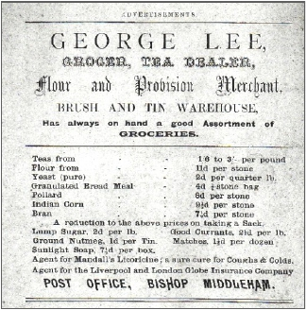
Those with more old-fashioned forms of transport would have known Henry Mason, joiner and
cartwright, and Richard Crowther, the village blacksmith (next to George Lee’s shop), who
would make shoes for horses. Most, I suspect, relied on the cobbler to maintain their main means
of transport.
Others may have been dragged reluctantly by girlfriends or sisters to the draper’s shop of Mrs
Kate Chapman or to see the delights offered by Miss Elizabeth Lee, the dressmaker.
This finery would have been bought for special occasions, such as Socials and Dances at the
Church Institute, (long-demolished) on Front Street. Who knows if any of these young men
might have stolen their first kisses at these events?
The Lee family, as well as providing groceries
and cycle and motor repairs, also ran the Post
Office.
Letters arrived from Ferryhill at 7.05 am and
4.40pm, and were dispatched at 10.40am and
5.45pm, weekdays only.
The nearest telegraph office was in Ferryhill.
Who could have imagined the horrors that
would be received there in the following
years?
Those who attended the elementary school
would have known Alfred Mossop Haile, the
Schoolmaster. In 1913 the school register
shows an average attendance of 152.
Many of them would have been baptised by
Rev. Charles Ashforth Cartledge, Dean of
Bishop Middleham, whose son (also Charles)
is commemorated on the family gravestone in
St Michael’s Churchyard. Durham County Record Office EP/BM 141

The Church was the hub of the community. All would have known the Rev. Matthew
Burra Parker MA, and as boys they would have watched his new Vicarage being built at
Nutgarth in 1902, and in the same year witnessed the installation of the first oil street
lamp in Church Street. And later they would have observed the completion of the Chapel
in Front Street in 1913.
Some may have been chased out of the Churchyard by sexton George Raine. I trust none
had to face the wrath of Thomas Kemp at the Police Station.
Indeed, the Rev. Spencer Wade recalled the detrimental effect the absence, of Constable
Kemp and Schoolmaster A M Haile was having on the bigger lads.

EXTRACT from Both Hands Before the Fire:

‘More and more of the young men were being called to the forces. Amongst them
were the village policeman and the schoolmaster. I fought hard with the military
authorities to retain these two important personages in the village life. In the end
they had to go, and I was left to ‘hold the baby’.
Very soon the bigger lads began to get out of hand and I was forced to assume the
role of policeman and schoolmaster. I saw there was nothing for it but to be firm
and uncompromising. I did not know that I had it in me to be a dictator - for a
dictator I became, to the gratitude of the mothers, left at home to make the best of
things.’

4

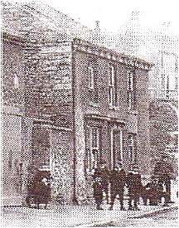
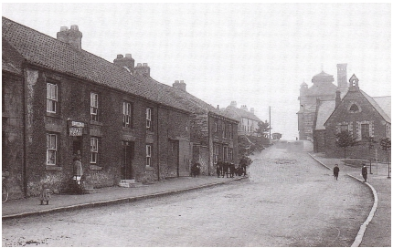
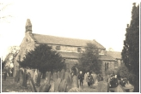
Some such ‘out of hand behaviour’ included damage to parish
seats. This was discussed and recorded in the Parish Council
Minutes. A proposal was made for a recreation area as ‘the poor
young people had nothing to do’. This had to be put on hold
until after the war.
More pressing matters included a number of public meetings to
promote national war efforts. In 1917 the issue of allotments
predominated. Within two months 35 allotments had been
established at the west end of the village.
As Newton Haile comments:
“Truly War brings about rapid changes.”
The matter of allotments had been discussed for decades since
the Parish Council had first been formed.
Even with allotments, food shortages would remain an issue.
Two of the suggestions that were sent forward to the District
Food Control Committee included:
1. The rations for prisoners of war to be reduced.
2. That a further tax on tobacco may increase consumption

The Church Institute
Front Street

of food, it having the effect of diminishing the appetite.
By January 1918, food shortages meant that more allotments were needed and 28 villagers made
requests. This time, negotiations for land ran less smoothly, but eventually, as the War ended,
five acres at the north-east end of the village were secured.
Thus, the Bishop Middleham the men had left behind, some never to return, was a self-contained
unit, commercially more active than now. All were doing their bit on the home front to support
themselves, their families, their country, and their loved ones in the Theatre of War. However, it
would be wrong to imagine Bishop Middleham, at the time, as a rural idyll, as the June 1913
Church Magazine shows (see page 7).
In it, the Rev. M. B. Parker condemns landlords who rent out sub-standard property to the poor
and suggests it as a contributory cause of infant mortality. The subject would have been close to
his heart, as in the last two months alone he had officiated at the burials of three local children.
Upon his return from Service as a War Padre in 1918, the Church Magazine newsletter of May
and September announce the burials of three more children under four months old. The death toll
abroad was also rising. The September issue also refers to the memorials planned within the
Church in memory of Captain Percy Robinson, the Rev. Parker’s son-in-law, to Lieutenant
Crabbe, nephew of General and Mrs Surtees, and to John Sidney Lee, son of George Lee, the post-
master. In November, 1918, the death of Private Bell was announced.

St Michael’s Church
Photograph: Peter Robinson
Life in Bishop Middleham
was hard, made harder by
wartime privations such as
food and fuel shortages.
Despite this, the spirit and the
determination of its people
remained indomitable.

Front Street

5

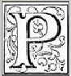




JUNE 1913 N0. 217

ST. MICHAEL’S CHURCH

ARISH

AGAZINE

BISHOP MIDDLEHAM

OFFICIALS OF THE CHURCH :-
Vicar :- Rev M. B. PARKER. MA
VICAR’S WARDEN :- Mr. T. BOVIL. PEOPLE’S WARDEN :- Mr. W.M. STACEY.
SIDESMEN :- Messers. T. KIRTLEY, W. GLENDINNING,
GEORGE RAINE, GEORGE LEE, T. GRAY, J. BROWN,
C. LEGGE, A. SADLER, CHARLES WALKER, T.F.SMITH, R.H.HARPER,
N. WILKINSON, THOMAS STACEY, WILLIAM GRAHAM and GEORGE LEE jnr.
ORGANIST :- Mr. RALPH HAILE.
HON. CHOIR MASTER :- Mr. D. W. FORSTER. SEXTON :- Mr. G. RAINE.

THE CHURCH HOURS OF SERVICE :
SUNDAY — Morning, 10.30 ; Evening, 6.

HOLY COMMUNION
FIRST SUNDAY at Mid-day ; THIRD SUNDAY at 8 o’clock am.

BAPTISMS AND CHURCHINGS
On the Sunday Afternoon at 3.

PRICE ONE PENNY .

J. T. STOKELD & SONS PRINTERS. GUISBOROUGH

Bishop Middleham Church Magazine 1913. DRO EP/BM 141

6


BISHOP MIDDLEHAM PARISH MAGAZINE
JUNE 1913

My dear Parishioners,
I hope we are all looking forward to the Bazaar to be
held in the grounds of Mainsforth Hall, by the kind per-
mission of Col. and Mrs Surtees. The date has not yet
been fixed, but we intend to hold it D.V., sometime in
July. I hope to announce definitely next month. It will be
a two days Bazaar, and will, I trust, be on a somewhat
large scale. I need hardly say that the object is to raise
funds for the School repairs, which are going to cost
about £900. Only £600 have been promised. The
School has been much enlarged and improved. The class
rooms now have a pleasing appearance. The Managers
are exceedingly obliged to the farmers and others who
have helped on the work so willingly.
On Friday evening, June 6th, the School will be re-
opened by a Social, which those who have attended the
sewing meetings are so vigorously getting up. The pro-
ceeds will also be given to the School fund.
The School Managers decided, on account of com-
plaints, that in future 7/6 should be paid to me for the use
of the School, and out of that, I should give 2/6 to the
caretaker in order to see that all was properly prepared
and made ready, and afterwards put in order for the Sun-
day School and Day School. Mrs Walker has been re-
appointed caretaker.
On Wednesday, May 28th, the Lord Bishop of Jarrow
held a Confirmation in the Church at 3.30. The candi-
dates from this Parish numbered 18: 6 males and 12 fe-
males. There were Candidates also from Sedgefield,
Holy Trinity, and the Parish Church, Stockton. The ser-
vice was very reverent. Let us hope that in thus carrying
out the Apostolic rite of “laying on of hands” , that a
great blessing was received by each Confirmee.

Home Life in the County of Durham
II.
Overcrowding and its Consequences.
INFANT MORTALITY,

There are conditions existing in Town and Mining
Centre and Country Village where decent ‘home life’ is
impossible.
There seems to be need of a preliminary lesson forced
home —— that the first use of a house is to provide a
decent habitation for a family and not an investment.
So many people look for house property as an invest-
ment, and are naturally anxious to make as much out of
it as possible.
They buy it as an investment, and often grudge the
money spent upon keeping it in good order. The people
living in the house, their comfort and happiness are often a
secondary matter.
Old property can not fetch a high price — it is bought at
a low one and is let at a lower rent than newer and better
ones, and the poorest crowd into these houses. But when a
ship is too old for safely conveying passengers — it is
condemned and broken up. Why should it be different with
old houses? That is one of the reforms needed.
Patched and patched, year after year, they become more
unfit for human habitations and yet they are continued as
such.
There is room surely here for rich men with a sense of
responsibility for their wealth and their neighbour’s good,
for doing something.
To be continued.

CHURCHING
May 11th — Mary Ellen Robson.

BAPTISMS
May 2nd — Florence Beatrice, daughter of Walter and
Eleanor Nobbs, Bishop Middleham, privately.

MARRIAGES
May 10th — William Hodgson, Ferryhill, to Harriet
Holdsworth, of this Parish.

May 31st — John Thomas Britton, of Ferryhill, to Sarah
Jane Richardson, also of this Parish.

BURIALS
Feb 26th — Mary Craggs, Bishop Middleham,
aged 93 years.
She was a very old inhabitant of Bishop Middleham, an
earnest Christian woman and deservedly respected by all.
She endured poverty with calm resignation.

April 6th — John Craggs, Bishop Middleham,
aged 17 months.

May 4th — Robina Craggs, Bishop Middleham,
aged 7 months.

May 7th — Florence Beatrice Nobbs, Bishop Middleham,
aged 9 months.

May 18th — Thomas Ashton, Highland Farm,
aged 74 years.

M. B. PARKER,
Vicar

Bishop Middleham Church Magazine 1913. DRO EP/BM 141

7


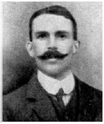

THE WAR
1914
4th August The War begins.

16th December SCHOOL LOG:
Children excited by the sound of
bombardment of Hartlepool.
The Bombardment of Hartlepool
The War was only a few months old, when for the
first time, British civilians were to come into the
line of fire on British soil.
Hartlepool was considered to be a legitimate target
by the Germans as it was a fortified town. In fact,
its two coastal batteries comprised merely of three
6 inch guns. The unequal contest started out of a
misty morning at 8.03 am and lasted for about 45

minutes.
Artist : Nathan Brimm, aged 13

During that time the German Warships fired 1,150 shells upon Hartlepool. The Heugh
and the Lighthouse Batteries managed 123 rounds in reply.
The effect on the residents going about their daily business was devastating. The attack
killed 83 civilians and injured 424. 7 soldiers were killed and 14 more wounded. Damage
was inflicted upon the steelworks, gasworks, railway, 7 churches and 300 houses. The
Germans lost 8 men and 12 were wounded. Amongst the dead of Hartlepool was one of
the first civilian fatalities and the first female to die on British soil: Hilda Horsley, a 17-
year-old seamstress, who was on her way to work. The youngest to die in this attack was
Eleanor Nesey, only 6 months old.
The first German shell killed Private Theo Jones of the 18th Battalion
in the Durham Light Infantry. He was the first soldier to die on British
soil in World War 1. An outraged British Press reported the deaths in
one family of a father, mother and 6 children. In another case only one
child out of a family of four escaped.
Further condemnation was reserved for the failure of the British Navy
to prevent this raid. The three British destroyers on patrol were out of
torpedo range and ineffective.

Private Theo Jones
In addition a light cruiser and a submarine that had been confined to
harbour by the poor weather, promptly ran aground under fire and

failed to engage with the enemy. The German battleships continued down the coast
bombarding Whitby and Scarborough, before returning to base. By the end of the day the
total British fatalities, mostly civilians, stood at 137 with a further 592 injured.
Meanwhile, 15 miles inland in Bishop Middleham, unaware, as yet, of the dreadful
consequences, the School Log records the children’s excitement at hearing the gun fire.

8



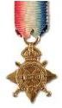
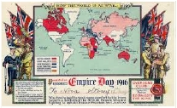
1915
10th May Corporal Joseph Watson dies aged 21.

29th September The Durham County Advertiser reported that the morning
service at Coxhoe Parish Church had included a parade of
Boy Scout troops from Cornforth, Bishop Middleham,
Coxhoe and Quarrington Hill, along with Girl Guides from
Bowburn.
10th November Private Thomas Murray dies aged 21.
Thomas Murray was born in Bishop Middleham and lived in
West Cornforth, where he enlisted.
He was awarded the 1914/15 Star Medal.
On the day of Thomas Murray’s death, Lt. Colonel A. E. Collins of the 11th
Battalion D.L.I. records in his intelligence summary:
“Billets at Epinette shelled. 3 men killed: 7 wounded: 2 later died in hospital.”
It is known that Thomas died of wounds; he may well have been one of the
men who died in hospital.
1916
10th May SCHOOL LOG:
War Savings established.
School Collection - £5 6s 1/2d.
Savings clubs were organised and administered by many schools. From the earliest
months of the War, school children had been encouraged by their teachers to provide
‘comforts’ for the troops. Gloves, balaclavas, cigarettes and jam were popular items and
often found their way to locally raised units at the front.
Additionally, there were national campaigns to mobilise school children to help with the
War effort. Queen Alexandra backed an initiative to collect eggs for the wounded.
Children wrote their names on them before they were sent off to the troops. Children
who donated money to the soldiers’ and sailors’ Christmas Fund received a letter of
thanks from Princess Mary.
1916 24th May SCHOOL LOG:
Empire Day.

Empire Day reminded children “that they formed part of the
British Empire . . . And that its strength depended upon them
and that they must never forget it.”
It was first celebrated in 1902 and became an annual event in 1916.
Each Empire Day millions of children across the far flung Empire would typically salute
the flag and sing patriotic songs, such as ‘Jerusalem’ and ‘God save the King’. They
would also hear inspirational speeches about Heroes of the Empire, for example: Clive of
India, Wolfe of Quebec and Gordon of Khartoum. Texts would be read, like Rudyard
Kipling’s ‘Recessional’ that emphasised the watchwords of the Empire movement:
Responsibility, Sympathy, Duty and Self-Sacrifice.

9


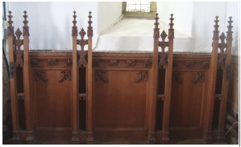

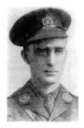
1916
Less seriously, all the children would receive a certificate, and would be let out of school
early to take part in marches, concerts and dances around the maypole.
Empire Day was celebrated for over 50 years on the 24th May. Its name was changed to
British Commonwealth Day in 1958, later to Commonwealth Day, its importance in the
calendar declining along with the British Empire.
7th July Captain Percy Douglas Robinson dies.

Percy Robinson was the son-in-law of Reverend
Matthew Parker. In the September 1918 Church
Magazine the Vicar writes about the reredos, or
panel his daughter and her mother-in-law plan
to erect in the Church in memory of Percy.
The inscription reads:
To the Glory of God and in loving memory of
Captain Percy Douglas Robinson
9th Battn Northumberland Fusiliers
Killed in action at the Battle of the Somme
July 7th 1916
28th July SCHOOL LOG:
War Savings - £135 18s 11 1/2d.
29th July Second Lieutenant Charles Cartledge
dies aged 33.
See page 30

4th August PARISH COUNCIL:
A public meeting and demonstration was held to record: “the determination of the villagers
to continue the war to a victorious end.” The Rev. Spencer Wade spoke at this meeting and
as his diaries and his parish newsletter show, he was a galvanising force during those
troubled times.
7th September PARISH COUNCIL:

Following a request from Sedgefield Rural District Council concerning the formation of
a War Savings Association affiliated to the National War Savings Association, and it was
decided to call a General Meeting. It was agreed to act in co-operation with the Savings
Association already existing at Bishop Middleham School.
Spencer Wade, the Vicar, was voted Treasurer. Mr T.F. Smith was elected Chairman,
and Mrs Forster became the Secretary.
19th September Private Joseph Crake dies aged 39.
Joseph Crake was born in Northallerton, but at the time he enlisted at Ferryhill he lived
in Ivy Cottages, Bishop Middleham, with his wife Alice. His mother was called Ellen.
18th October Private Albert Davison dies.
Albert Davison, son of Edward and Mary Jane Davison, was born in Bishop Middleham.
In 1911 the family were living in High Street. Edward was a farmer, assisted by John,
his middle son. The eldest son Fred was a Limestone Quarryman.
Albert, then aged 14 ,was a farm labourer and the youngest child, a daughter called
Mary, was aged 12 and attending school. Albert enlisted at Ferryhill.

10




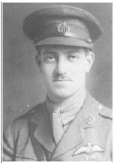
1916
2nd November Private Joseph Maddison dies aged 22.

Joseph Maddison was the son of Robert and the late Isabella Maddison who lived
at 2, Kirtley Terrace, Bishop Middleham.
28th November SCHOOL LOG:
Destruction of a German Airship in full view.
The German Airship

Nearly two years on from the bombardment, Hartlepool
was under attack once more. It was to be another historic
first, but this time in Britain’s favour. Close to midnight,
Zeppelin L34 commanded by Kpt Max Dietrich was shot
down in flames by 2nd Lt. Pyott of 34 squadron who
was based at Seaton Carew.
Artist : Nathan Brimm, aged 13
It was the first success of the Royal Flying Corps against
the zeppelins. Ian Vernon Pyott was acknowledged a hero,
being mentioned in dispatches and awarded the DSO,
the Distinguished Service Order.

This time the Press Association reported around the world
that the raid had caused “very slight casualties and damage.”

Also of note, is the change in public opinion. Gone is the anti-German
outrage of the bombardment. The Heugh lifeboat crew rowed out in

an attempt to rescue any survivors from the airship. All had perished.
Then on January 11th 1917 the two-zeppelin crew, whose bodies had
Lt. I V Pyott

washed ashore, were buried with full military honours in Seaton Carew. Subsequently
three more crew members were retrieved from the sea and buried with their comrades.
On 29th November headlines reported “Thrilling Spectacle for Eye Witnesses.”

In Bishop Middleham the School Log records the airship’s destruction “in full view”.
Imagine amazed Middleham children gazing to the East through their bedroom windows
at “the great, bright glow” descending slowly into the sea.

EXTRACT from Both Hands Before the Fire:
‘All during my time at Bishop Middleham the village was pestered night after night by
Zeppelin raids, from the North Sea.
Tom Palmer was one of the air-wardens and very meticulous he was about his duties,
particularly that no light should be shown when the German marauders were about.
The villagers would at times behave stupidly, just to annoy Tom, and strike matches in the
darkness, with the sole intention of setting Tom running hither and thither to correct them.
It was very naughty of them, but it did reveal the spirit of our people in the face of danger. In
the end I myself took them in hand, and got them to see that Tom was only doing his duty
and that it was up to them not to play the fool in times of grave danger for us all.
The seriousness of the situation was brought home to them when a Zeppelin appeared one
night over the coast of Hartlepool. Searchlights were scouring the sky, the long white beams

11


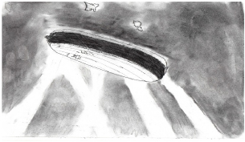

1916
crossing and re-crossing each other. At last one steely finger caught the huge ship, which
seemed to be a silver cigar suspended in the heavens. Then began the barrage! Shells burst
all round the big balloon, some far from the target, some nearer. At last one hit its mark. It
was as if Orion had lit his cigar. From the nose the flames spread along the side. A number
of us were gathered in the vicarage garden and gazed in awe-struck silence at the doomed
monster. The gondola, in which the crew were suspended, was severed from the main body
and fell a flaming mass into the sea.

“Thank God!” someone called out, and in
the next breath added: “Poor Devils!”
That voice expressed the sentiments of us
all. We English are not as sadistic as we are
sometimes, by our fellow-countrymen, made
out to be.’

1917

Artist : Nathan Brimm, aged 13

6th February Private J Walker dies.

J Walker was born in Bishop Middleham.

16th February PARISH COUNCIL:
Having received 35 requests for allotments, an Allotment Association was formed.
Spencer Wade was voted Secretary.
5th April PARISH COUNCIL:
A letter had been received from the National Service Recruiting Committee asking the
Parish Council to organise a house to house canvas in the village for volunteers. It was
agreed not to do this:
“in view of the fact that nearly every man left in Bishop Middleham is engaged in essential work,
in quarries, mines and agriculture, the Parish Council did not consider any useful purpose would
be served by such a canvas.”
19th April SCHOOL LOG:
His Majesty’s Inspector of Schools spoke on the
importance of the War Loan and asked for economies.
Food rationing was to be introduced.
HMI also checked the School garden.
Food Rationing

For the first half of the War, after initial panic-buying, food
shortages were not a problem. But in 1917 the Germans
adopted the tactic of unrestricted Submarine Warfare in which
all ships supplying Britain were targeted.
The effect was devastating. By April, 1917, Britain was 6 weeks
away from running out of wheat. A voluntary rationing system
led by the King and Queen was introduced.

12

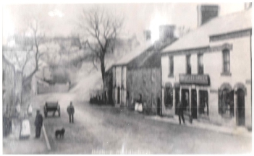
1917
The more wealthy were encouraged not to buy basic foods, such as bread, upon which
the poor relied. Queuing, rising prices and Black Marketing led to growing frustrations
and resentment. Thus, by January 1918, the Government felt obliged to introduce a fairer
and more formal rationing system. Every citizen was issued with a ration card. Sugar was
rationed first. Then meat, bacon and butter or margarine were added to the restricted list.
It should be noted that during this time civilian populations in Germany, Russia, Turkey
and Austria-Hungary suffered from even greater food shortages.
The reason that Britain faired better was two-fold. Coupled with rationing came
increased production. The 1917 wheat harvest was the best ever. Also, Victory Gardens,
sometimes called War Gardens or Food Gardens of Defence, were encouraged. Parks,
private gardens and new allotments were given over to the growing of vegetables, fruit
and herbs. Gardeners were also made to feel empowered by doing their bit for the war
effort. In the absence of men, the war introduced a generation of women to gardening.
Conversely, some soldiers created trench gardens, full of flowers, bringing life, colour,
scent and humanity to the mud, death and squalor of the front.
EXTRACT from Both Hands Before the Fire:
‘To meet the decreasing food stocks in the country it was necessary that every town and
village should pull its weight. I consulted with one of the farmers whose land lay just behind
the vicarage garden, and arranged with him to let us have the use of three acres of his land
for garden allotments, at a nominal rent, and soon every inch of that ground was growing
food. It was refreshing to see miners, after a hard day’s work, toiling on their respective
plots.
I asked a personal friend of mine, an agricultural and horticultural expert, to deliver to us
a series of lectures on the best methods of food production, and Sis and I were determined to
set an example by making our own garden a show-piece. Country folk are slow to learn,
even from experts, and they set about their new job according to their own customary ideas.
Sis and I put the expert’s theories into practice, with astounding results.
I invited the allotment holders to come to see for themselves. They were dumfounded,
particularly at our potato crop, grown on sea-weed manure, and began to copy our methods,
with similar results.
Those allotments brought the parson and his people very much closer together.’
23rd April Corporal Robert Barton dies aged 23.

Robert Barton was born in Easington, the son of James and Jane Ann Barton. During the
War they lived in North Terrace, Ferryhill, where Robert enlisted.
Robert is also commemorated in Ferryhill Cemetery.
27th April Lance Corporal John Sidney Lee dies aged 20.
John Lee was the son of George and
Sarah Lee of Church Street.
The 1911 Census shows he has an elder
brother, George Cecil (17) and a younger
sister Mary Grace (8), while John Sidney
(14) was still at School. His brother
George, already described as a motor
engineer, returned from the War and in
February 1920 set up the first Bus Service
in the village, running from Ferryhill to
Fishburn.

13

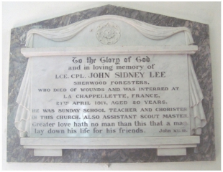

1917
What might John Sidney Lee (known as Sidney) have done had he survived? Before going to War
he was a Sunday School teacher, chorister at St Michael’s Church, and assistant Scout Master. His
potential is acknowledged in Rev. Spencer Wade’s Memoir.

EXTRACT from Both Hands Before the Fire:
‘I was keen on the Boy Scouts movement, having founded the first troop in the City of
Manchester, in my undergraduate days. I found a troop in Bishop Middleham. The
Scoutmaster, Walter Holmes, a married man, had the heart of a boy and a marked gift
for leadership. Among the boys, a fine set, was Sydney Lee, the son of the postmaster. He
was the first youth in the village to volunteer for the forces. He was a lovable and much
beloved lad, and we were all proud of him. He had been in France but a few weeks when
word came that he had been killed in action. The village was stunned, and we were all
deeply grieved for his loss to us and his parents.’
‘Sydney was the first from the village to offer his services to the crown and the first to
lay down his life for his country.’
This was not strictly accurate. Rev. Spencer Wade came to Bishop Middleham in 1916, replacing
the Rev. Matthew. B Parker MA, who had also joined up.
John Sidney is therefore the first youthful recruit he knew personally, and the first to die.
This ‘lovable’ and ‘much beloved lad’ had joined the Sherwood Foresters (the Nottingham and
Derbyshire Regiment). Why he enlisted in Richmond, Surrey and ended up in the Sherwood
Foresters is not clear. Sometimes recruits were moved from their local regiment to make up for a
shortfall elsewhere. Maybe lessons had been learnt from the devastation of the Pal’s regiments in
1916.
The date of his death and the location of his internment suggest he was a casualty of the Arras
Offensive, a plan to end the War in 48 hours. After 6 weeks it was abandoned.
A marble plaque remembering John Sidney, on a wall inside St Michael’s Church, reads:

To the Glory of God
And in loving memory of
Lce. Cpl John Sidney Lee
Sherwood Foresters
Who died of wounds and was interred at
La Chappellette, France
27th April 1917, aged 20 years
He was Sunday School Teacher and chorister
In this Church, also Assistant Scout Master.
Greater love no man than this that a man
Lay down his life for his friends. John XV 13

15th May SCHOOL LOG:
Food economy stressed again.
12th June Robert Johnson goes missing in action.

Robert was born in Bishop Middleham and enlisted in
Ferryhill.
26th June A quick fire postcard, a multiple choice pre-printed card
offering simple messages home, is received from R Palmer
to a Miss A Palmer. This is likely to be Tom Palmer’s
daughter Annie, described by Spencer Wade as “A beautiful
17 year old girl.”

14

Subscriptions - | £ | s. | d.
Rev. M.B.Parker | 1 | 0 | 0
Mrs Robinson | 1 | 0 | 0
Mr Vickers |  | 5 | 0
Mr Moore |  | 5 | 0
Mr Moorhead |  | 5 | 0
Brig. Gen. and Mrs Surtees | 2 | 0 | 0
Mrs Lockey |  | 10 | 0
DIOCESAN FUND.
Quota £6/12/- | £ | s. | d.
Offertories | 4 | 11 | 3
Subscriptions:-
Anon | 1
Mrs Lockey |  | 5 | 0
Rev. M.B. Parker |  | 5 | 0
Mr Davison (Farnless) |  | 2 | 6
Mr Dearing |  | 2 | 6
Mrs Lee |  | 1 | 0
Miss Wright |  | 1 | 0
 | £6 | 8 | 3


Dear Parishioners,
BISHOP MIDDLEHAM PARISH MAGAZINE
OCTOBER 1917

CHURCH EXPENSES.

After nearly two years of extremely happy service in
your ancient parish, I find myself in the position of hav-
ing to bid you good-bye. I do so with a genuine feeling
of regret; and, when I say this, I know I am voicing the
feelings of Mrs Wade, who has appreciated being here
just as much as I have. For myself, though I have worked
in several parishes, widely separated in atmosphere as in
distance, in no place have my efforts being more readily
made and more cordially welcomed. There has been, as
far as I know, nothing in the nature of a “hitch” between
us. Everything has run smoothly. “Give and take” has
been the underlying principle of our mutual relation-
ships; and whatever I may have given has been amply
repaid by sacrifices on your part.
I have been privileged to be your spiritual advisor in
your day of trouble. We have often laughed together; we
have alas, more frequently had cause to weep. I have
regarded it as my bounden duty, from the first day of my
coming to your parish, to bring before you in church and
out of Church, the One and Only Consoler, Jesus Christ,
“The Man of sorrows.” And what a Comforter He has
been to us all: God grant that He may continue to be.
It rests entirely with ourselves.
The war is not yet over, though I myself believe that
the end will come suddenly, and perhaps soon. One thing
is certain there must be no peace until Prussian milita-
rism has been irrecoverably destroyed. This desirable
consummation is not, believe me, very far off. We
should even now be preparing ourselves for the “days
after the war”. God has been teaching us a lesson in a
hard school. I trust we may have learnt it beyond the
possibility of forgetting. At all events, during my stay
amongst you, I have endeavoured to drive home the les-
son that without God in Christ there can be no peace,
either amongst the nations of the world or in the individ-
ual heart.
Now, I must not lose this opportunity of expressing my
gratitude to you all for your many and unstinted kind-
nesses to my dear wife and myself. In a thousand ways
you have shown an exceptionally friendly spirit to two
people who, after all, were strangers to you. Robert
Louis Stevenson somewhere says, that people get in this
world pretty much the entertainment they give to others.
If , however, I were to measure my giving by yours, I
should indeed have no regrets. But truth compels me to
offer the prize in this respect to you.
Mrs Wade associates herself cordially with me in all
these sentiments, and joins in prayer and hope that the

Full amount has been sent on.
Church debt over £10

BAPTISM
September 19th — John Robert, son of William and Mary
Ann Slee.

MARRIAGES
Aug 11th — Harry Coates and Sarah Mabel Wilson.
Sept 17st — Frederick George Ford and Olivia Carr.

BURIALS
Aug 23rd — Jane Wilson, aged 75 years.

parish of Bishop Middleham may be blest abundantly in
the only things that really matter in the eyes of God,
Your humble servant in Christ.
SPENCER WADE

Bishop Middleham Church Magazine 1917. DRO EP/BM 142
15


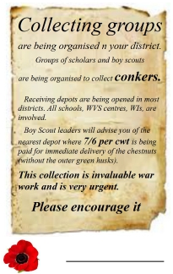
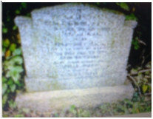
1917

17th July SCHOOL LOG:
War Savings stressed again.

23rd July PARISH COUNCIL:

A letter was received from the Central Committee of the National Patriotic Association
suggesting a Public Meeting on 4th August, the third Anniversary of the start of the
War. An open-air meeting was agreed and it was decided to invite General Surtees,
from Mainsforth, to speak.
Also a payment was authorised to the Rev. M B Parker of 10 shillings for lighting the
schoolroom during the year 1916. So Spencer Wade’s time at Bishop Middleham was
over, and Rev. Parker had returned to the New Vicarage on Nutgarth.

6th August Sergeant Thomas Legge dies aged 18.

Thomas Legge was born in Ferryhill. He was the son of Thomas W and Mary A Legge,
who lived at 8, Chilton Cottages, Ferryhill. He lived at Acomb in Yorkshire.

1st October SCHOOL LOG:
Children bring chestnuts to School.
Conkers

A shortage of acetone, a component required in the
making of smokeless bullets, led to an unusual request
from the War Office. School children were offered 7/6d
(37.5p) per hundred weight (50.8kg).
The response was so massive and the supply trains so
few, that while 3,000 tonnes did reach their destination
(the Cordite Factory in King’s Lynn), the remainder
were to be seen rotting in piles at railway stations
throughout the land.

30th November Lance Corporal Thomas Laverick dies aged 24.
Thomas Laverick, the son of William Andrew and Margaret Jane Laverick who were
living in Bishop Middleham by 1911, was born in Darlington. In the Census of 1911,
Thomas, (18), is still living at home in Church Street, working as a joiner’s apprentice.
His father is a night attendant, and his brother Horace (16) a cleaner, probably both at
Winterton Hospital. Maud (14) and William (6) were still attending school.
Thomas is also commemorated on the family grave stone in St Michael’s Church Yard.

The inscription reads:

Also their eldest son
Thomas Joseph
Died of wounds Nov 30th 1917
Aged 24 years
Interred Rocquigny British Cemetery, France.

16


BISHOP MIDDLEHAM PARISH MAGAZINE
FEBRUARY 1918

My dear Parishioners,
We are approaching Lent; Ash Wednesday the first
day is on February 13th. If I can arrange for special
preachers I shall certainly do so as in the past, but at the
present time it is difficult to arrange for anything. I hope
it will be a real Lent with us all. The War should make it
more real. I think this year we can not do better than give
more time to the services of God and the Church, and
this should be backed up by our private prayers at home.
Prayer moves the Will that moves the world. I am glad
to say that on January 6th, the day appointed by the King
as a day of Intercession and Thanksgiving, our congrega-
tions were good both morning and evening. In the morn-
ing we had a parade of the V. T. C’s. One felt that the
Church was just as it should be every Sunday morning. It
was certainly a loss to anyone who did not enter into the
spirit of that important day.
We have a nice and reverent little service on each
Wednesday evening. We mention and pray for all those
serving in the War from this Parish. We should like to
see all parents and relations present. It is their duty. The
Social for the Sunday School prizes was well attended
and well conducted as usual, and a most enjoyable eve-
ning was spent. It will pay for the prizes for last year, but
this year’s prizes will have to be purchased on credit. We
expect to give them on Sunday, February 3rd. I should
like to give a prize to each child, but this we cannot do. I
need hardly say, we are guided entirely by the register
marks. When speaking of the children that I always take
the greatest interest in and I am glad to help whenever I
have an opportunity, I am sorry to hear complaints of a
certain roughness on the part of some and I specially call
the notice of parents to this fact. It is not anything I have
seen myself, but what I have been told by others viz.
girls shouted at in going through the village, and chil-
dren knocking at doors and then running away.
On Thursday evening a Lantern Lecture will be given
in the school room in connection with the War Savings
Association. Although this would have taken place when
the magazine will be in the hands of the readers, I hope
the meeting will be well attended. I am glad to hear how
well Bishop Middleham has done and especially the
school. It is a splendid work in every way. It is not only
good for the individual, but tends to solidify the country
and it will be a balancing power when the War is over,
because each one will have an interest at stake. I am
sorry to say that the War out-look is not very bright yet,
but there are some symptoms of a desire for peace, both
by Germany and Austria. What we have got to do is to
In a short time we shall be rationed in food. We may
say that this is almost taking place now on account of the
shortage of supply. But compulsory rationing will to a
great extent equalize things. The complaint has been that
some have voluntarily rationed themselves and others have
not. It is sometimes stated that the wealthier class has not,
but from my experience this statement is not correct. There
should be as far as possible, which is no doubt difficult to
carry out, just proportion between work, mentally or physi-
cally, and food. More work, more food, less work, less
food. This is not only good for the health but the country.
May God be with us in all we do.
I have been appointed Secretary and Treasurer of the Par-
cel Committee. These parcels are very acceptable. I hope
the work will go on as usual.

1917 CHURCHINGS.
Dec. 23rd — Margaret Nicholson, Bishop Middleham.
30th — Eliza Jane Legg, Ferryhill.
1918
Jan 9th — Amy Lizzie Harrison, Bishop Middleham.
13th — Margaret Eleanor Denton, Bishop Middleham.
— Ada Fishwick, Bishop Middleham.

1917 BAPTISMS.
Dec 30th — Dorothy Gwendoline, daughter of Robert and
Eliza Jane Legg.
1918
Jan 9th — Freda, daughter of Frederick and Amy Lizzie
Harrison.
13th — Gwendoline, daughter of Joseph and Margaret
Eleanor Denton.
— Mary Elizabeth, daughter of Arthur Ernest and
Ada Fishwick.

MARRIAGE.
Jan 3rd — Bernard Terens Gerard Arbuckle Ryan O’dwyer
Di-mond, of Crowborough to Dulcie Mary
Carlisle Parker.

BURIALS.
Jan 16th — Christiana Springall, aged 43 years.
Jan 23rd — Thomas Crowther, Bishop Middleham,
aged 65 years.

M. B. PARKER,
Vicar

hold on till we have the full effect of the American
Army.

Bishop Middleham Church Magazine 1918. DRO EP/BM 143
17


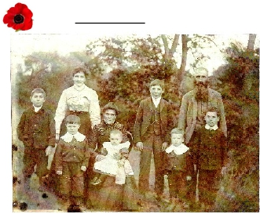
1917
3rd December Lance Sergeant George Duffield dies.

George Duffield was born in Fishburn and enlisted at Ferryhill.
1918
6th February PARISH COUNCIL:
The Council agreed that children should be allowed to work in the allotments, but only
when under supervision.
5th March SCHOOL LOG:
Distribution of Meat Ration Cards.

13th March Corporal Ronald Bulman dies aged 21.
Ronald Bulman was the son of William and Agnes Bulman, who lived on High Street,
Bishop Middleham. William was a Parish Councillor.
The 1911 census shows that Ronald, aged 15, worked as a miner mechanic.
Before the War he became a limestone quarryman.
He enlisted in Sunderland on 28th November 1914 and was discharged on 12th April
1917 due to Neurasthenia brought on by shell-shock. He died at home 11 months later.
28th March Private Fred Hirst dies aged 21.

The 1911 Census tells us that Fred Hirst
was 14 and already working. His father
John, originally from Goole in Yorkshire,
was a farmer, but having married Annie,
a Trimdon girl, had settled here. Fred’s
sister Lily and his eldest brother Richard
were born in Trimdon but Fred and his
four other brothers were born in
Fishburn. By 1911, the family was living
at Holdforth Farm, Bishop Middleham.
Lily had married and was living with

Jack (John). Lily, Richard, John,
Fred, Annie and Joe. Walter, Charlie.
her husband Herbert Danby and their 3
year old son George, at the family home.

We don’t know when Fred joined up, but as he was 18 in 1915 and we believe he served
in the D.L.I. 18th Battalion, the ‘Durham Pals’, we can surmise he was with them when
they arrived in France in March 1916. That being so, he would have survived the baptism
of fire they endured on 1st July 1916 at the Somme. On that day alone, half the ‘Pals’ were
killed or wounded.
In 1917 his Battalion encountered the horrors of the mud of Passchendale.
In late March, 1918, Fred Hirst’s Durhams were deployed to rebuff the Germans’ Spring
Offensive. A shell-shocked Brigade Major, in error, ordered them to withdraw from good
defensive positions in Moyenneville. In an attempt to recapture the positions, B company
found themselves trapped and exposed, unable to attack or withdraw. Over a hundred
men were killed or wounded. (Continued on page 24.)

18


BISHOP MIDDLEHAM PARISH MAGAZINE
MAY 1918

My dear Parishioners,
We are passing through in our Church season what is
known as the Great Forty days: that is, the season be-
tween Easter Sunday and Ascension day. During this
period our Lord was constantly appearing to His disci-
ples, comforting and instructing them in things pertain-
ing to His Church. His last command was “ Go into all
the world and preach the gospel to every creature.”
Then He ascended. We shall, I hope, think of this on the
9th of this month, i.e. Ascension Day. The period be-
tween Ascension Day and Whitsunday is known as the
ten days of Expectation. Why is it so called? The disci-
ples were expecting and praying for the great power and
gift of the Holy Ghost which He had promised to send.
This was fulfilled on the Day of Pentecost.
On Whit-Sunday we shall have a Celebration of the
Holy Communion at 8am and also at mid-day. I am glad
to say the Bishop of Jarrow has promised to preach in
the evening, when I hope we shall have our Church
crowded. The collections on that day will be given to
meet our quota for the Diocesan Financial Board. We
have to raise this year £6:16:0. There were only about
three parishes in the Diocese last year who failed to meet
the demand made upon them. Fortunately Bishop Mid-
dleham was not one of the three, so I hope we shall do as
well this year.
On Easter-Tuesday the Charities were distributed be-
tween Cornforth and this parish, after which we held our
annual Vestry Meeting. The Church Accounts were pre-
sented by the Peoples’ Churchwarden, Mr. William Sta-
cey, and were considered satisfactory, as certain repairs
done to the Church had to be met.
I intend (D.V.) next month to give a few details in the
Magazine. Mr Thomas Bovill was re-elected the Vicar’s
Warden and Mr William Stacey as People’s Warden. All
the Sidesmen were re-appointed.
On Wednesday, April 17th, we had our Parochial
Church Missionary Meeting in the School. The Rev. F.
Mellows, the Diocesan Secretary, gave the lecture on
China. What he said was interesting and instructive. I was
sorry there were not more to hear it. These are the things
which tell. Our social gatherings are good in a way, but
these are far more important, they have to do with the life
and soul of the nation. It is rather strange that in a year
when there have been so many calls upon the people in
connection with the war, the Church Missionary Society
has had a record year. They have never before received so
much money. How thankful we ought to be. I am glad to
say four missionary boxes were given out to four collec-
tors.
Mrs. Surtees has kindly given £1:10:0 towards the Chil-
dren’s Christmas Prizes. I am sorry to say Mrs. Houson’s
brother, of Mainsforth, is missing, but it is thought he may
be a prisoner of war. Let us hope she may hear from him
soon.

CHURCHING.
April 7th — Isabella Madderson, Bishop Middleham.

BURIAL.
April 1st — Elizabeth Nicholson, aged 4 months,
Bishop Middleham.

M. B. PARKER,
Vicar

Bishop Middleham Church Magazine 1918. DRO EP/BM 144

19

EXPENDITURE
 | £ | s. | d.
Debit Balance for 1917 | 4 | 13 | 6
Organist’s Salary | 12 | 10 | 0
Sexton’s Salary | 14 | 19 | 0
Church Cleaning | 8 | 0 | 0
Organ Blower | 1 | 5 | 0
Archidiaconal Visitation | 1 | 2 | 0
Insurance | 3 | 1 | 9
Insurance (Aircraft) | 1 | 10 | 0
Organ Tuning | 3 | 10 | 0
Coke | 6 | 16 | 8
Carting and Housing Coke | 1 | 0 | 0
Water Rate |  | 16 | 0
Printing | 2 | 2 | 2
Sacrament Wine | 1 | 4 | 0
Mr Lee’s A/c | 3 | 13 | 5
Messrs. Caldeleugh’s A/c. | 2 | 5 | 0
Messrs. Holmes’ A/c. |  | 3 | 4
Church Cleaning (extra) | 1 | 10 | 0
N.E.Railway A/c. (Carriage) |  | 4 | 0
Mr Scriven’s A/c. (Blinds,&c) | 2 | 9 | 0
Cask of Oil | 3 | 7 | 5
Mascall’s A/c. (Church Roof) | 8 | 13 | 8
 | £84 | 14 | 0
Subscriptions - | £ | s. | d.
Mrs Parker | 1 | 0 | 0
Mrs Lockey |  | 10 | 0
Rev. M.B.Parker |  | 5 | 0
Mr T. Davison (Farnless) |  | 10 | 0
Mr A. Crowther |  | 5 | 0
Mr G. Lee |  | 5 | 0
Mr Dearing |  | 2 | 6
Mr W. Stacey |  | 2 | 6
 | £3 | 0 | 0
Expenditure
Mr E. Scrivens for keeping Churchyard in order | 3 | 0 | 0
RECEIPTS. | £ | s. | d.
Interest of Clerk’s Close | 3 | 0 | 6
Offertories:- Morning | 27 | 11 | 11
 | 49 | 12 | 10
Evening | 1 | 1 | 10
 | 81 | 7 | 1
Balance due to the Churchwardens | 3 | 6 | 11
 | £84 | 14 | 0


My dear Parishioners,
BISHOP MIDDLEHAM PARISH MAGAZINE
JUNE 1918
I am placed in a difficulty with regard to the Monthly
Magazine; the S.P.C.K. depot have reduced the numbers
20%. In this parish we distributed a little more than one
hundred so that in the future we shall only receive about
eighty.
Had it been at the beginning of the year I should have
given up the Magazine. But the difficulty is the story is
continued and people naturally like to read it through. I
think the best plan will be for the distributors to draw
lots each month as to those who only receive a cover. I
have decided that the cover to the end of the year will be
given without any charge. But whatever is done there
will be no favouritism shewn. I should like those who
receive each month to lend to those who do not.
I wish to give this month a few statistics.
On Whitsunday we had collections for the Diocesan
Financial Board, which is for the extension and increase
of Church work. The Right Reverend The Lord Bishop
of Jarrow was the preacher in the evening. The result
was £3:6:11. We have to raise as our quota £6:16:0. So
that we have £3:9:1 still owing.
I now give the results of the Social held to pay off the
debt for the school blinds. The receipts were £7:0:9. The
expenses £4:14:9; leaving a balance of £2:6:0. The debt
owing to Mr Wade was £2:11:6. I paid the 5/6 deficit
myself in order that this account should be done with.
The Church Institute Social
The receipts, £8:1:6, expenses £4:1:6; leaving a bal-
ance of £4. Payments due from the Secretary, £2:7:6;

leaving a final balance for further expenses of £1:12:6.

I promised last week to give a balance sheet of the
Church Accounts up to last Easter for the year, which are
as follows:
Bishop Middleham Church Accounts.
Easter, 1917 - 1918.

BAPTISMS.
The Churchyard Account for 1917-18 . Receipts
CHURCHING.
May 22nd — Elizabeth Charlton, Bishop Middleham.
June 2nd — Elizabeth Robson, Bishop Middleham.

MARRIAGE
May22nd — Jennie, daughter of James and Elizabeth Charlton.
June 2nd — Elsie, daughter of John Robert and Elizabeth Robson.
May 18th — Ralph Watson to Eveline Hutchinson, both of Camp Whin
Cottage. M. B. PARKER. Vicar.

Bishop Middleham Church Magazine 1918. DRO EP/BM 145

20

BISHOP MIDDLEHAM PARISH MAGAZINE
AUGUST 1918

My dear Parishioners,
I am writing this Parish matter after the 4th Sunday in
August, so that the magazines will be rather late in get-
ting into the hands of the distributors. The reason is that
I had to leave the parish for a short time on account of a
sudden attack of Rheumatism. I went where every one
should go with the same complaint, i.e. Harrogate. When
I was there the number drinking the sulphur water was
twelve hundred. Sunday, August the 4th, has been a
great day, in fact a “Red Letter Day”, when our good
King and Queen, the House of Lords and Commons
went to St. Margaret’s to ask for divine aid for the War.
It does shew some improvement in the statesmen of our
country, that they are beginning to realise the source of
all strength. Although other days of National interces-
sion and prayer have been held, this in some respects
was different. It was a recognition by the leaders of our
country that “the Lord God Omnipotent reigneth”. As I
said on Sunday, Christianity is the real strength of the
man and Christianity is the real strength of the nation.

While I am writing I am thankful to say the news from
the seat of war is certainly more cheering. There is al-
ready much to thank God for. We all wish the war fin-
ished, yet at the present we need perseverance and hope.
Sunday was a day of Remembrance. There is much to
remember. There are those noble young men who have
gone forth from this parish, who will not return. We
shall not forget them. They have made the greatest sacri-
fice that can be made. Christ says of himself which also
applies to others, “Greater love hath no man than this,
that a man lay down his life for his friends.” I hope we
shall have some permanent memorial of this noble Army
of Martyrs. There are many things in connexion with this
war we shall not be likely to forget.
We had our Choir and Sunday School Teachers’ Excursion
to Seaton Carew. About 40 went to have a day at the sea-
side. The weather on the whole was favourable. I believe a
very pleasant day was spent.

I am rather more surprised that more do not join the Dur-
ham County Volunteer Regiment. The drill and discipline
is bound to be good and it is a link in connexion with the
Army. I hope their services will never be required, but at
the same time it is well to be prepared. It is pleasant at the
present time to see men in khaki.

The “Spanish Flu” made its appearance in the Parish. Al-
though some families suffered severely, yet on the whole
we escaped wonderfully well.

We are passing through the holiday period of our school. I
hope that our teachers, who have had an anxious time, will
get a well earned rest.

CHURCHINGS.

July 17th — Elizabeth Duff, Bishop Middleham.
21st — Elizabeth Agnes Honeyball, 29, Morrison
Terrace.

BURIALS.

July 23rd — Eveline Fanny Nobbs, Bishop Middleham,
aged 27 years.

M. B. PARKER,
Vicar

Bishop Middleham Church Magazine 1918. DRO EP/BM 146

21

BISHOP MIDDLEHAM PARISH MAGAZINE
SEPTEMBER 1918

My dear Parishioners,
At the time of writing I am glad to say there is a
great improvement in the War news. We appear to be
“getting on”. As the Allies advance there is one cheering
thing to look forward to, they will gradually increase and
grow stronger; on the other hand the Germans will de-
crease and grow weaker. America has to a great extent
saved the situation. The principal fighting in the past
week has been chiefly on the English front. But all have
fought well. One cannot but wish those Pacifists or De-
featists would sit still and say nothing. They do a great
deal of harm and play into the enemy’s hands. One is
most surprised, that a man like Lord Lansdowne taking
this line. Probably his age has something to do with it. If
things go as we expect they will, there is no doubt that
the Anglo-Saxon race will in the future exercise a great
influence in the world. Let us hope that this will be the
last war, but future wars for generations will depend
upon England and America. That is something to look
forward to if we win the war and by God’s help we shall.
It is an “ill wind that blows no-one good”. Some sad
events will lead to an improvement in our Church. My
daughter and Mrs Robinson, of St Margaret’s, Newcas-
tle, are going to erect a Reredos to the memory of Cap-
tain Robinson better known as “Mr Percy Robinson”,
husband of one and son of the other. It is the one thing
needed in our Church and it will be a great addition.
Messrs. Hicks, of Newcastle, will do the work. Mr
Hicks is well known as one who loves his work for the
sake of God. Our Squire, Brig. Gen. Surtees and Mrs
Surtees are going to erect a Stained Window on the
North side of the Chancel to the memory of their
nephew, the Late Ltn. Crabbe, RAF. This will help to
beautify the Chancel, and Mr and Mrs Lee are also going
to erect a tablet to the memory of their dear son, Sidney
(who made the noble and great sacrifice), on the South
wall of the Church. I hope in the future some permanent
memorial will be raised to all who have so bravely laid
down their lives for their King and Country.
I am at present trying to arrange for a preacher for our
Harvest Thanksgiving. While I am writing the corn is
not all gathered in, but there is every prospect it will
soon. We must all acknowledge it has been a plentiful
year. The crops of corn are remarkable, and it is the one
thing this year, as far as earthly things are concerned
needful, so I hope we shall have a crowded Church and
an enthusiastic service. We shall come together with
thankful hearts to praise the Giver of all.

I am sorry to be informed that for a few Sunday evenings
that there has been talking and misbehaviour on the part of
some grown up boys at the West end of the Church, boys
who ought to know better as they belong to respectable
parents. The names of 4 or 5 have been given to me. I shall
speak privately to their parents. If this has no effect I intend
to print their names in the Magazine. We want no one in
the Church who is not capable of decent behaviour. I pray
God to give them a better spirit. I wish to deal with them in
all kindness, but at the same time it must stop. It is not the
first time these names have been given to me. They were
also given to me in connection with the Scouts.

BURIALS.
Aug 6th — George and William Lake, of 5, Morrison
Terrace, twin brothers, aged respectively
eighteen hours and two days.

27th — Lambeth Bailey, aged 43 years,
Bishop Middleham.

M. B. PARKER,
Vicar

Bishop Middleham Church Magazine 1918. DRO EP/BM 147

22

BISHOP MIDDLEHAM PARISH MAGAZINE
OCTOBER 1918

My dear Parishioners,
There is much to be thankful for in the way the War is
going. The tide has evidently turned and there seems a
general advance all round. The Turkish Army in Pales-
tine has been annihilated. This is one of the greatest vic-
tories of the War. One naturally traces God’s Provi-
dence more in Palestine than anywhere else—a land
which was trodden by the Son of God. Let us hope it will
never be occupied by the Turks again.
There has been a wonderful change since the nation
asked for “Divine Aid”. I think it is a clear sign that God
has heard our Nation’s prayers. Let us hope the time is
fast approaching when we shall have to thank God for
final victory and the prospects of a final peace.
We are looking forward to our Harvest Thanksgiving.
The weather this year has been rather uncertain, so that
the farmers have had an anxious time. A good deal has
been gathered in, but a good deal is still out. This year is
no doubt a very remarkable one for produce. Many of
the crops have not been so good for years. Probably
never before has there been so much produced in one
year in England. Every corner and nook has been culti-
vated. It is likely to become true what the Prime Minister
said, that England can maintain herself. The Allotments
have added considerably to the nation’s supply of food.
The Rev. Dr. Short, Vicar of St Helens , West Auk-
land, has promised to preach for us at our Harvest Festi-
val. We intend immediately afterwards to have a
“Harvest Home” in the School in order to raise funds for
the Sunday School prizes. This will take the form of a
Social.
The Newcastle Breweries, Ltd., have kindly promised
£3 per annum to the School. Up to recently we have had
no income worth speaking of, but have been chiefly de-
pendent upon payments from Socials.
We have to pay for every time the School is used; for
the Sunday School on account of fire and cleaning.
There are again continual repairs needed.
I have recommenced the Scouts Corps. I hope this time
it will be a success.
An appeal has been made to the Clergy to bring before
their parishioners the duty of saving coal. The following
is the contents of a leaflet which has been sent to me.
COAL - URGENT
The Controller of Coal Mines writes:-
“The country is faced with a serious coal shortage . . . , .
Coal is the key industry of Great Britain and the Allies,
and the out look to-day is very much more serious than
is generally realised. The causes of the shortage are:-
1. The call to the Colours of 75,000 miners to meet the
peril of the German offensive in March; and
2. The almost complete stoppage of the mines in
Northern France as a direct result of the German advance
in the West.”
“Coal is the key to Victory.”
Marshal Foch
“British coal supports the War in France. It is the great
source of power. It is wanted for moving trains. It is
wanted for driving ships. It is wanted for high explosives.
It is wanted for making munitions. It is wanted to exchange
for food and wood and ships.
All the Allies want British Coal and must have it. The
Germans have seized French coalfields. Italy has none.
America’s coal is too far away. It is Britain’s part to supply
them all.
All the coal you save is used for WAR purposes - to
bring Victory nearer.”
...................

“England today is short of 36,000,000 tons of coal. By the
system of household rationing we hope to save 9,000,000
tons of coal.
“Twenty-seven million tons, therefore, remain still to be
found. This deficit can be reduced - not made good -
only if the miners get more coal, and if the householders
use less than their ration . . . . . .
“The miners’ leaders have promised to do their utmost to
induce the men to increase the output, and the public are
being asked to do their part in reducing the consumption of
coal, coke, gas, and electricity to a minimum.
“Every consumer should try to manage on three-quarters
of his ration. The quarter saved will help to keep our brave
soldiers warm.”
How to save coal.
“Mix coke with it; a third of coke will have no bad
effect upon the fire.
Use fire bricks to reduce the size of the grate, or have
a false bottom fitted.
Use the small coal to damp down the large.
Keep your pans and kettles clean outside as well as
inside. Dirt and soot absorb and waste heat.
Never use gas for cooking when the kitchen fire is
alight. Do not light the kitchen fire for cooking when you
can use gas instead.
Put in smaller electric light bulbs and smaller gas
burners where less light will serve.
Never mend a fire late at night. Take the coal off
when you go to bed. Save the cinders.
Burn all your rubbish. Remember the dustbin often
contains a supply of fuel of sorts. The kitchen fire will
burn all sorts of fuel.

You CAN Save Coal - Will You Fail.”

M. B. PARKER,
Vicar

Bishop Middleham Church Magazine 1918. DRO EP/BM 148

23



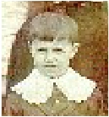
24
1918
The next day, March 28th 1918, which was to be Fred Hirst’s last, all
four companies of the 18th Battalion engaged to repel German attacks.
Having done so, they dug in but “the enemy shell fire continued and
there were many casualties.” One of them was Fred Hirst, who in turn
was one of 320 men of the 18th reported killed, wounded or missing
near Moyenneville in the last days of March, 1918.

Alfred Smith dies.

There has been some confusion regarding Alfred Smith’s War record. However, his family have
provided personal memories of ‘Uncle Alfie’. The family lived in Hawthorn Terrace where they
owned several houses. The son of John and Sarah Smith, Alfie was one of 8 brothers and sisters,
including Percy, Phoebe, Sarah, Hilda and Gordon. Alfie attended Bishop Middleham School and
his big brother Percy used to give him a piggy-back down to school in the morning.
The family story goes that Alfie falsified his age to fight for his country and died the day before
Armistice Day. He was never forgotten.

11th November The War ends.
SCHOOL LOG:
News received of Armistice at 11:00 hrs.
Patriotic songs sung. Suitable remarks made by
Headmaster. National Anthem sung.
9th December Private J Burney dies a month after Armistice Day.

J Burney is also commemorated at Ferryhill Cemetery.

THE AFTERMATH
While all were delighted with the end of the War, there were differing opinions as to its
meaning. With over three quarters of a million dead, the nation had been left massively
bereaved. Thus, returning veterans felt it inappropriate to over celebrate victory and their
survival. Many were deeply affected by their own experiences and many were angry
about the futility of the conflict, but the presumed needs of bereaved parents and wives
meant there was a strong social taboo against saying so.
After the War many young men and women did return to the village, and life went on.
Sidney Lee’s brother George returned and started the first bus service through the village.
The following names of survivors are taken from N. Haile’s ‘BISHOP MIDDLEHAM’:
Bainbridge E. Bulman J. A. Duff G.E. Forster W.S. Harper E.
Bainbridge T. Bulmer R. Duffield W. Foster E. Harper R.H.
Barton M. Chapman R. Elliott J. Garbutt T. Harper S.
Bell H. Craggs J.K. Elsey J. Gittins Florence L. Harrison W.
Blunden P. S. Craggs W. Fishwick A. Gittins R.C. Hodgson T.
Brown F. C. Crowther G.L. Fishwick F. Gittins W.A. Holmes W.R.
Brown J. Curbeson A. Ford F. Glendenning J. Hufford A.
Brown R. Curbeson W. Forster Dora B. Glendenning N. Hufford G.
Brown W. Dearing F. Forster P.A. Godley H. Jobling J.
Bulman A. Duff G. Forster W. Haile A.M. Kemp T.

(Continued on page 26.)

BISHOP MIDDLEHAM PARISH MAGAZINE
NOVEMBER 1918

My dear Parishioners,
As I am rather late in writing the Parish Magazine
matter I am thankful to say that I am writing at a time
when the news is glorious at the seat of war. Both Tur-
key and Austria have surrendered, and although Ger-
many is asking for a armistice, yet every-one is wishing
rather for a surrender too. One of the things many of us
wish to see enforced most of all is reparation. It does not
come in as one of President Wilson’s fourteen points,
but it does not touch America to the same degree as Bel-
gium, France, and England, yet at the same time she has
not escaped Germany’s atrocities. Personally I should
like to see every man dealt with who has been guilty of
cruelty to those within his power. This to my mind is
more important than anything else. It should be carried
out from the highest to the lowest, which will make it,
amongst other things, a warning for the future. I think
this to a great extent, will be done. It is a time, therefore,
for mouths to be filled with praise and thanksgiving. St
James tells us what a high use the tongue can be made
of, and what a low use. It can bless God, it can curse
men. It can be used in praise and thanksgiving, it can be
used to slander innocent people. It is a mark of the char-
acter of an individual, the way he or she uses the tongue.
The same fountain cannot bring out, as St. James says, at
the same time sweet water and bitter.
We have made a new beginning with the Scouts, and
so far things have gone well. I hope the parents will help
me, because it can only be carried on by regularity and
strict discipline. I want to see the boys grow up smart
boys and well mannered.
In many parishes meetings are being held for women
on account of the coming election, when they will be
privileged to exercise their vote. We intend to have one
in this parish about the end of next week, when some
invited speaker will give an address. At these meetings
no distinction is made; it is for non-conformists as well
as the Church of England. No politics are introduced, or
denominational religion. It is intended to be for the good
of the Empire and England. If religion is introduced,
which probably can hardly be excluded, it will be in gen-
eral terms, and have nothing to do with any denomina-
tion. We should like to see at it non-conformist speakers.
At present time we are all looking forward to a great re-
union of Christendom.
The War Office has conferred upon me the privilege of
“Honorary Chaplain”, so that I am responsible for duty
wherever soldiers are near, and to wear khaki with the
letter “R,” i.e. retired.
Unfortunately, I have to refer to another soldier who has
given his life for his country, i.e. Private Bell. I understand
he was a fine young man. He is another of the “Noble
Army of Martyrs”. We have all had great sympathy for his
family.
Our Harvest Thanksgiving Services were well attended. I
have never seen the Church so full as it was on the Sunday
evening. The Wednesday evening collection was for the
School. The amount was £2:6:0. The “Harvest Home” held
for the Sunday School prizes produced £3 net.
It was with deep sympathy and sorrow that we heard of
the death of Mrs Legge, at Acomb, York. She was better
known in this Parish as “Miss Harriet Walker”. She was
always in close touch with our Church life and ever help-
ful. I have never known anyone bear the heavy cross that
was laid upon her so patiently. To add to her own bodily
suffering she lost a dear husband in the war. I have reason
to believe she was perfected through her sufferings. She
had taken up her cross to follow Jesus.
May God comfort her family.

CHURCHINGS.
Sept 8th — Elizabeth Ann Wheatley, Bishop Middleham.
Oct 6th — Charlotte Elizabeth Milburn,
Bishop Middleham.
Oct 27th — Elizabeth Ross, Bishop Middleham.
— Mary Elizabeth Smith, Bishop Middleham.

BAPTISMS.
Sept 8th — Francis Alice, daughter of Thomas and
Elizabeth Ann Wheatley.
Oct 6th — Eric George Martin, son of George and
Charlotte Elizabeth Milburn.
Oct 27th — Fred Reed, son of George and Elizabeth Ross.
— Nora, daughter of James Walter and Mary
Elizabeth Smith.

MARRIAGE.
Oct 28th — Ernest Forster, 2, Conyers Terrace, The
Broom, Ferryhill, to Elizabeth Annie
Wearmouth, North Terrace, Mainsforth.

M. B. PARKER,
Vicar

Bishop Middleham Church Magazine 1913. DRO EP/BM 149

25



Kirby C. Mayman W. Palmer R. Rutter J. Springhall C. Watson Jas.
Lambert J.B. Mc.Cormack J. Parker M.B. Rutter W.H. Surtees H.C. Wilkinson E.
Laverick H. Mc.Cormack P. Plummer G.H. Sadler T. Tinkler G. Wilkinson N.
Lee G.C. Metcalf J. Prior G. Siddle W. Turnbull J. Willis T.
Legg C. Milburn J. Raine W. Smare A. Turnbull N. Wills J.
Legg F. Milburn W. Rippon G. Smare W. Turney J. Wilson E.
Legg H. Mills E. Robinson A. Smith A.W. Walker C. Wilson S.
Legg J. Moffat R. Ross A. Smith H. Walker Hy.
Mallam W. Nobbs Evelyn Ross H. Smith H.W. Walker Herbert
Mayman R. Nobbs Mary L. Ross J. Smith J.H. Wardle J.

Newton Haile also records that A. Mills lost his life in the War, although his name
does not appear on the War Memorial. No details are known about A Mills.

1919
30th April PARISH COUNCIL
A Public General Meeting was called to consider the question of a War Memorial.
1921
9th October The War Memorial Dedication Service takes place.

The War Memorial Committee who organised the memorial comprised of disabled soldiers and sailors.
Money was raised by public subscription. It cost £245 and the sculptor was recorded as Francis Jones from
Ainsley and Collins of West Hartlepool.
The War Memorial was unveiled in St Michael’s Churchyard on Saturday 9th October 1921
by Lt Col. Tomlinson of Seaton Carew.
The Dedication was given by Archdeacon Derry.

The Inscription reads:
To the glory of God
And in loving memory of
The men of
Bishop Middleham
and Mainsforth
Who laid down their lives
In the Great War 1914 - 1918
Greater love hath no man than this,

That a man lay down his life for his friends.

After World War 2 a stone book was added.
The Inscription reads:
Also the following
who died on active service
during the World War
1935 - 1945
In 2013, time and weather had eroded some of
the names recorded on the War Memorial and
the foundations had subsided so repairs were
carried out.

The RE-DEDICATION SERVICE
took place on 10th July 2014,
presided by the Bishop of Jarrow.

26


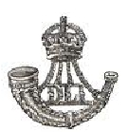
THE MEN

DURHAM LIGHT INFANTRY

Many of the men from the Bishop Middleham area joined the D.L.I.

In World War One the Durham Light Infantry suffered huge losses.
In September, 1914, the 2nd Battalion lost as many men in one day as the entire regiment
lost during the Boer War.
In Spring 1915, the Territorials lost a third of their strength in a few weeks. Worse was to
follow:- on the 1st of July 1916 at the Somme, the ‘Durham Pals’ (18th Battalion D.L.I) lost
half their men, either killed or wounded.
The D.L.I. fought in every major battle of the Great War. Members of the regiment were
awarded six Victoria Crosses, but the cost was horrific, with nearly 13,000 dead and
many more thousands gassed or wounded.
Despite this, in the 1920s and 1930s, the regiment had few problems in recruitment such
was the high level of unemployment in County Durham.

Artist : Nathan Brimm, aged 13

27

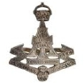

ROBERT BARTON
REGIMENT: DLI 1/5th Bn.
RANK: CORPORAL
SERVICE NUMBER: 200530
DUTY LOCATION: France and Flanders
DATE of DEATH: 23/04/1917
AGE at DEATH: 23
FATE: Killed in action
CEMETERY: ARRAS MEMORIAL
Bay 8
Roclincourt,
Pas de Calais, France.
P BELL
RANK: PRIVATE See page 25
RONALD BULMAN
REGIMENT: Alexandra, Princess of Wales’s
Own (Yorkshire) 9thBn.
RANK: CORPORAL
SERVICE NUMBER: 17692
DATE of DEATH: 13/03/1918
AGE at DEATH: 21
FATE: Died at home
CEMETERY: HENDON CEMETERY
and CREMATORIUM
D.9.23878
J BURNEY
REGIMENT: Grenadier Guards
RANK: PRIVATE

SERVICE NUMBER: 31497
DATE of DEATH: 09/12/1918

A CAMPAN
No Details are known about A Campan.

JOSEPH CRAKE
REGIMENT: DLI 1/5th Bn.
RANK: PRIVATE
SERVICE NUMBER: 4017
DATE of DEATH: 19/09/1916
AGE at DEATH: 39
CEMETERY: PUCHEVILLERS
BRITISH iv.D.14
Department de la Somme,
Picardie, France.
28
ALBERT DAVISON
REGIMENT: DLI 10th Bn.
RANK: PRIVATE
SERVICE NUMBER: 28088
DUTY LOCATION: France and Flanders
DATE of DEATH: 18/10/1916
AGE at DEATH: 23
FATE: Died of wounds
CEMETERY: St SEVER CEMETERY
B.13.46
Rouen,
Seine-Maritime, France.

GEORGE DUFFIELD
REGIMENT: DLI 14th Bn.
RANK: CORPORAL / LANCE
SERGEANT
SERVICE NUMBER: 28430
DUTY LOCATION: France and Flanders
DATE of DEATH: 13/12/1917
AGE at DEATH: 23
FATE: Killed in action
CEMETERY: MARCOING BRITISH
CEMETERY
II.C.21
Nord, France.

FRED HIRST
REGIMENT: DLI 18th Bn.
RANK: PRIVATE
SERVICE NUMBER: 28134
DUTY LOCATION: France and Flanders
DATE of DEATH: 28/03/1918
AGE at DEATH: 21
FATE: Killed in action
CEMETERY: MOYENNEVILLE
(TWO TREES) CEMETERY
A.24
Pas de Calais, France.

W T HUTCHINSON
No Details are known about W Hutchinson.


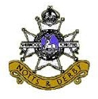
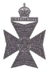
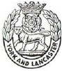

ROBERT JOHNSON
REGIMENT: DLI 13th Bn.

SERVICE NUMBER: 33264
DATE of DEATH: 12/06/1917
FATE: Missing

CEMETERY: YPRES (MENIN GATE)
MEMORIAL
Panel 36 and 38
West Flanders,
Belgium.

THOMAS JOSEPH LAVERICK
REGIMENT: Worcestershire 4th Bn
RANK: LANCE CORPORAL
SERVICE NUMBER: 26241
DUTY LOCATION: France and Flanders
DATE of DEATH: 30/11/1917
AGE at DEATH: 24
FATE: Died of wounds
CEMETERY: ROCQUIGNY-
EQUANCOURT ROAD
BRITISH CEMETERY,
MANANCOURT, France.
III.C.16

JOHN SIDNEY LEE
REGIMENT: SHERWOOD
FORESTERS 2nd/7th Bn
RANK: LANCE CORPORAL
SERVICE NUMBER: 267271
DUTY LOCATION: France and Flanders
DATE of DEATH: 27/04/1917
AGE at DEATH: 20
FATE: Died of wounds
CEMETERY: La CHAPELETTE
BRITISH and INDIAN
CEMETERY,
PERONNE
II.A.12
Somme, France.

29
THOMAS TINKLER LEGGE
REGIMENT: King’s Royal Rifle Corps
RANK: SERGEANT
SERVICE NUMBER: C/12187
DUTY LOCATION: France and Flanders
DATE of DEATH: 06/08/1917
AGE at DEATH: 18
FATE: Died
CEMETERY: JANVAL CEMETERY
I.I.3
Dieppe,
Seine-Maritime,
France.

JOSEPH MADDISON
REGIMENT: York and Lancs 9th Bn
RANK: PRIVATE
SERVICE NUMBER: 34517
DATE of DEATH: 02/10/1916
AGE at DEATH: 22
FATE: Killed in action
CEMETERY: THEIPVAL MEMORIAL
Pier and Face
14A and 14B
Somme, France.

THOMAS MURRAY
REGIMENT: DLI 11th Bn.
RANK: PRIVATE
SERVICE NUMBER: 25228
DUTY LOCATION: France and Flanders
DATE of DEATH: 10/11/1915
AGE at DEATH: 21
FATE: Died of wounds
CEMETERY: SAILLY-SUR-La-DYS
CANADIAN CEMETERY
III.A.12
Somme, France.

PERCY DOUGLAS ROBINSON
REGIMENT: Northumberland
Fusiliers 9th Bn
RANK: CAPTAIN
DUTY LOCATION: France and Flanders
DATE of DEATH: 07/07/1916

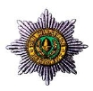
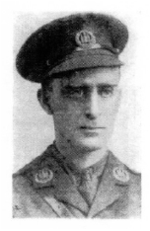
ALFRED SMITH
Many men called Alfred Smith were killed in WW1.
It is unclear which of them was our Alfie Smith.
See page 24.

G S TAYLOR
No Details are known about G Taylor.

J WALKER

CHARLES
ASHFORTH
CARTLEDGE
continued

CEMETERY:
AVELUY COMMUNAL
CEMETERY EXTENSION
F.64
Somme, France.

2nd Lt. Charles Cartledge.

REGIMENT: Cheshire
RANK: PRIVATE
SERVICE NUMBER: 28170
DATE of DEATH: 16/02/1917
CEMETERY: St HILAIRE CEMETERY,
FREVENT
II.A.2
Pas de Calais,
France.

JOSEPH MATTHEW WATSON
REGIMENT: DLI 1st/7th Bn
RANK: CORPORAL
SERVICE NUMBER: 1983
DATE of DEATH: 10/05/1915
AGE at DEATH: 21

ALSO
Commemorated on a family grave stone
in St Michael’s Churchyard:

CHARLES ASHFORTH CARTLEDGE

REGIMENT: Northamptonshire
RANK: SECOND LIEUTENANT
DUTY LOCATION: France and Flanders
DATE of DEATH: 29/07/1916

AGE at DEATH: 33

FATE: Killed in action

30

Charles Ashforth Cartledge was less typical
of the men who were commemorated on the
War Memorial. He was in his thirties when he
joined up as an officer in the Northamptonshire
Regiment.
However, like many of the men, he was born in
Bishop Middleham. His father, also called
Charles Ashforth Cartledge, was the Dean of
Bishop Middleham from 1875 to 1892.
We know that the family had strong associations
with the Church.
The announcement of the wedding of Charles’
parents, in the Harrogate Advertiser on the 20th
June 1874, states the following:

“On June 17th, at the Holy Trinity Church, Ripon,
by the Venerable Edward Prest MA, Archdeacon of
Durham, brother of the Bride, and the Rev. W. A.
Cartledge MA, Vicar of Bilton, Harrogate, Charles
Ashforth Cartledge BA, Curate of Bilton, to Harriet
Anne Prest.”

Thus, Charles’ father, grandfather and uncle
were all clergymen. It is possible the uncle, being
Archdeacon of Durham, helped secure his father
the living of Bishop Middleham.

The 1891 Census reveals that Charles, aged 7,
has two elder sisters: Charlotte (14), Agnes (12),
and a brother William (11), all of whom were
born in Bishop Middleham.
The family also had three living-in servants.
Hannah Kirk, the youngest, was only 14. What
contrasting lives the two 14-year-old girls must
have led while both living in the Vicarage - the
Old Vicarage on Church Street.

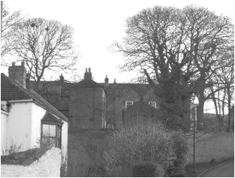
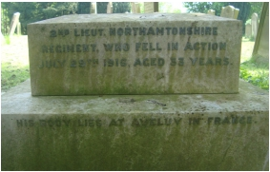
The Old Vicarage in the bottom left corner,
Living next door to them at the Hall were
the famous brewing family of Matthew
Forster, including his wife, four children
and four servants. We know that these well-
to-do Middleham families must have
known and trusted each other, because in
1908 when Charles’ mother Harriet died in
York, Matthew Forster was named executor
to her estate. The reason for her departure
from Bishop Middleham was the early
death of her husband in 1892, when Charles
was only 9.

and the Hall in the distance.

The Rev. C. A. Cartledge is buried in St Michael’s
graveyard, close to the Church. Harriet’s body
returned to Bishop Middleham to be interred
with him.
The inscription includes the words :
“This cross is erected by his friends and parishioners.”
Later still, an inscription was added to the family
gravestone, to commemorate Charles, their son,
when he fell at the Somme in 1916.

The inscription for Charles Cartledge.

However, the 1901 Census finds Charles alive and well, and living in Harrogate with two
unmarried sisters. (Charlotte married a surgeon, John Prest Wightman, later that year).
His widowed mother’s occupation is described as “living on her own means”. They no
longer have household servants but as Charles is being educated at Gigglesworth School
and his sisters have not been required to find work, circumstances can’t have been that
desperate.
After leaving school, Charles went to university but in a break from the family clerical
tradition he studied to become a civil engineer. The 1911 Census shows Charles, now 27,
as lodging with a family in Withernsea in the East Riding of Yorkshire. He is described as
a civil engineer working as a general contractor. He must have been a successful one, as
upon his death, he left £3,500. This would have been a considerable sum at the time and
was more than ten times the amount that was left by his mother.
In 1914, he was living in the Parish of Tottenham, North London, where on the 21st June
he married Ethel Cooper Snowden, of Headingley, Leeds. Within 6 weeks Britain was at
war with Germany.
In February 1915 Charles joined the 5th Battalion of the Northamptonshire Regiment as a
pioneer. Pioneers, as well as fighting, were used for the massive construction projects that
were required on the Western Front, including trench building and railway construction.
Charles’ civil engineering skills would have been invaluable.
From his medal index card we know Charles entered the Theatre of War on May 30th,
1915. He served for over a year but a month into the Battle of the Somme, he was killed in
action, aged 33. He was buried in the Aveluy Cemetery in France.
In January 1919 his grieving widow Ethel applied for the 1914—15 Star on his behalf.
By then she was living in Cheltenham. They had no children.

31

Herbert DODSWORTH was the husband of Vera Mary Dodsworth of Bishop Middleham.
He was a Private in the Army Catering Corps and then the Royal Engineers. He died on
15/10/1944 aged 36 years, and is buried at BEIRUT WAR CEMETERY, 4.B.4, Lebanon.
Philip Bellerby HAILE was the son of Alfred. M. and Amy C. Haile of Bishop Middleham.
He was a Flight Sergeant in the Royal Air Force Volunteer Reserve, 99th Sqn. He died on
21/01/1945, aged 22 years, and is buried at MAYNAMATI WAR, CEMETERY,
Coll. Grave 3.D.19, Bangladesh.
L HEWIT: No details are known about L. Hewit.
Henry HODGSON was the son of William and Harriet Hodgson of Bishop Middleham. He
was an Able Seaman in the Royal Navy and served on SS Harpangar. He died on 20/05/1941,
aged 24 years, and is commemorated on CHATHAM NAVAL MEMORIAL, 43.1, Kent, England.
Isabella JONES was the daughter  of Samuel and Johanna Jones of Bishop  Middleham. She was a Private in the  Auxiliary Territorial Service. She died on  26/11/1945, aged 20 years, and is buried  at St MICHAEL’S CHURCHYARD,  Bishop Middleham. Isabella is the only  woman remembered on the Memorial  who lost her life serving her country. | REST AFTER WEARINESS, PEACE AFTER PAIN
W. MORALEE: No details are known about W. Moralee.
H ROBSON: No details are known about H. Robson.
Bernard SAYERS was the son of Robert and Martha Ann Sayers, of Bishop Middleham. He
was an Able Seaman in the Royal Navy Patrol Service, and served on HMS Southern Flower. He
died on 03/03/1945, aged 25 years, when his ship was sunk by a U-Boat. He is commemorated
on LOWESTOFT NAVAL MEMORIAL, England.
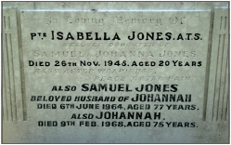








32
WORLD WAR 2

