SERVICE OF REDEDICATION
THE WAR MEMORIAL OF THE 5TH BATTALION
NORTHUMBERLAND FUSILIERS
WHO FELL IN THE GREAT WAR 1914 - 1918
WALKER PARK
11.00 AM SATURDAY JULY 30TH 2016

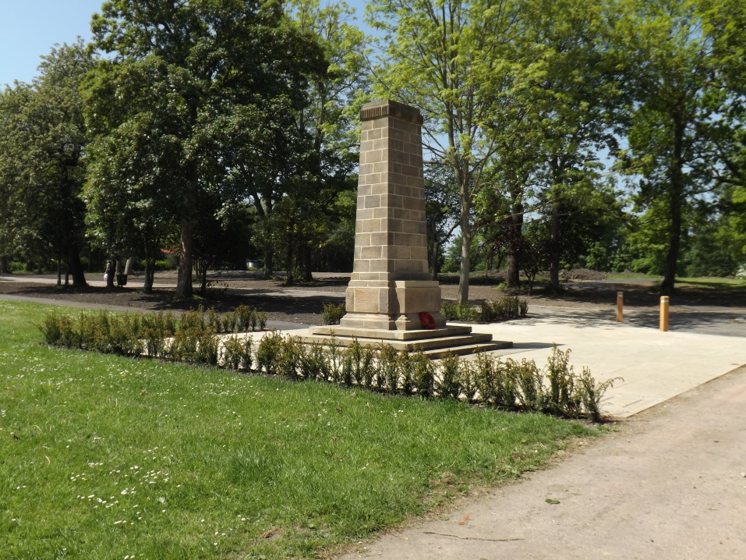

Introduction by Major Chester Potts TD
Rev. Padre Cecil Dick TD
THE FIRST HYMN
Make me a channel of your peace
Where there is hatred let me bring your love
Where there is injury your pardon Lord
And where there’s doubt true faith in you

O Master grant that I may never seek
So much to be consoled as to console
To be understood and to understand
To be loved as to love with all my soul

Make me a channel of your peace
Where there’s despair in life let me bring hope
Where there is darkness only light
And where there’s sadness ever joy

O Master grant that I may never seek
So much to be consoled as to console
To be understood and to understand
To be loved as to love with all my soul

Make me a channel of your peace
It is in pardoning that we are pardoned
In giving of ourselves that we receive
And in dying that we’re born to eternal life
……..
Mrs Josephine Valerie Chexal,
German Consul in Newcastle
A reading from Paul’s letter to the Corinthians
If I speak in the tongues of men, and of angels, but have not love, I am a noisy gong or a clanging cymbal.
And if I have prophetic power, and understand all mysteries and all knowledge, and if I have all faith, so as to remove mountains, but have not love, I am nothing.
And if I give away all I have, and if I deliver my body to be burned, but have not love, I gain nothing.
Love is patient and kind; love is not jealous or boastful; it is not arrogant or rude. Love does not insist on its own way; it is not irritable or resentful; it does not rejoice at wrong, but rejoices in the right.
Love bears all things, believes all things, hopes all things, endures all things.
Love never ends; as for prophesies, they will pass away; as for tongues, they will cease; as for knowledge, it will pass away.
For our world is imperfect, and our prophesy imperfect, but when the perfect comes, the imperfect will pass away.
When I was a child, I spoke like a child, I thought like a child, I reasoned like a child, but when I became an adult, I gave up childish ways.
For now, we see in a mirror dimly, but then, I shall understand fully, even as I have been fully understood.
So, faith, hope, love abide, these three;
But the greatest of these is love.
This is the word of the Lord.
……..
THE SECOND HYMN
Be still, my soul: the Lord is on your side;
Bear patiently the cross of grief and pain;
Leave to your God to order and provide;
In every change he faithful will remain.
Be still, my soul: your best, your heavenly friend
Through thorny ways lead to a joyful end.
Be still, my soul: your God will undertake
To guide the future as he has the past.
Your hope, your confidence let nothing shake,
All now mysterious shall be clear at last.
Be still, my soul: the tempests still obey
His voice, who ruled them once on Galilee

Be still, my soul: the hour is hastening on
When we shall be forever with the Lord,
When disappointment, grief and fear are gone,
Sorrow forgotten, love’s pure joy restored.
Be still, my soul: when change and tears are past,
All safe and blessed we shall meet at last.
……..
Major Chester Potts TD
A reading from Paul’s letter to the Ephesians
Finally, be strong in the Lord and in the strength of his power. Put on the whole armour of God, so that you may be able to stand against the wiles of the devil.
For our struggle is not against the enemies of blood and flesh, but against the rulers, against the authorities, against the cosmic powers of this present darkness, against the spiritual forces of evil in the heavenly places.
Therefore take up the whole armour of God, so that you may be able to withstand on that evil day, and having done everything, to stand firm.
Stand therefore, and fasten the belt of truth around your waist, and put on the breastplate of righteousness.
As shoes for your feet, put on whatever will make you ready to proclaim the gospel of peace. With all these, take the shield of faith, with which you will be able to quench all the flaming arrows of the evil one.
This is the word of the Lord
….....

Rev Padre Cecil Dick TD
……..

Lieutenant General Robin V. Brims, CB, CBE, DSO, DL
UNVEILING THE MEMORIAL
……..

The Exhortation – W01 (RSM) John Thompson
“They shall grow not old, as we that are left grow old, age shall not weary them, nor the years condemn; at the going down of the sun, and in the morning, we will remember them”
ALL – We will remember them
The Last Post
Two minutes silence
Reveille
The laying of wreaths will take place. Members of the public are invited to lay personal wreaths and floral tributes at the end of the service
……..
W01 (RSM) John Thompson - The Kohima Epitaph
“When you go home, tell them of us and say, for your tomorrow, we gave our today”
……..
A YOUNG PERSON’S VIEW ON THE GREAT WAR
……..
FINAL HYMN
Guide me, O thou great redeemer,
Pilgrim through this barren land;
I am weak, but thou art mighty,
Hold me with thy powerful hand:
Bread of heaven, bread of heaven
Feed me till I want no more
Feed me till I want no more

Open now the crystal fountain,
Whence the healing stream doth flow;
Let the fire and cloudy pillar
Lead me all my journey through;
Strong deliverer, strong deliverer
Be thou still my strength and shield
Be thou still my strength and shield

When I tread the verge of Jordan,
Bid my anxious fears subside,
Death of death, and hell’s destruction,
Land me safe on Canaan’s side;
Songs of praises, songs of praises
I will ever give to thee,
I will ever give to thee
……..
Rev Stephen Herbert, Vicar of St. Martins
PRAYERS
……..

Act of Commitment
All say: Lord God our Father, we pledge ourselves to serve all mankind in the cause of peace, for the relief of want and suffering, and for the praise of your name. Guide us by your spirit; give us wisdom; give us courage; give us hope, and keep us faithful now and always. Through Jesus Christ our Lord, Amen
……..
THE NATIONAL ANTHEM
God save our gracious Queen
Long live our noble Queen
God Save the Queen
Send her victorious
Happy and glorious
Long to reign over us
God save the Queen

Thy choicest gifts in store
On her be pleased to pour
Long may she reign
May she defend our laws
And give us ever cause
To sing with heart and voice
God Save the Queen
……..
FINAL BLESSING – Rev Stephen Herbert

The rededication of the new plaques on the 5th Battalion war memorial is the final part of the WW1 project of Walker Churchyard Memorial Group.
It began in late July 2014 with the planting of a Centenary Oak tree and placing floral tributes on the WW1 graves, followed by a three day exhibition commemorating the outbreak of the Great War. The exhibition closed on the 4th of August with a service at this 5th Battalion war memorial.
On May 24th 2015 the Roll of Honour of the 1,051 lost lives of the battalion in WW1 was installed into Walker Parish Church.

Walker Churchyard Memorial Group wish to extend their thanks and great appreciation for the valuable help given to this project by the following –
The Directors of Pearson Engineering for their most generous donation which enabled the new plaques to be purchased.
Community Foundation for their Comic Relief grant.
Lieutenant General Robin V. Brims, CB, CBE, DSO, DL
Major Chester Potts TD
Rev Padre Cecil Dick TD
Rev Stephen Herbert, Vicar of St. Martins
Major Gary Jones MBE, Fifth Fusiliers
W01 (RSM) John Thompson, Fifth Fusiliers
Colour Sgt Richard Stacey & Band of Royal Regiment of Fusiliers
Ian Wood Memorials
Rt. Hon. Nick Brown MP
Councillor David Wood
Jeff Hurst and John Bennett of YMCA Newcastle
Chris Davis, Director of TGP Landscape Architects.
Seamus Tollitt, Park Manager
Brambledown landscapes

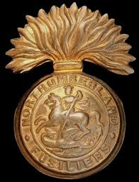

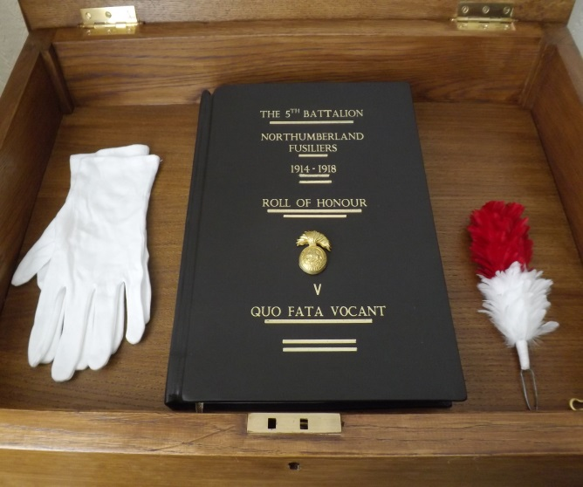

The 5th Battalion Northumberland Fusiliers
Roll of Honour
In Walker Parish Church

