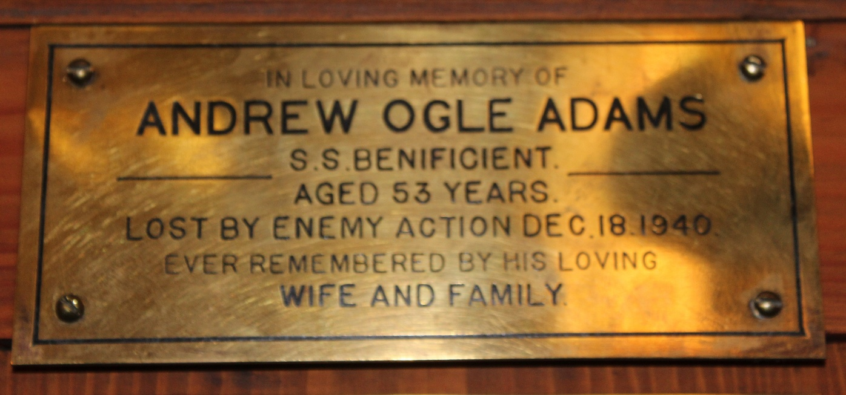
Adams, Andrew Ogle, S.S. Beneficent, lost by enemy action 1940 aged 53

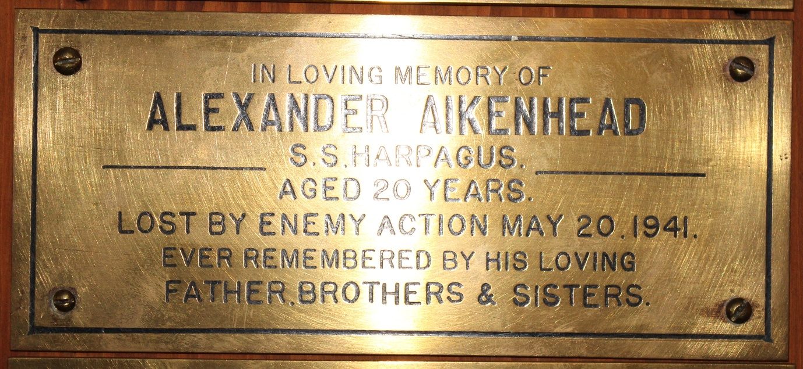
Aikenhead, Alexander, S.S. Harpagus, lost by enemy action 1941 aged 20

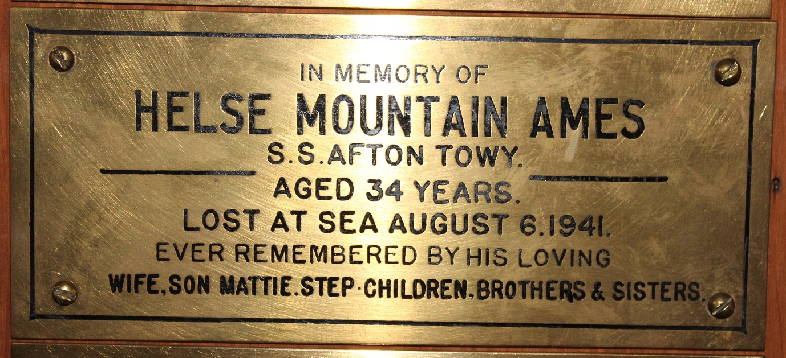
Ames, Helse Mountain, S.S. Afton Towy, lost at sea 1941 aged 34

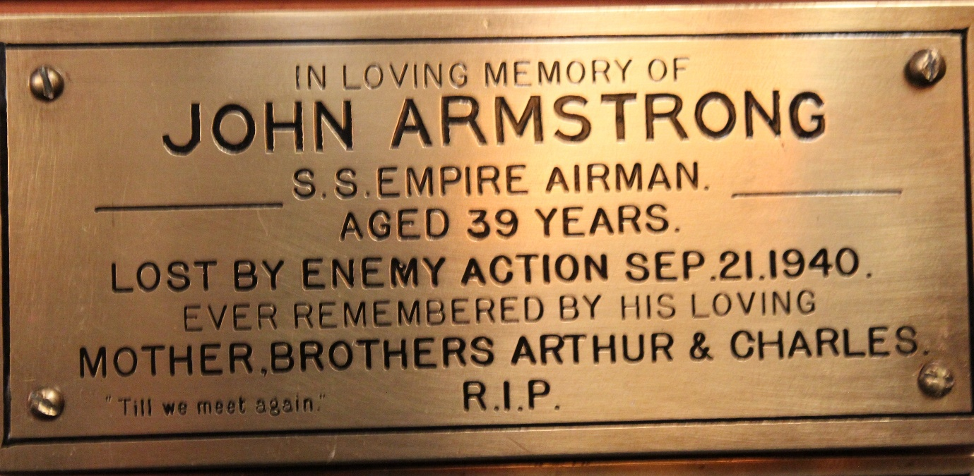
Armstrong, John, S.S. Empire Airman, lost by enemy action 1940 aged 39

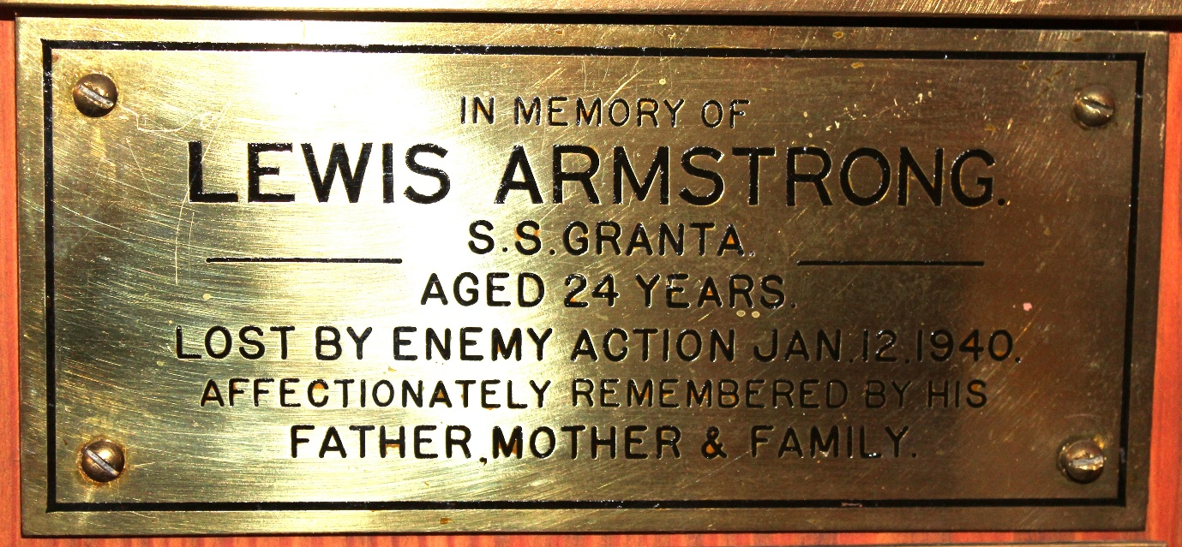
Armstrong, Lewis, S.S. Granta, lost by enemy action 1940 aged 24

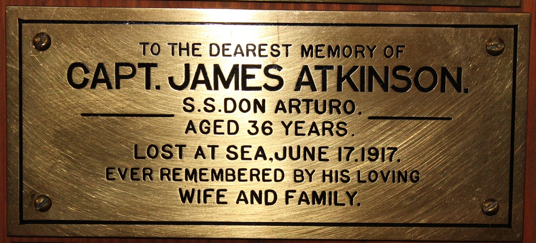
Atkinson, Captain James, S.S. Don Arturo, lost at sea 1917 aged 36

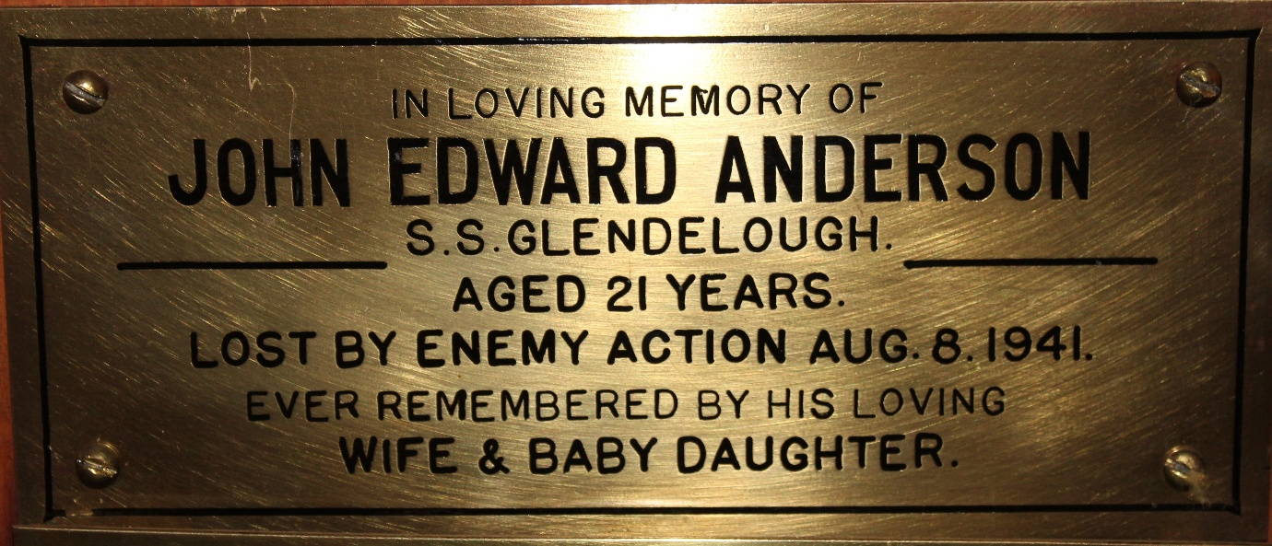
Anderson, John Edward, S.S. Glendelough, lost by enemy action 1941 aged 21

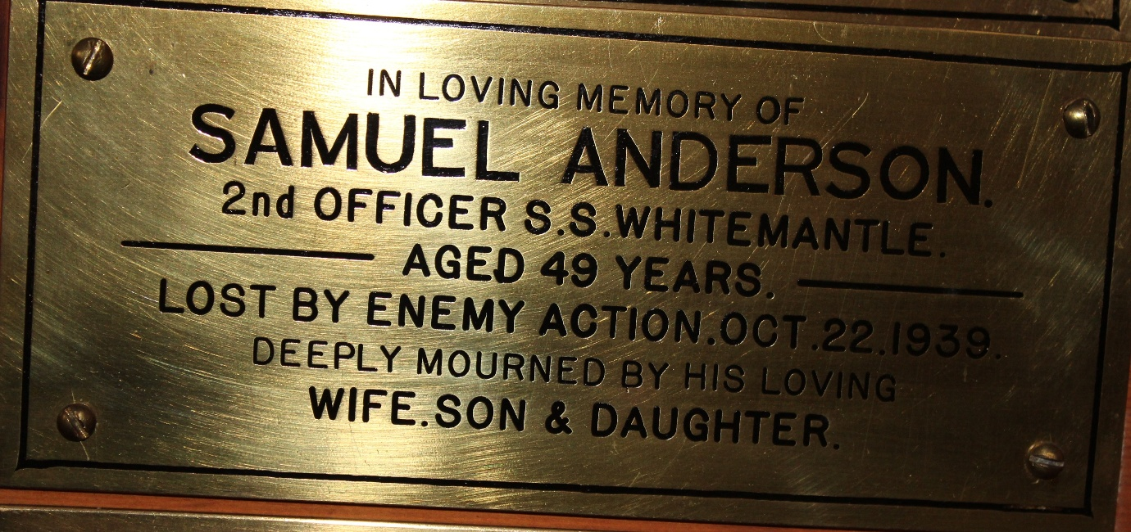
Anderson, 2nd Officer Samuel, S.S. Whitemantle, lost by enemy action 1939
aged 49

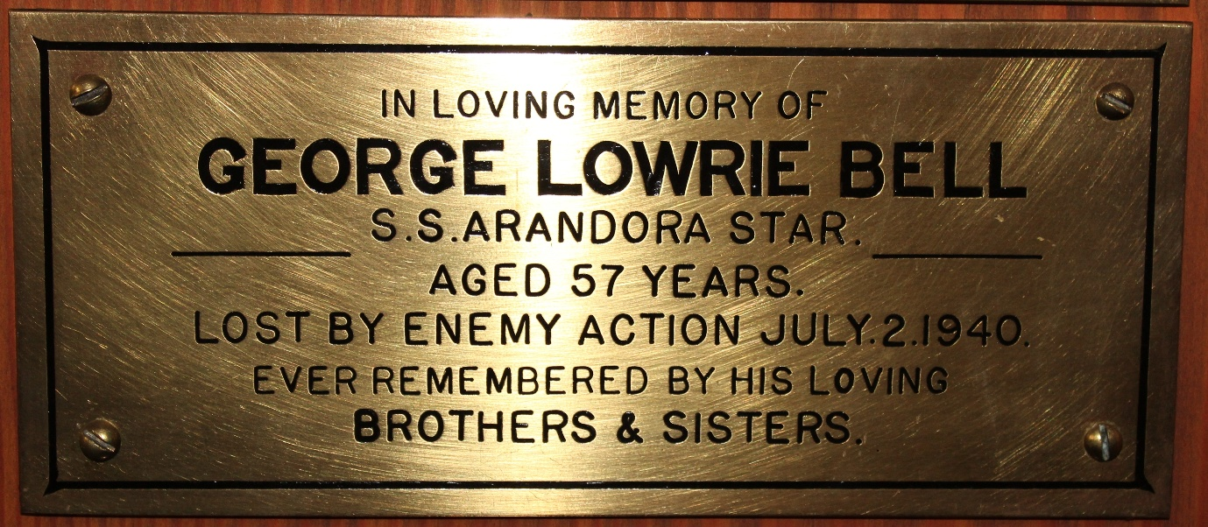
Bell, George Lowrie, S.S. Arandora Star, lost by enemy action 1940 age 57

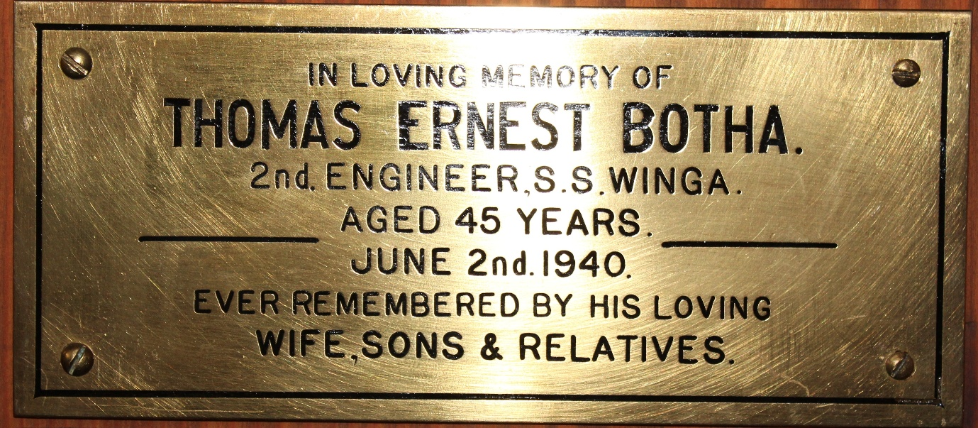
Botha, 2nd Engineer Thomas Ernest, S.S. Winga, 1940 aged 45

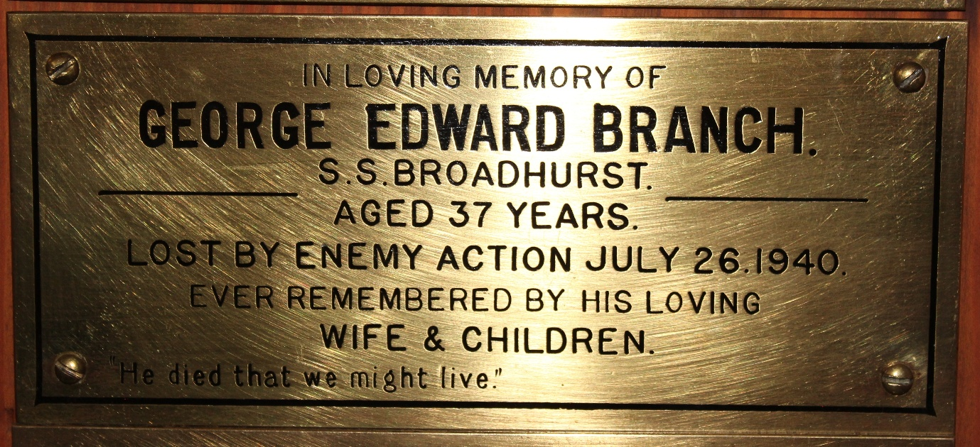
Branch, George Edward, S.S. Broadhurst, lost by enemy action 1940 aged 37

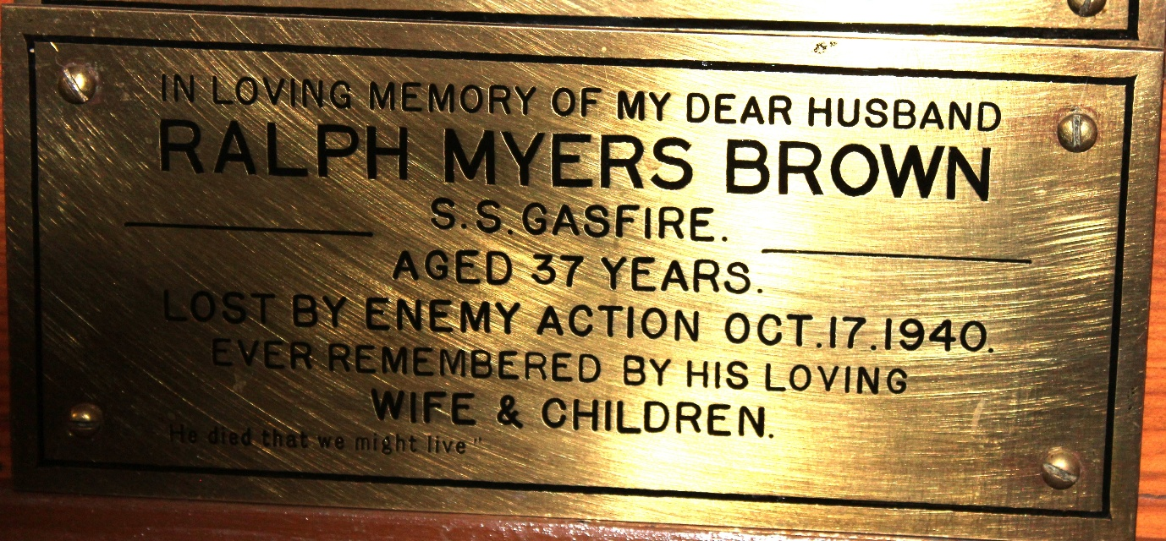
Brown, Ralph Myers, S.S. Gasfire, lost by enemy action 1940 aged 37

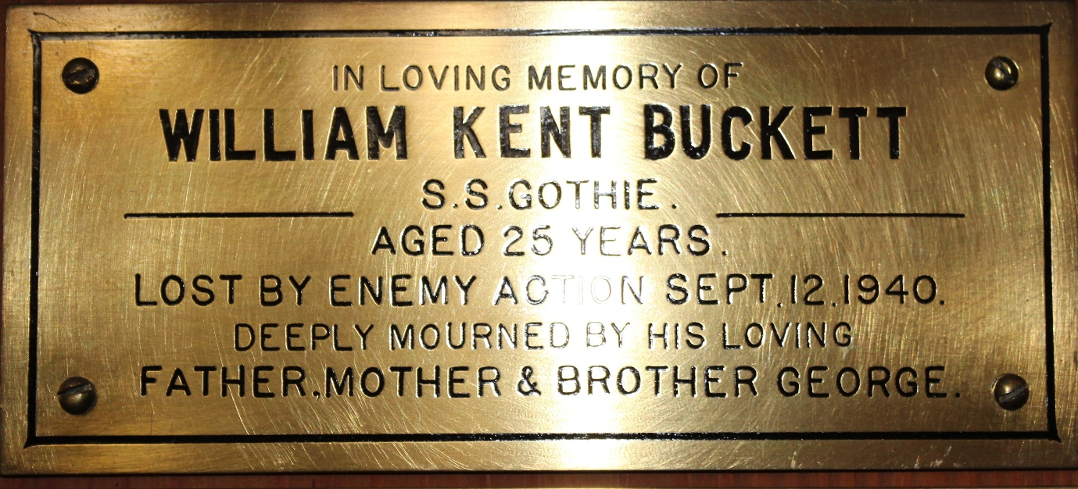
Buckett, William Kent, S.S. Gothic, lost by enemy action 1940 age 25

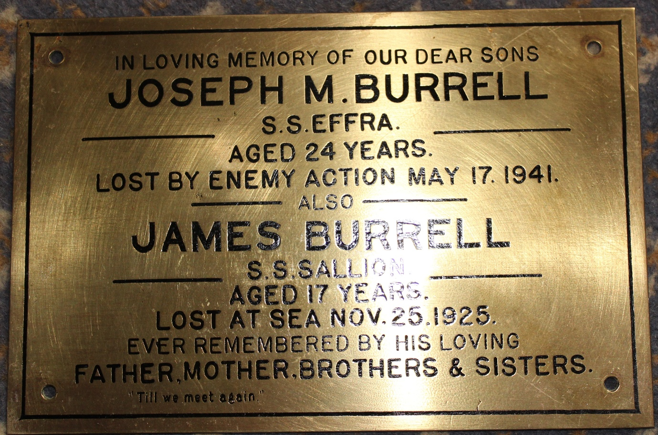
Burrell, Joseph M., S.S. Effra, lost by enemy action 1941 aged 24
also James Burrell, S.S. Sallion, lost at sea 1925 aged 17

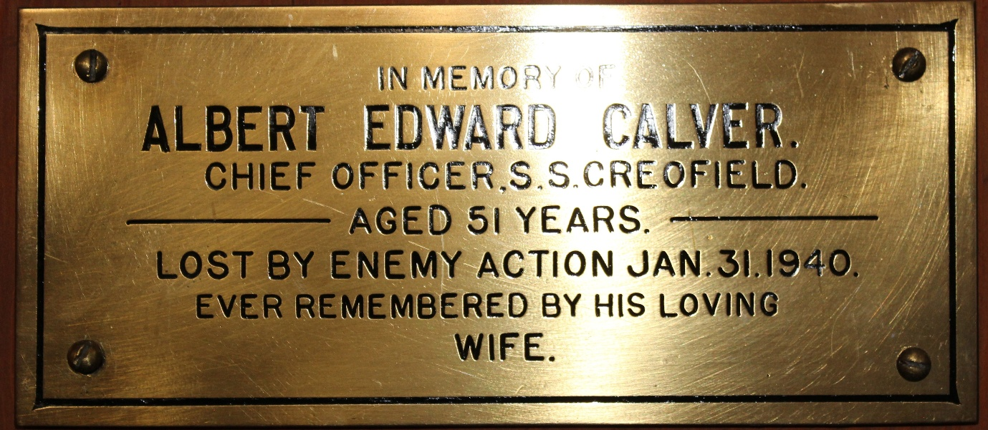
Calver, Chief Officer Albert Edward, S.S. Creofield lost by enemy action 1940 age 51

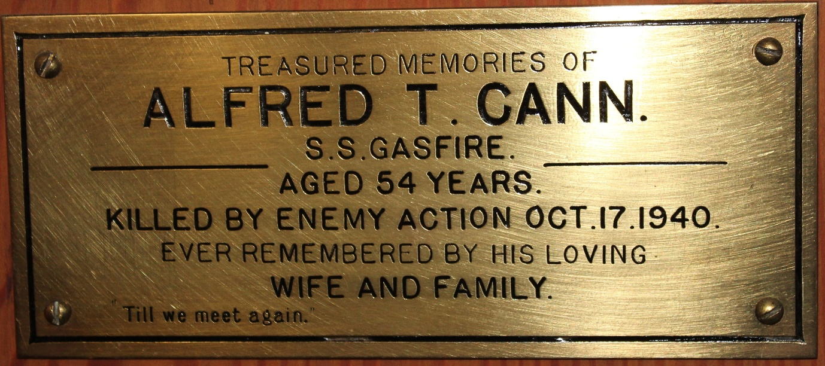
Cann, Alfred T., S.S. Gasfire, killed by enemy action 1940 age 54

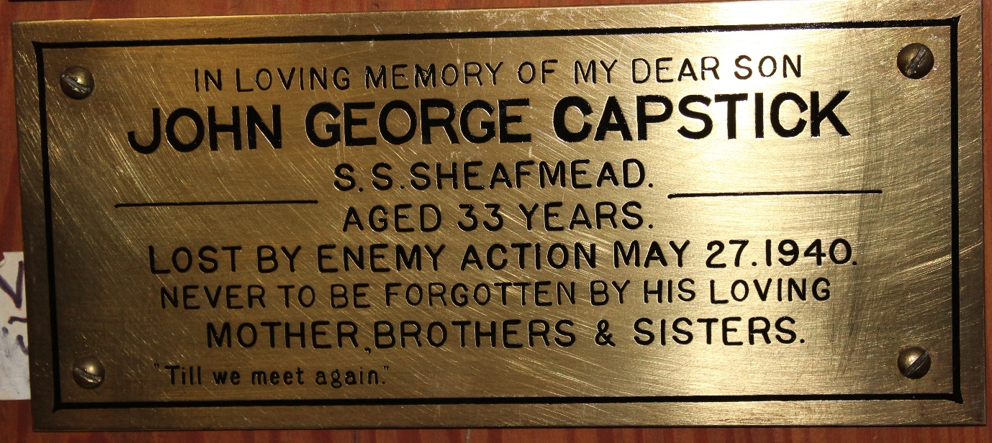
Capstick, John George, S.S. Sheafmead, lost by enemy action 1940 aged 33

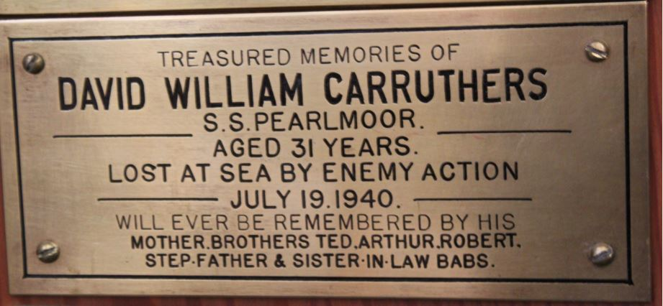
Carruthers, David William, S.S. Pearlmoor, lost by enemy action 1940 aged 31

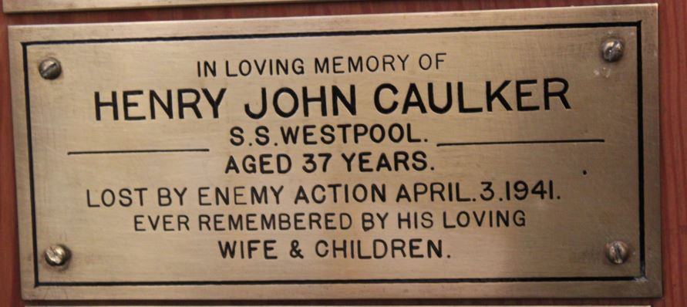
Caulker, Henry John, S.S. Westpool, lost by enemy action 1941 aged 37

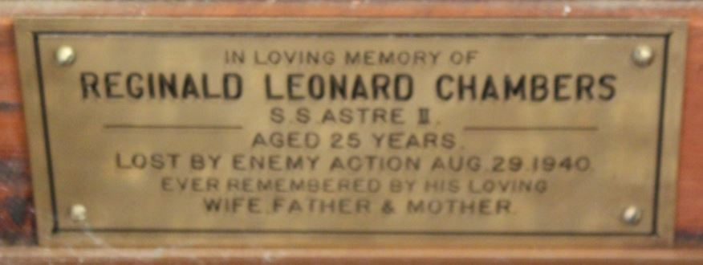
Chambers, Reginald Leonard, S.S. Astre II, lost by enemy action 1940 aged 25
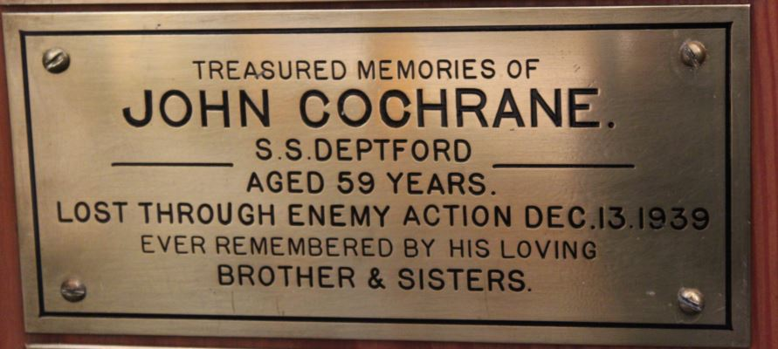
Cochrane, John, H.M.S. Deptford, lost by an enemy action 1939 aged 59
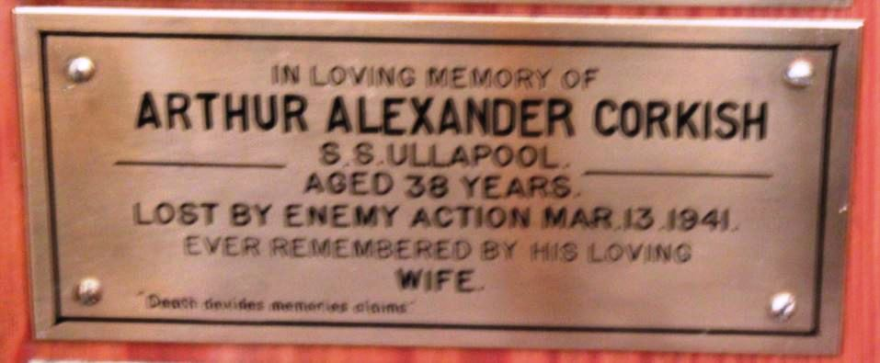
Corkish, Arthur Alexander, S.S. Ullapool, lost by enemy action 1941 aged 38

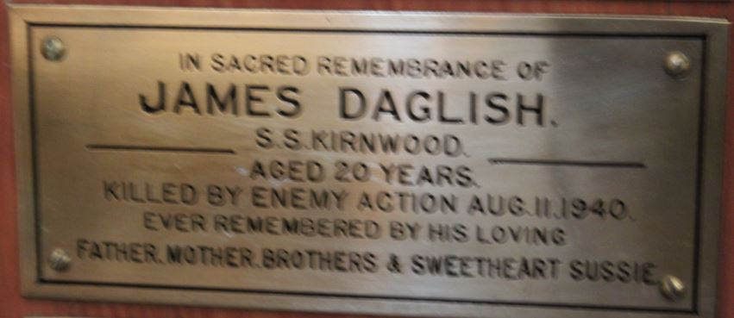
Daglish, James, S.S. Kirnwood, killed by enemy action 1940 age 20

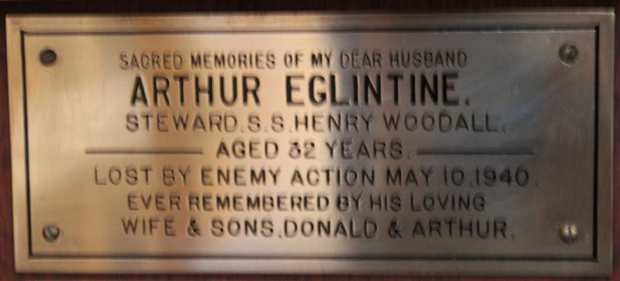
Eglintine, Stewart Arthur, S.S. Henry Woodall, lost by enemy action 1940 aged 32

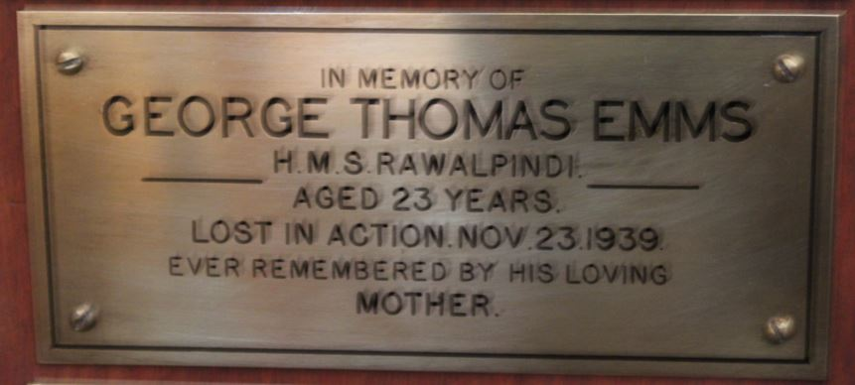
Emms, George Thomas, H.M.S. Rawalpindi, lost in action 1939 aged 23

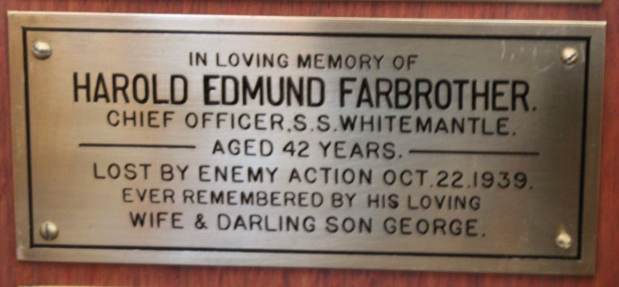
Farbrother, Chief Officer Harold Edmund, S.S. Whitemantle, lost by enemy action 1939
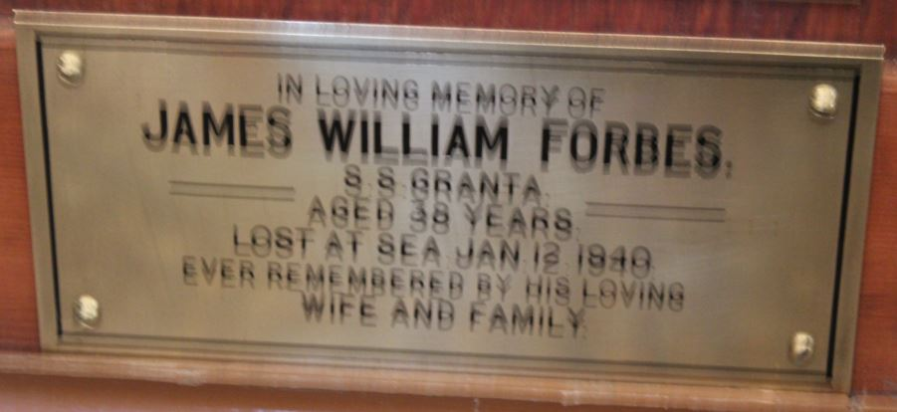
Forbes, James William, S.S. Granta, lost at sea 1940 aged 21

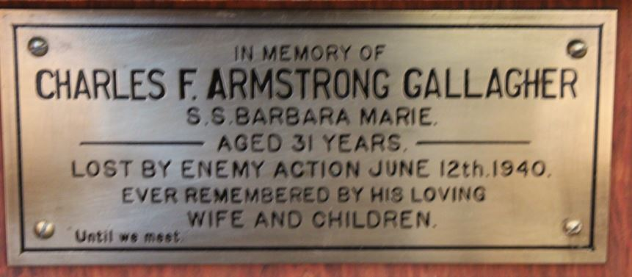
Gallagher, Charles F. Armstrong, S.S. Barbara Marie, lost by enemy action 1940 aged 21

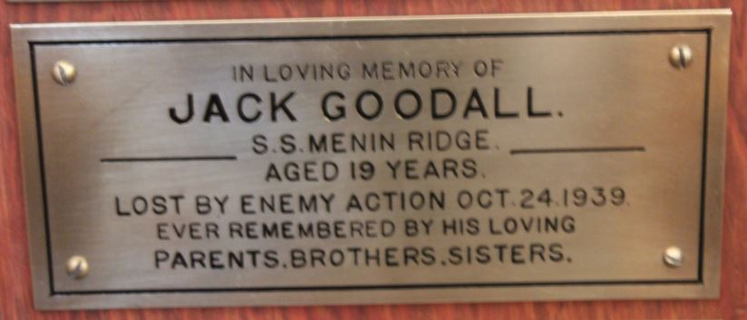
Goodall, Jack, S.S. Menin Ridge lost by enemy action 1939 aged 19

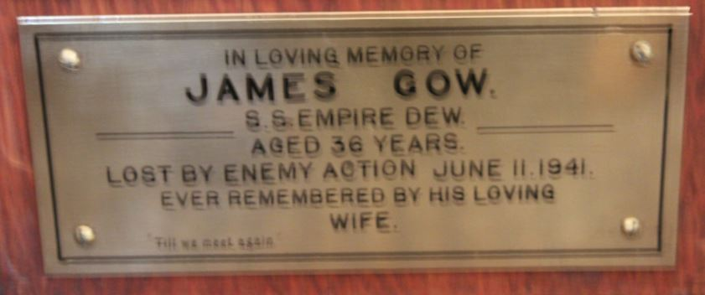
Gow, James, S.S. Empire Dew, lost by enemy action in 1941 aged 36

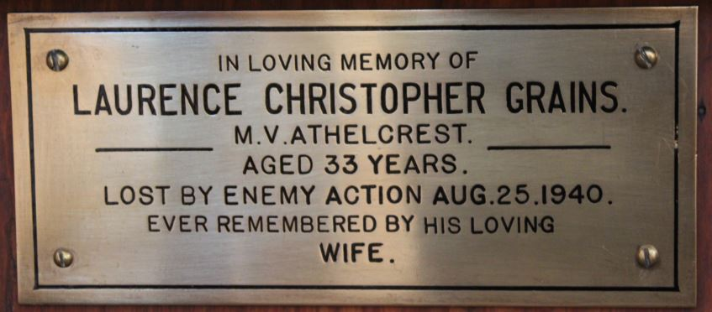
Grains, Laurence Christopher, M.V. Athelcrest, lost by enemy action 1940 aged 33

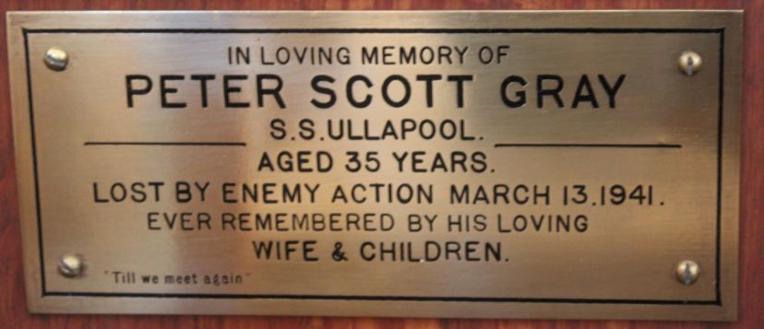
Gray, Peter Scott, S.S. Ullapool, lost by enemy action 1941 aged 35

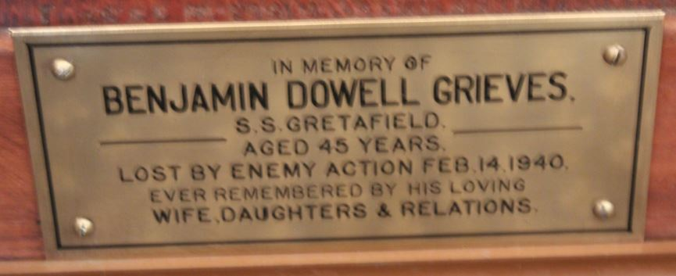
Grieves, Benjamin Dowell, S.S. Gretafield, lost by an enemy action 1940 age 45

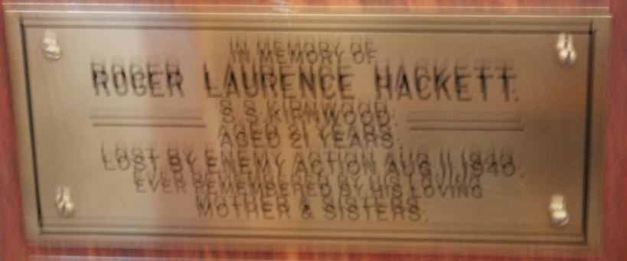
Hackett, Roger Laurence, S.S. Kirnwood, lost by enemy action 1940 aged 21

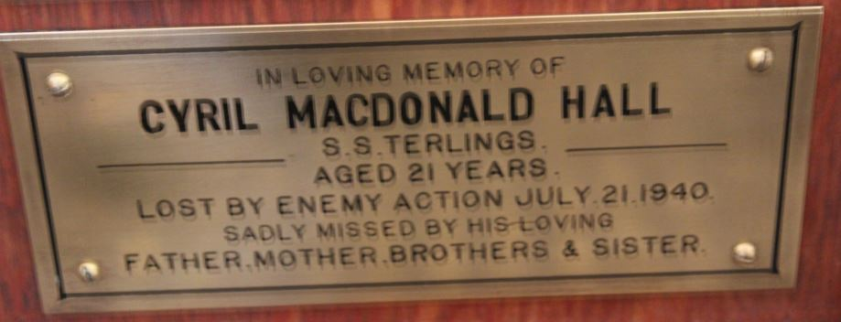
Hall, Cyril Macdonald, S.S. Terlings, lost by enemy action 1940 aged 21

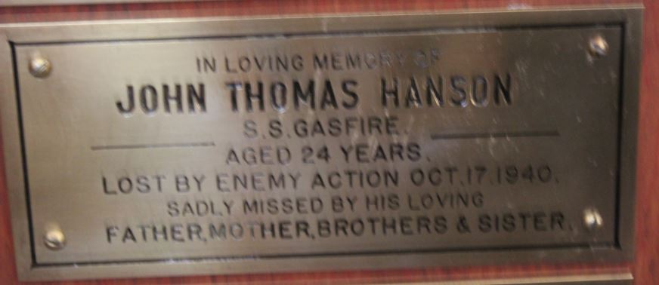
Hanson, John Thomas, S.S. Gasfire, lost by enemy action 1940 aged 24
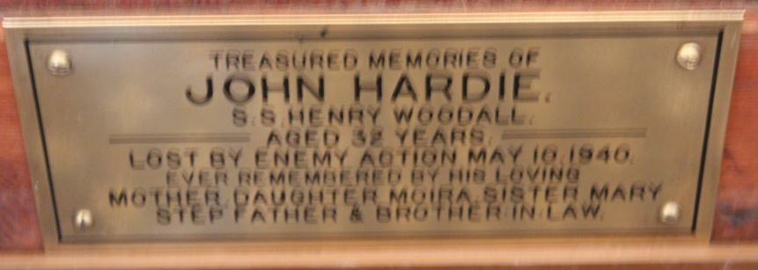
Hardie, John, S.S. Henry Woodall, lost by enemy action 1940 aged 32

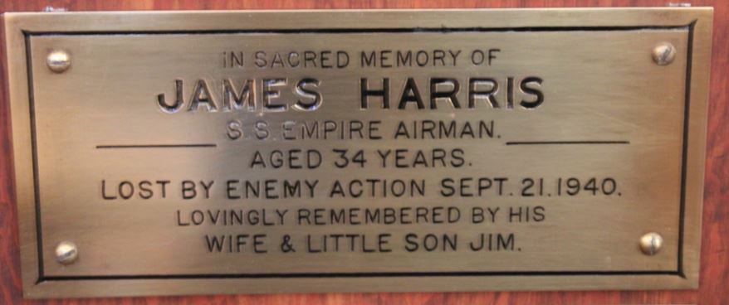
Harris, James, S.S. Empire Airman, lost by enemy action 1940 aged 34

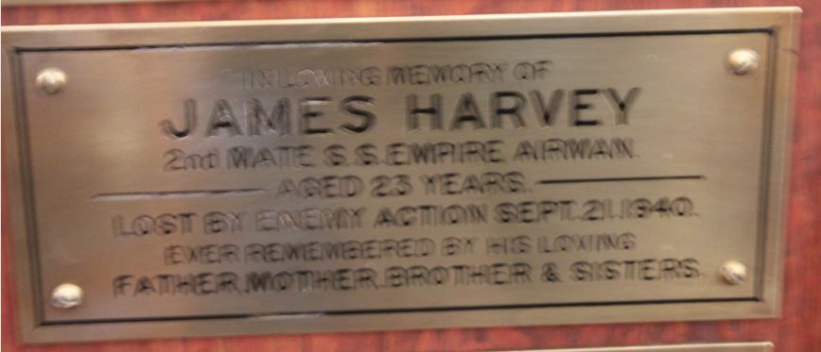
Harvey, James, 2nd Mate, S.S. Empire Airman, lost by enemy action 1940 aged 23
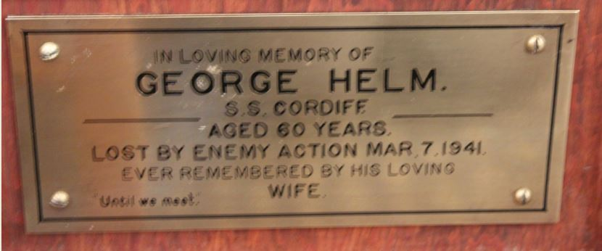
Helm, George, S.S. Cardiff, lost by enemy action 1941 aged 60

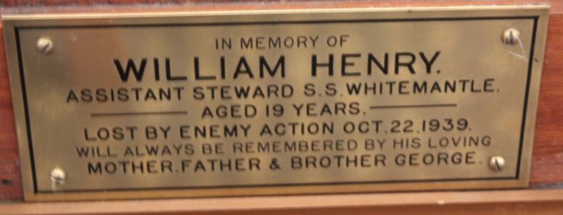
Henry, Assistant Steward William, S.S. Whitemantle, lost by enemy action 1939 aged 19

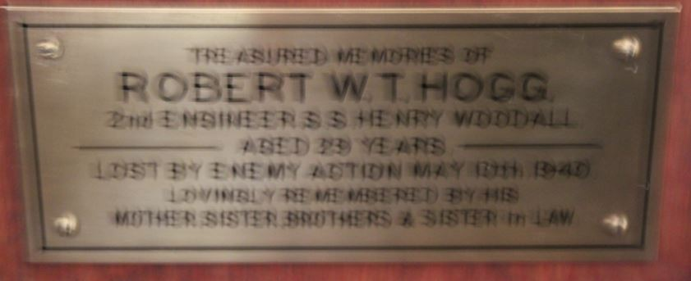
Hogg, 2nd Engineer Robert W. T., S.S. Henry Woodall, lost by enemy action 1940 aged 29
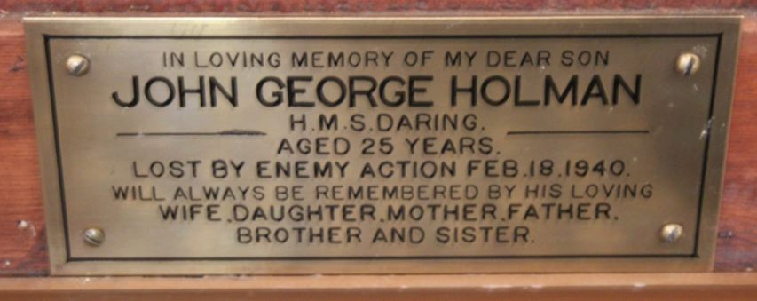
Holman, John George, H.M.S. Daring, lost by enemy action 1940 aged 25

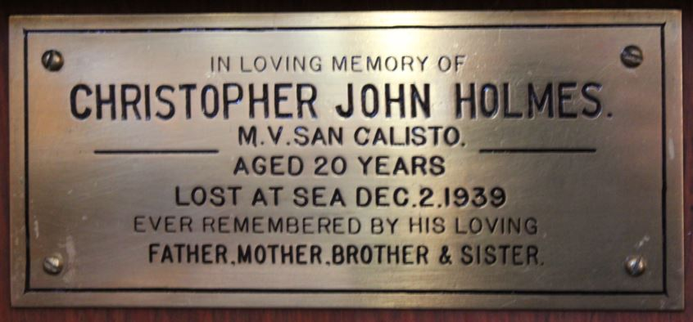
Holmes, Christopher John, M. V. San Calisto, lost at sea 1939 aged 20

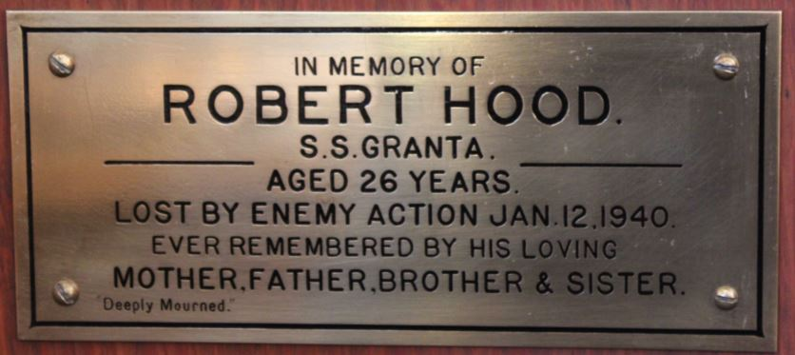
Hood, Robert, S.S. Granta, lost by enemy action 1940 aged 26

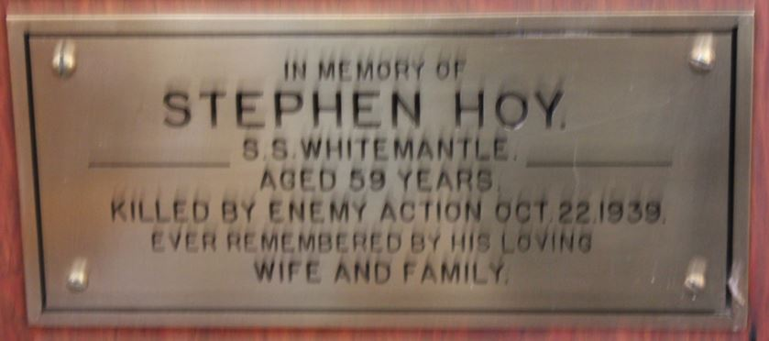
Hoy, Stephen, S.S. Whitemantle, lost by enemy action 1939 aged 59

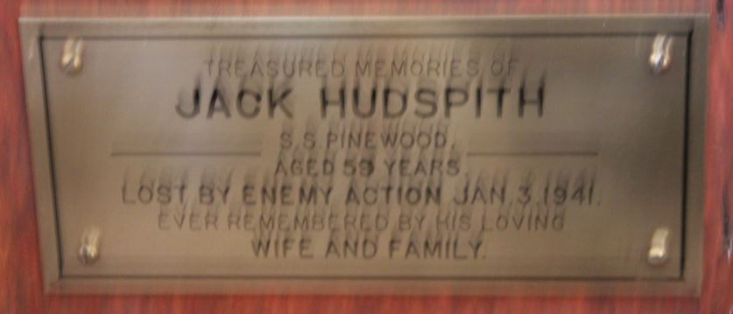
Hudspith, Jack, S.S. Pinewood, lost by enemy action 1941 aged 59

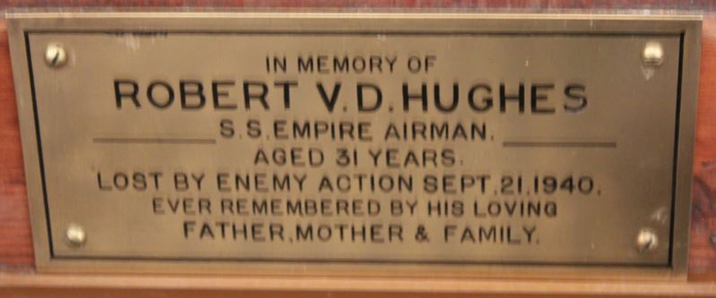
Hughes, Robert V.D., S.S. Empire Airman, lost by enemy action 1940 aged 31

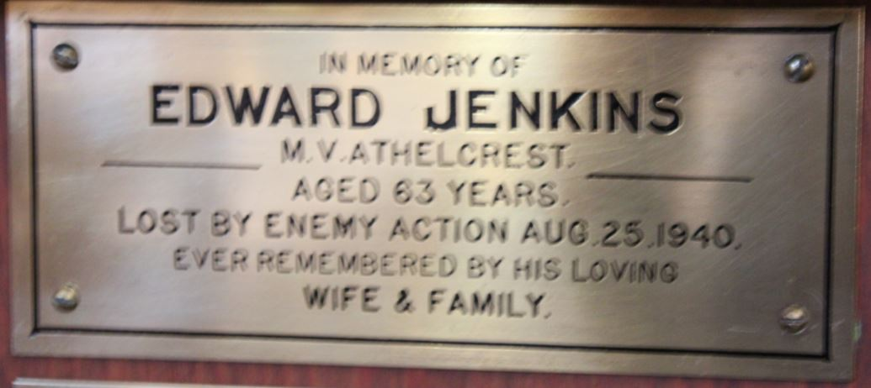
Jenkins, Edward, M.V. Athelcrest, lost by enemy action 1940 aged 63

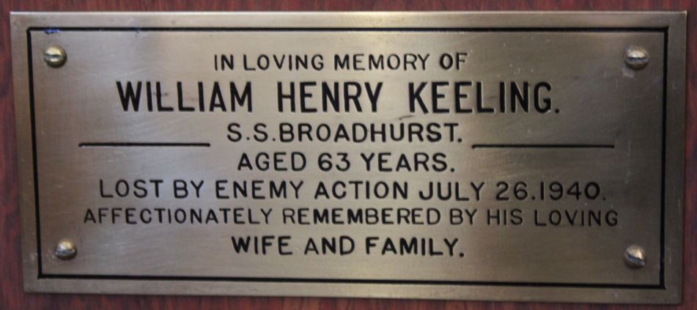

Keeling, William Henry, S.S. Broadhurst, lost by enemy action 1940 aged 63
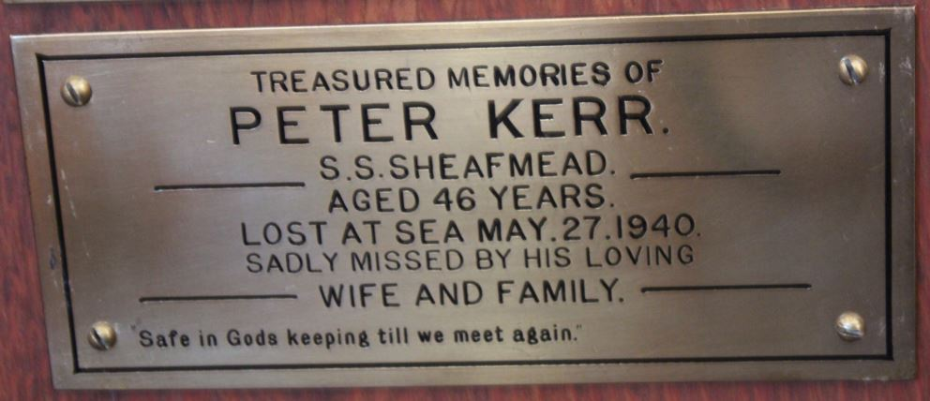
Kerr, Peter, S.S. Sheafmead, lost at sea 1940 aged 46

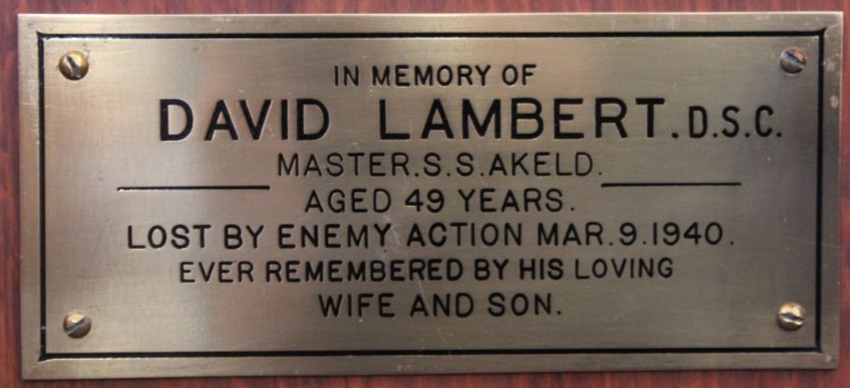Lambert, Master David, D.S.C, S.S. Akeld, lost by enemy action 1940 aged 49

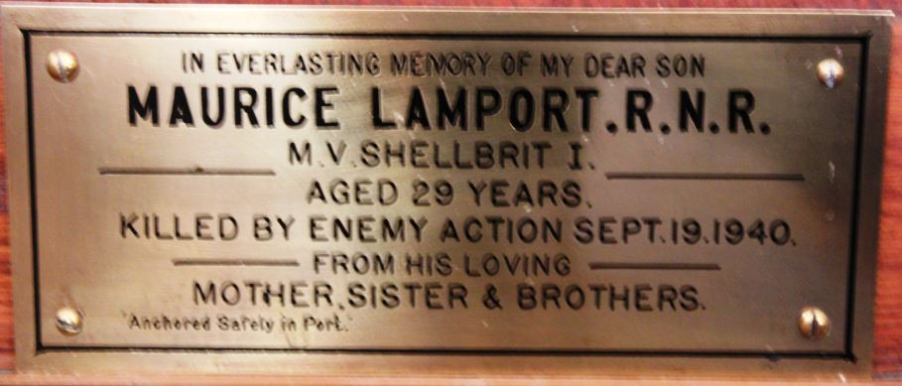
Lamport, Maurice, R.N.R., M.V. Shellbrit 1, killed by enemy action 1940 aged 29

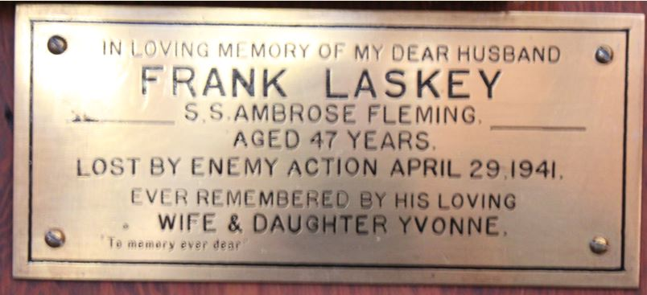

Laskey, Frank, S.S. Ambrose Fleming, lost by enemy action 1941 aged 47
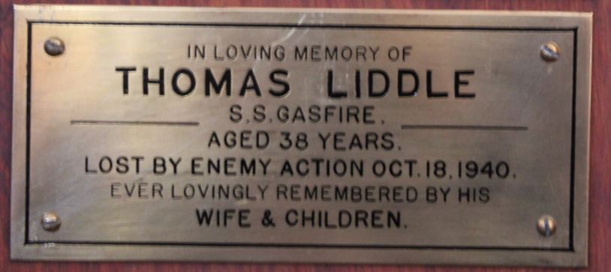
Liddle, Thomas, S.S. Gasfire, lost by enemy action 1940 aged 38

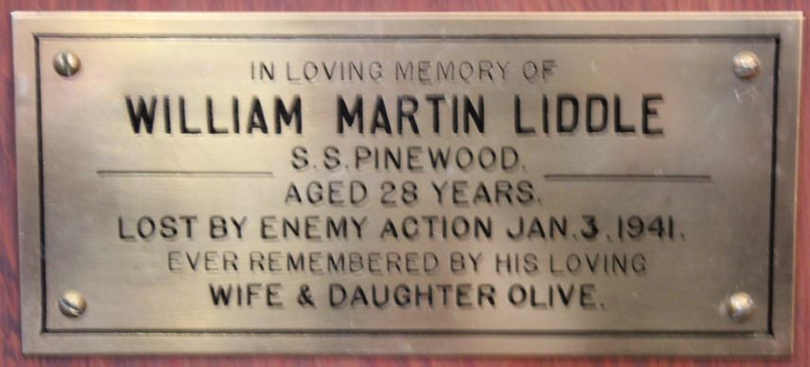
Liddle, William Marton, S.S. Pinewood, lost by enemy action 1941 aged 28

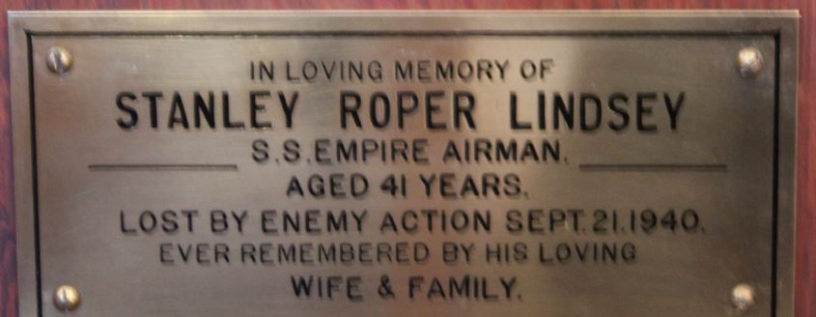
Lindsay, Stanley Roper, S.S. Empire Airman, lost by enemy action 1940 age 41

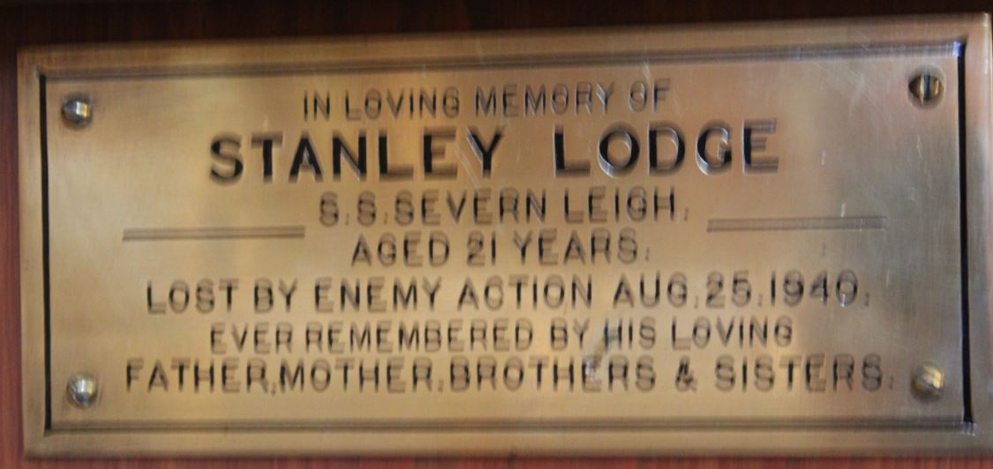
Lodge, Stanley, S.S. Severn Leigh, lost by enemy action 1940 aged 21
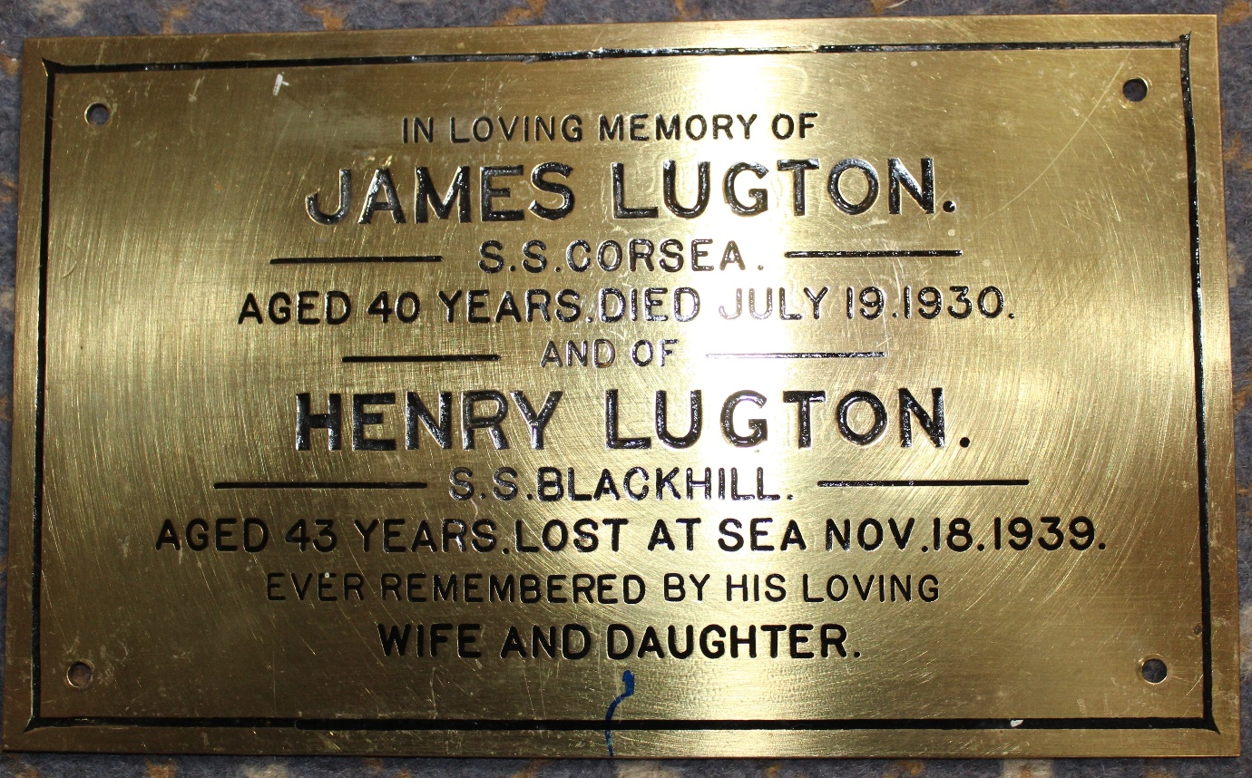
Lugton, James, S.S. Corsea 1930 aged 40 and Lugton, Henry, S.S. Blackhill lost at sea 1939 aged 43

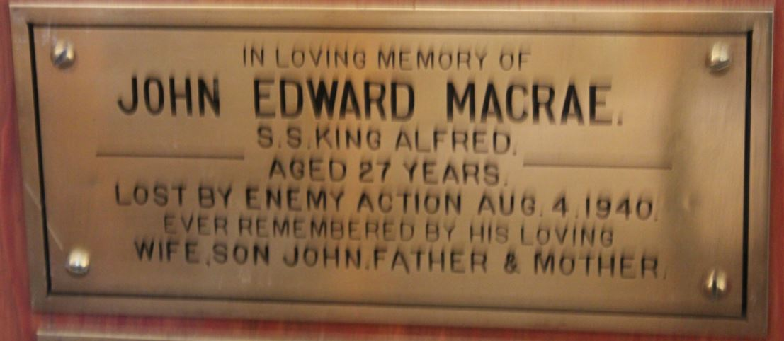
Macrae, John Edward, S.S. King Alfred, lost by enemy action 1940 aged 27

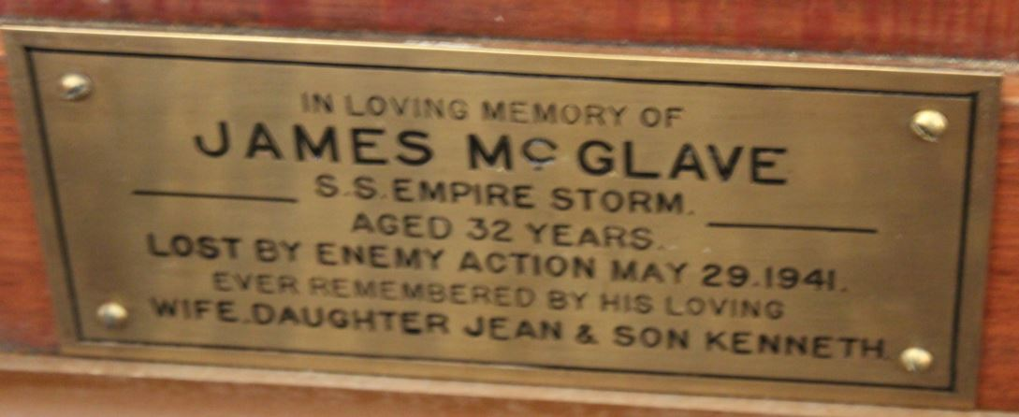
McGlave, James, S.S. Empire Storm, lost by enemy action 1941 aged 32
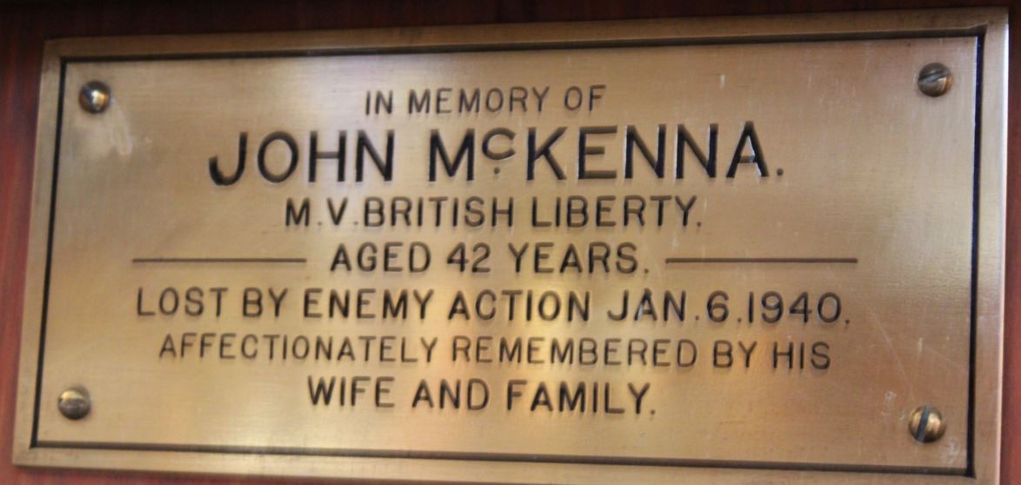
McKenna, John, M.V. British Liberty, lost by enemy action 1940 aged 42

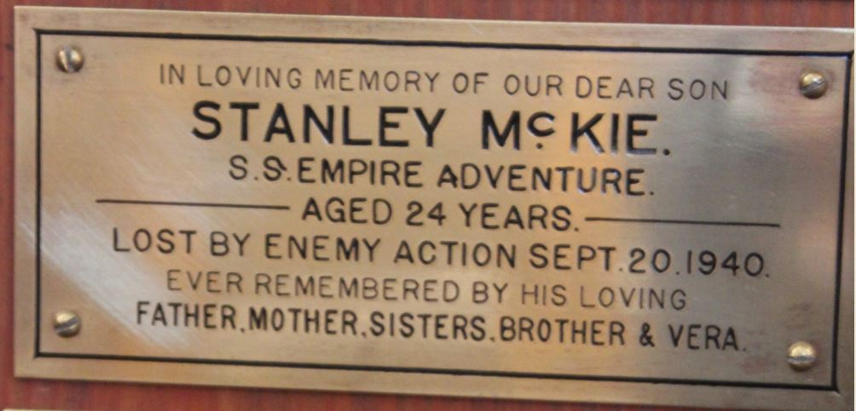
McKie, Stanley, S.S. Empire Adventure, lost by enemy action 1940 aged 24
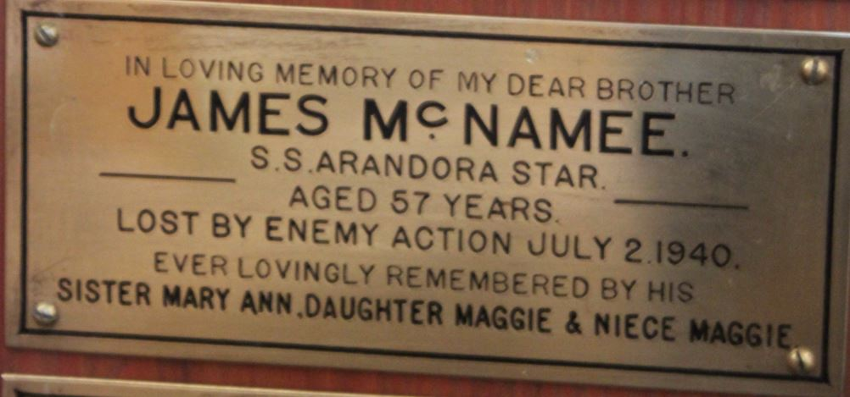
McNamee, James, S.S. Arandora Star, lost by enemy action 1940 aged 57

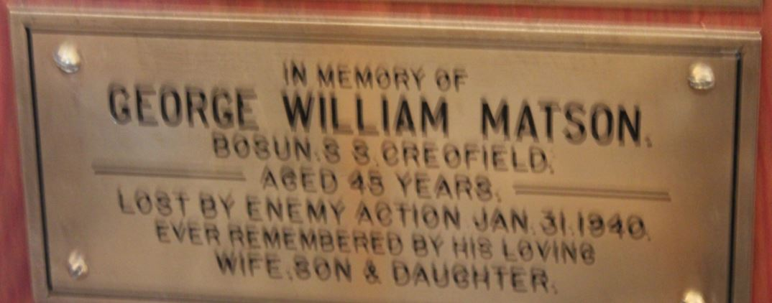
Matson, Bosun George William, S.S. Creofield, lost by enemy action 1940 aged 45

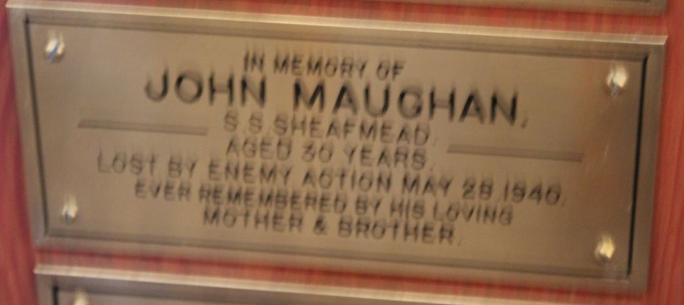
Maughan, John, S.S. Sheafmead, lost by enemy action 1940 aged 30
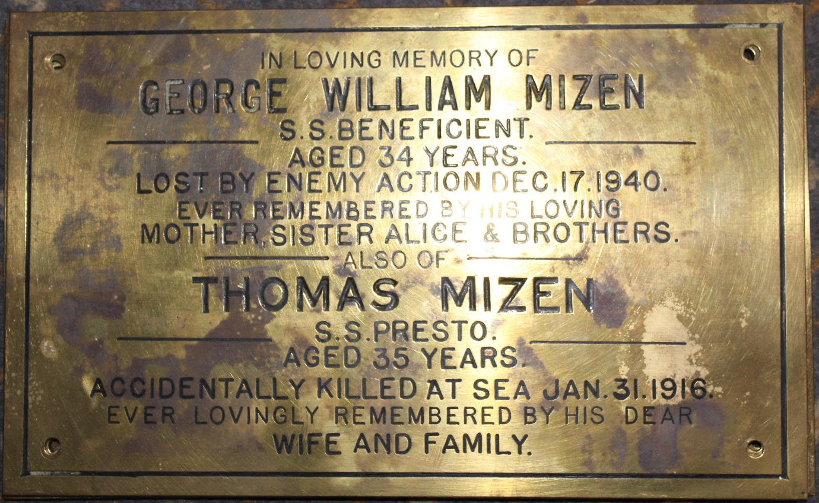
Mizen, George William, S.S. Beneficent, lost by enemy action 1940 aged 34
also Thomas Mizen, S.S. Presto, accidentally killed at sea 1916 aged 35

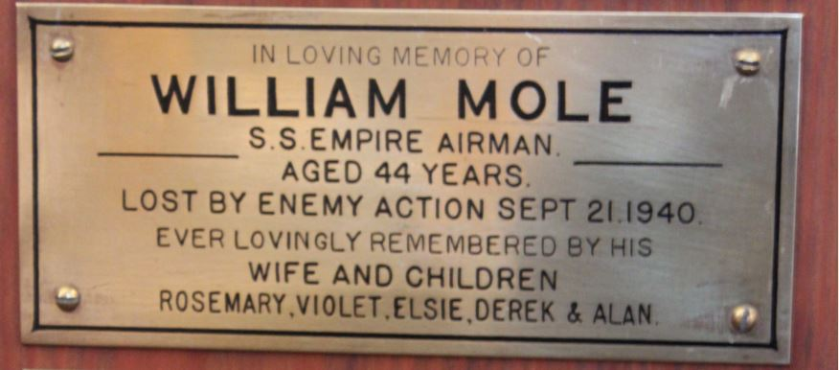
Moles, William, S.S. Empire Airman, lost by enemy action 1940 aged 44
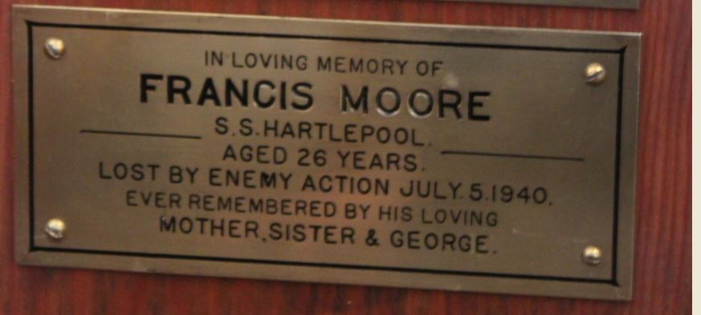
Moore, Francis, S.S. Hartlepool, lost by enemy action 1940 aged 26

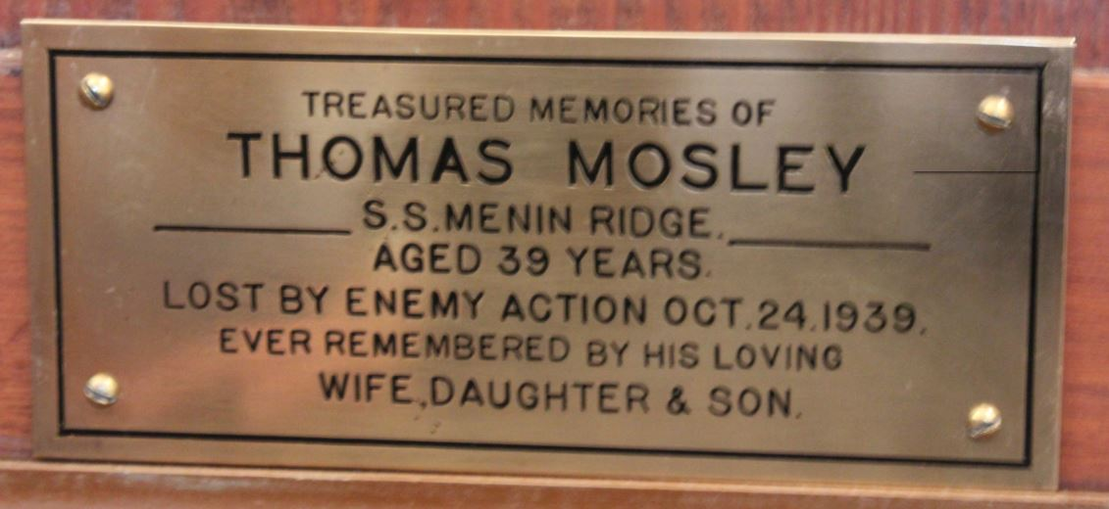
Moseley, Thomas, S.S. Menin Ridge, lost by enemy action 1939 aged 39

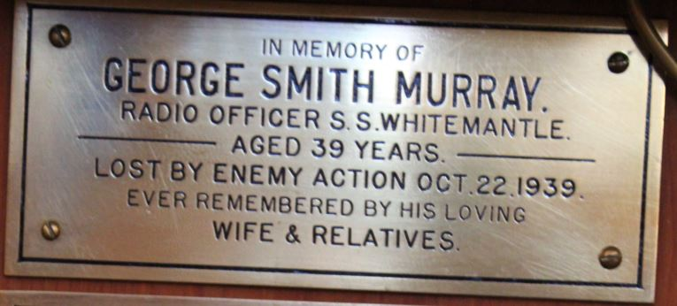
Murray, Radio Officer George Smith, S.S. Whitemantle, lost by enemy action 1939 aged 39

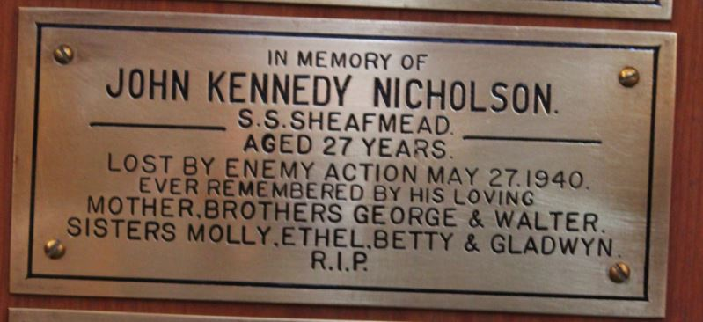
Nicholson, John Kennedy, S.S. Sheafmead, lost by enemy action 1940 aged 27

Norton, Robert, S.S. Caduceus, died at sea 1939 aged 38 – no plaque

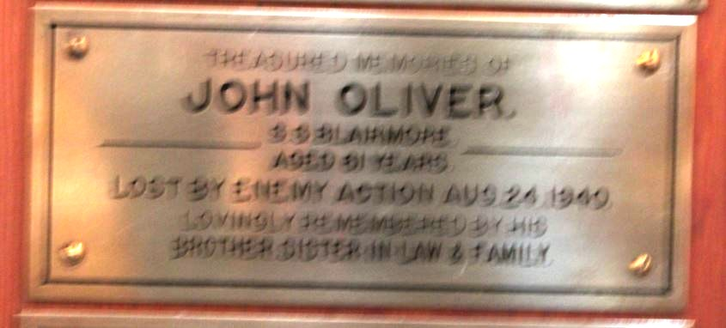
Oliver, John, S.S. Blairmore, lost by enemy action 1940 aged 61

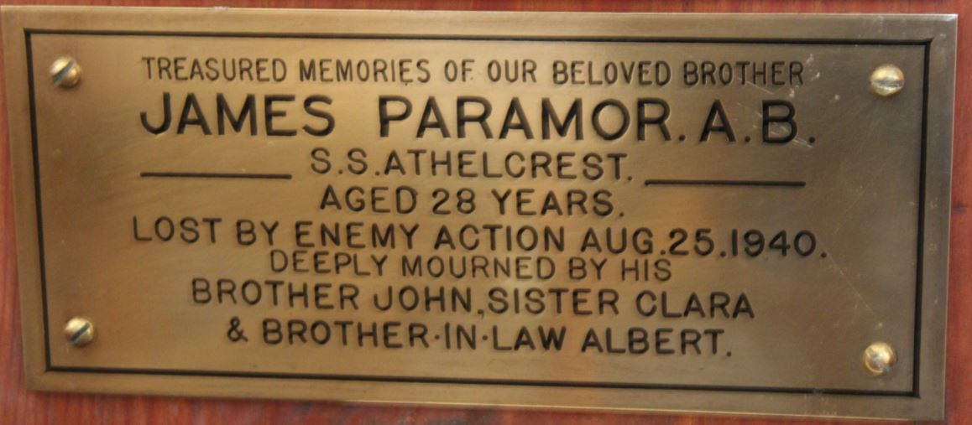
Paramor, A.B. James, M.V. Athelcrest, lost by enemy action 1940 age 28

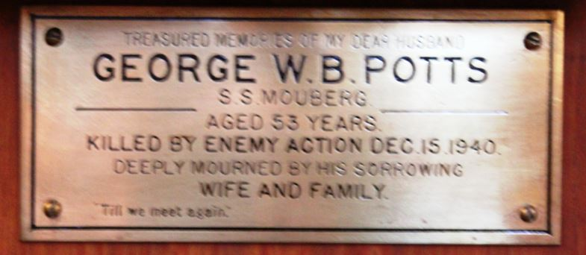
Potts, George W.B., S.S. Mouberg, killed by enemy action 1940 aged 53

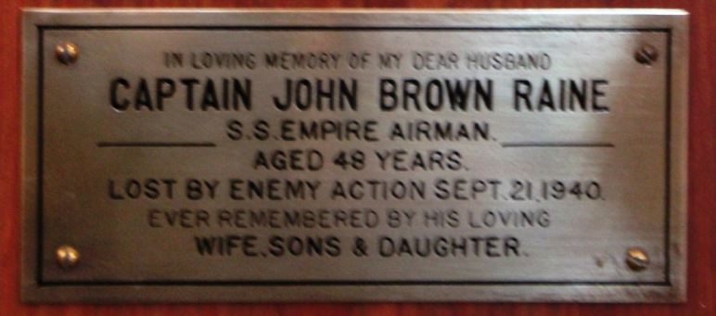
Raine, Captain John Brown, S.S. Empire Airman, lost by enemy action 1940 aged 48

Rattey, Joseph, S.S. Biddlestone, lost at sea 1939 aged 22 – no plaque
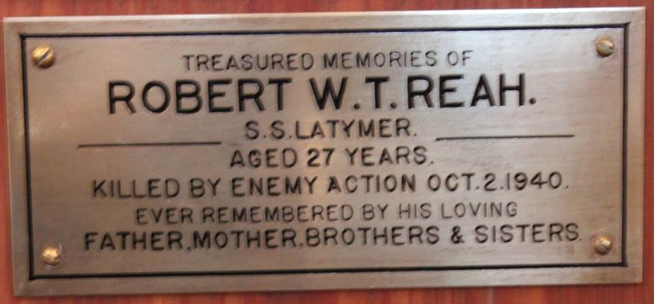
Reah, Robert W. T., S.S. Latymer, killed by enemy action 1940 aged 27

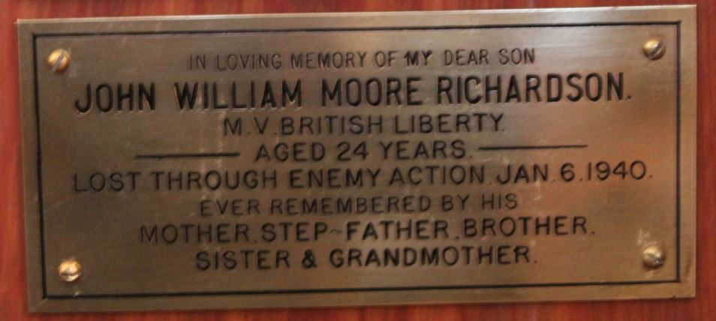
Richardson, John William Moore, M.V. British Liberty, lost by enemy action 1940 aged 24
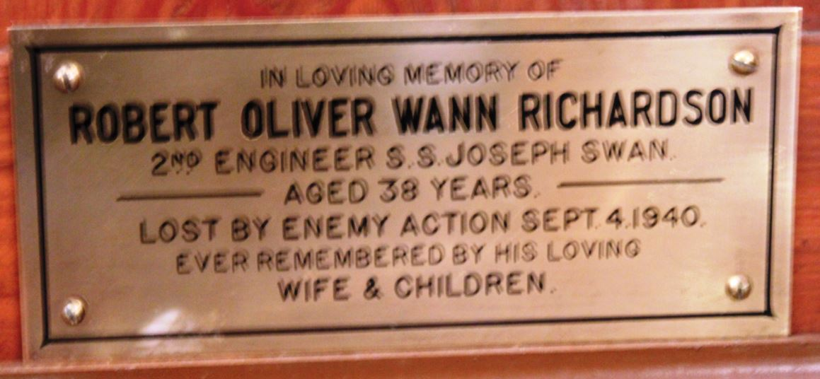
Richardson, 2nd Engineer Robert Oliver Wann, S.S. Joseph Swan, lost by enemy action 1940 aged 35

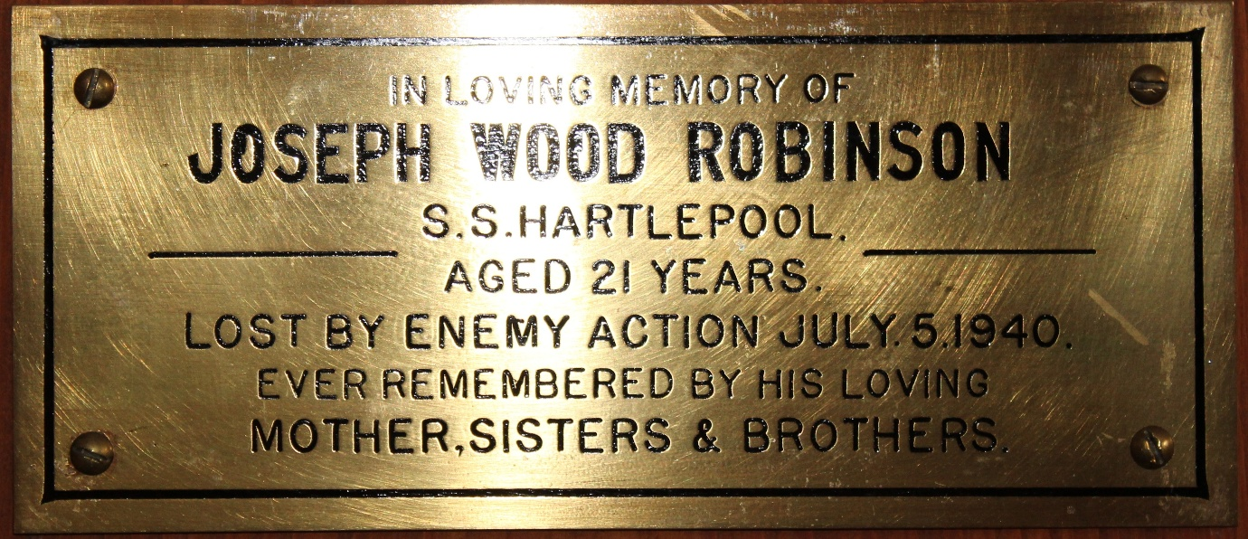
Robinson, Joseph Wood, S.S. Hartlepool, lost by enemy action 1940 aged 21
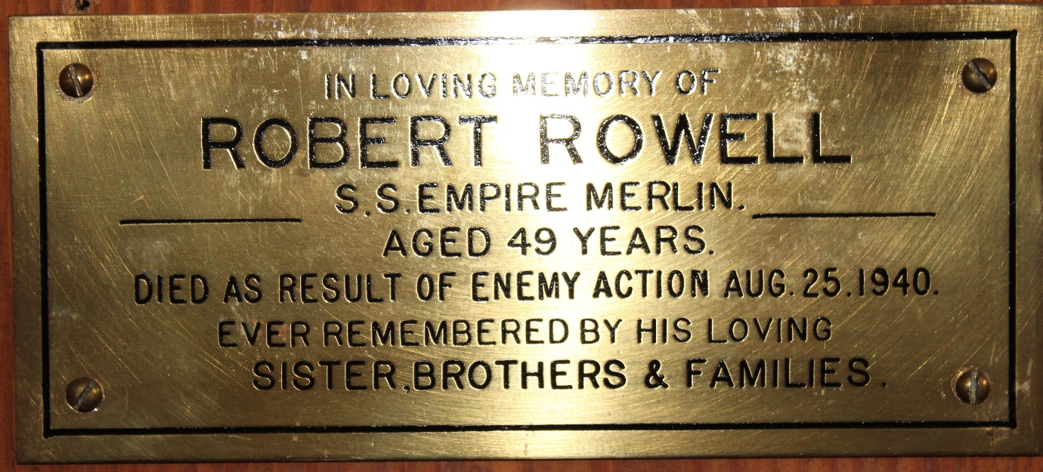
Rowell, Robert, S.S. Empire Merlin, died as a result of enemy action 1940 aged 49

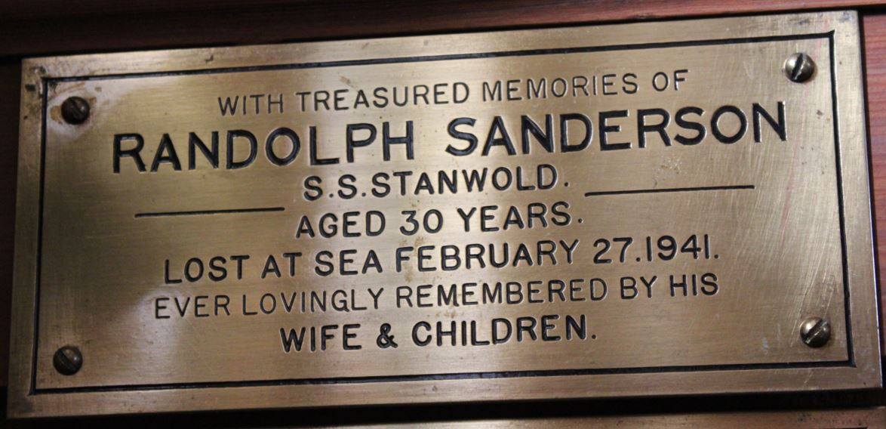
Sanderson, Randolph, S.S. Stanwold, lost at sea 1941 aged 30

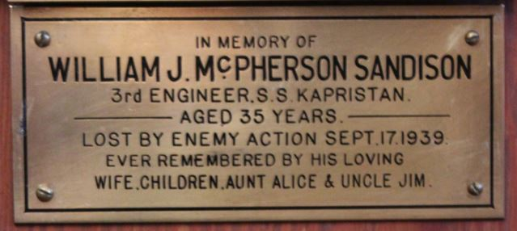

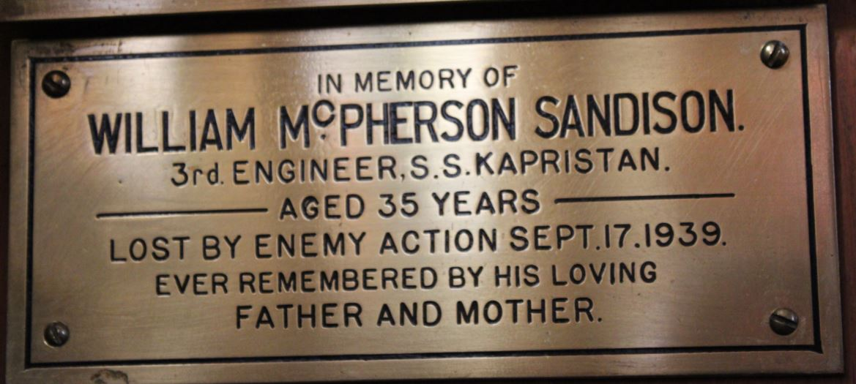

Sandison, 3rd Engineer William MacPherson. S.S. Kapristan. lost by enemy action 1939 aged 35 (2 plaques)
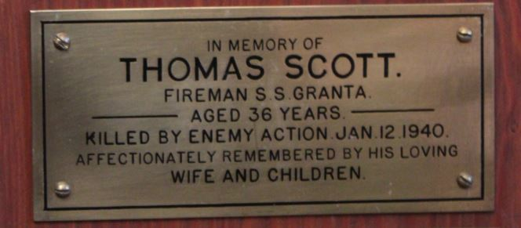
Scott, Fireman Thomas, S.S. Granta, killed by enemy action 1940 aged 36

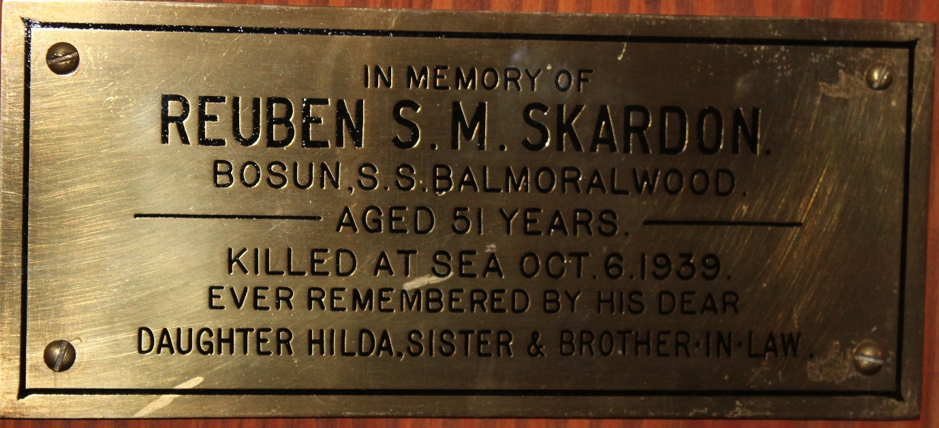
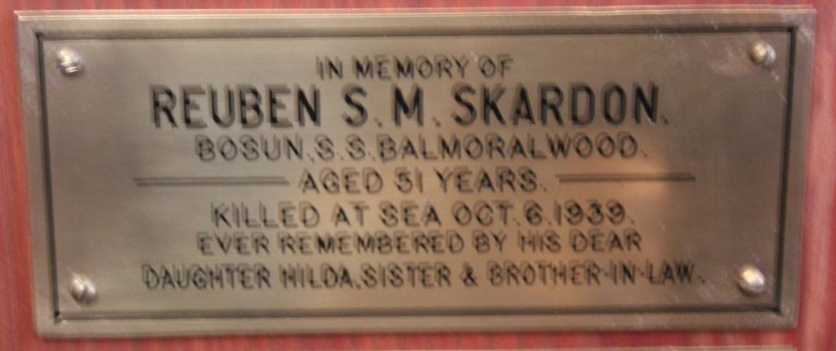
Skarden, Bosun Reuben S.M., S.S. Balmoralwood, killed at sea 1939 aged 51
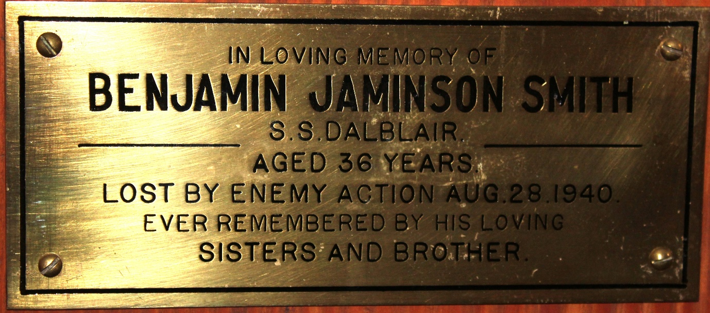
Smith, Benjamin Jaminson, S.S. Dalblair, lost by enemy action 1940 aged 36

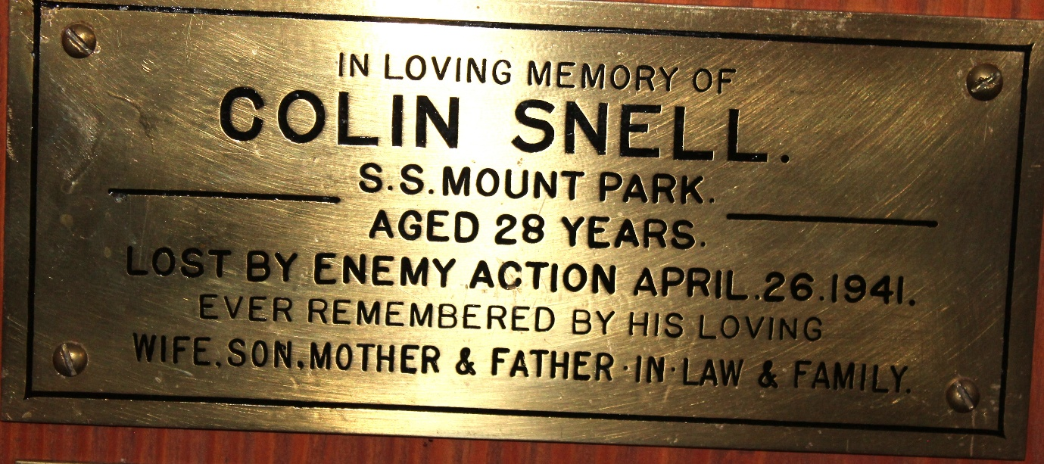
Snell, Colin, S.S. Mount Park, lost by enemy action 1941 aged 28

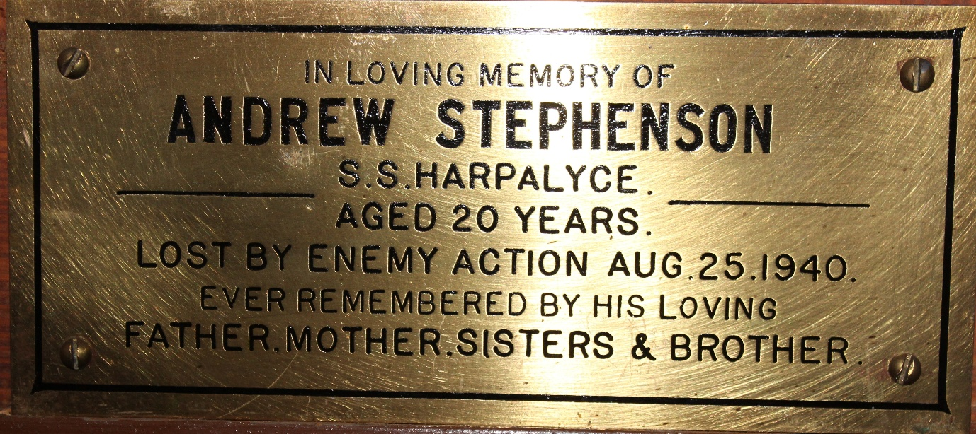
Stephenson, Andrew, S.S. Harpalyce, lost by enemy action 1940 aged 20

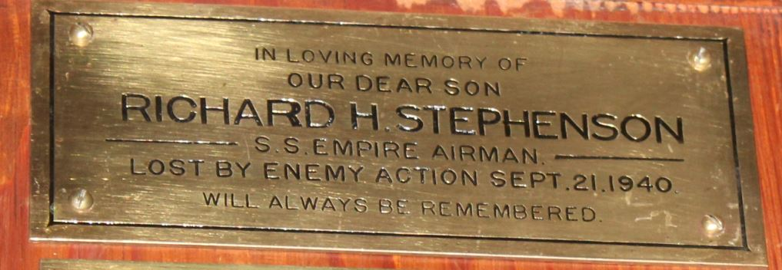
Stephenson, Richard H., S.S. Empire Airman, lost by enemy action 1940

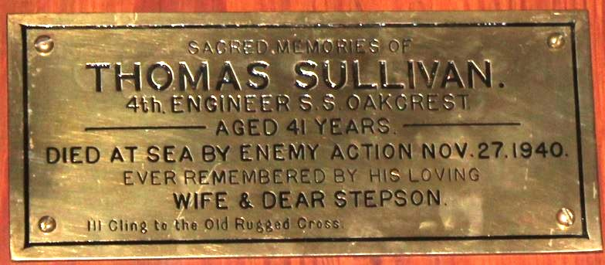
Sullivan, 4th Engineer Thomas, S.S. Oakcrest, died at sea by enemy action 1940 aged 41
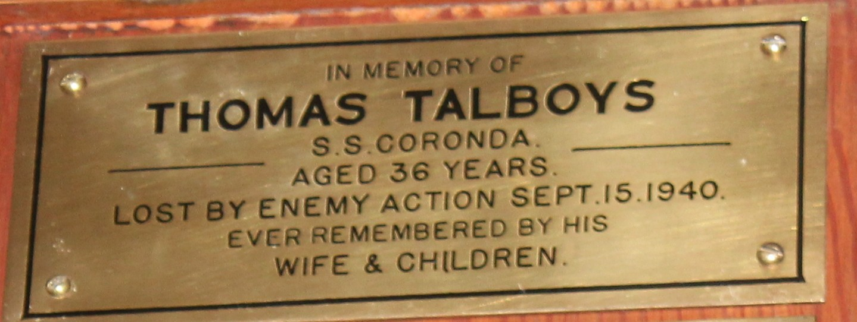
Talboys, Thomas, S.S. Coronda, lost by enemy action 1940 aged 36

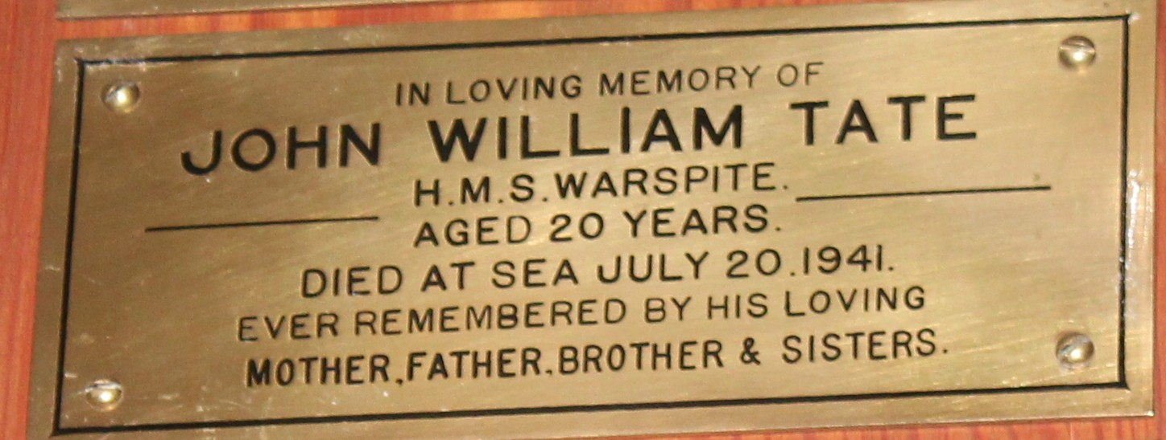
Tate, John William, H.M.S. Warspite died at sea 1941 aged 20

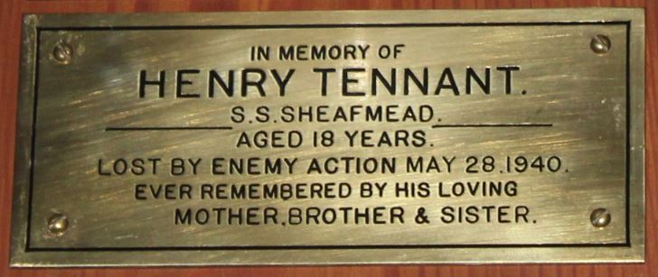
Tennant, Henry, S.S. Sheafmead, lost by enemy action 1940 aged 18
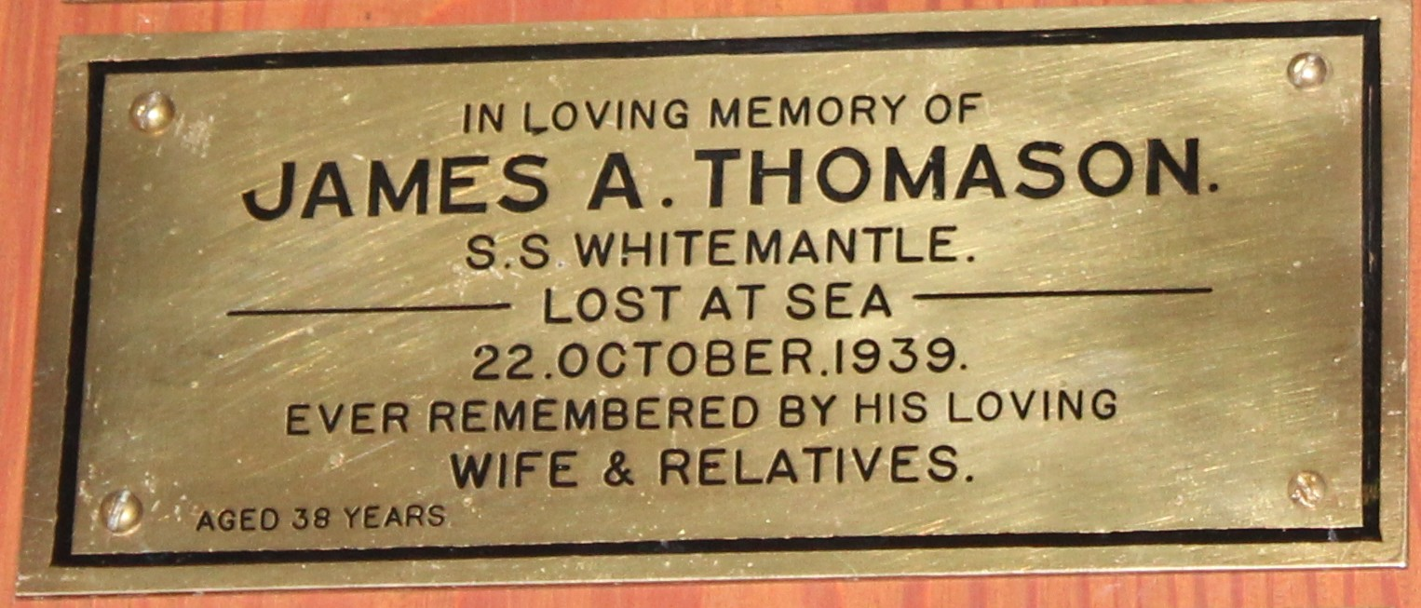
Thomason, James A., S.S. Whitemantle, lost at sea 1939

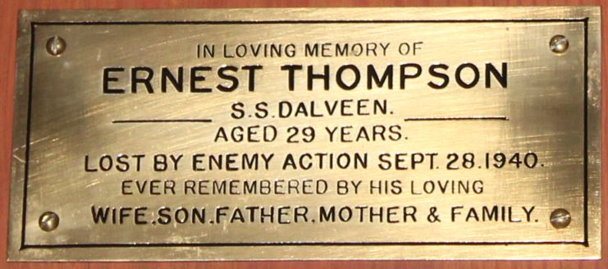
Thompson, Ernest, S.S. Dalveen, lost by enemy action 1940 aged 29

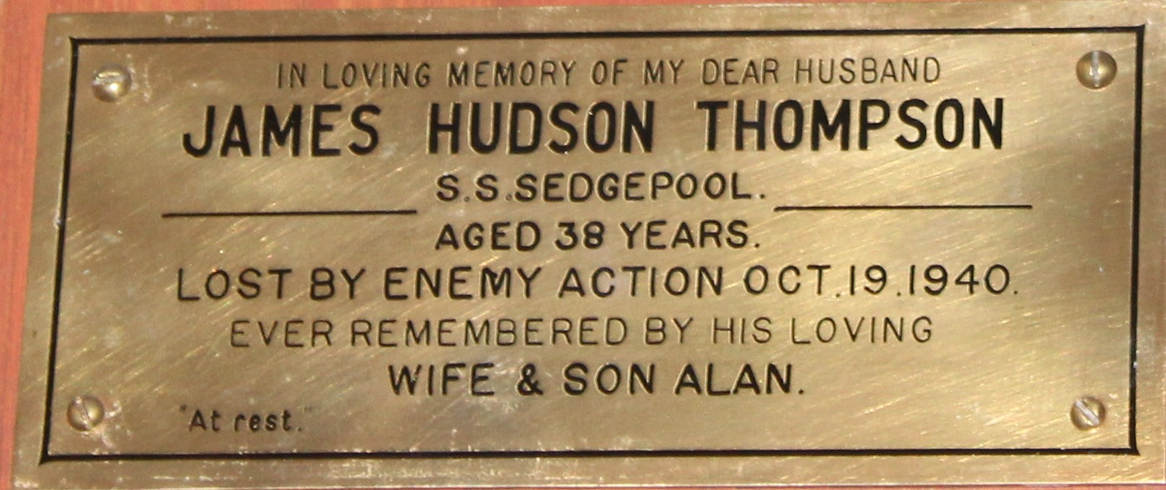
Thompson, James Hudson, S.S. Sedgepool, lost by enemy action 1940 aged 38

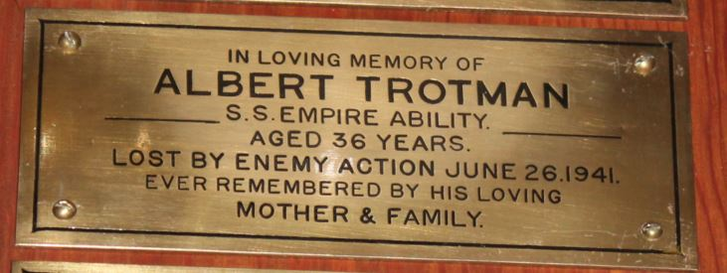
Trotman, Albert, S.S. Empire Ability, lost by enemy action 1941 aged 36

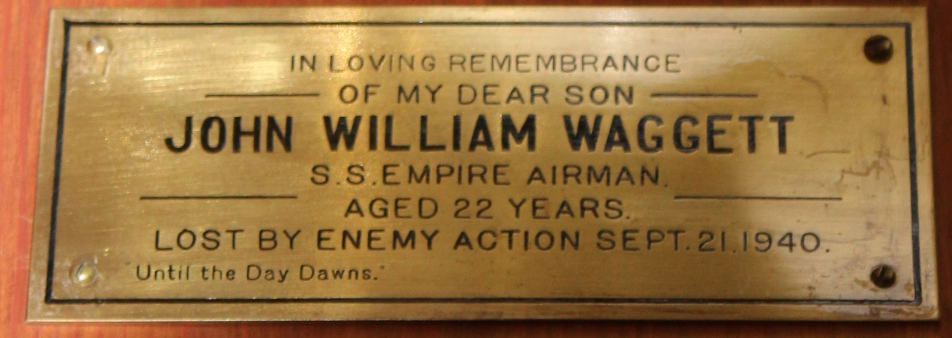
Waggett, John William, S.S. Empire Airman, lost by enemy action 1940 aged 22
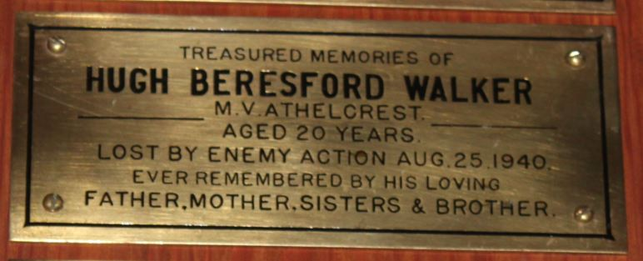
Walker, Hugh Beresford, M.V. Athelcrest, lost by enemy action 1940 aged 20

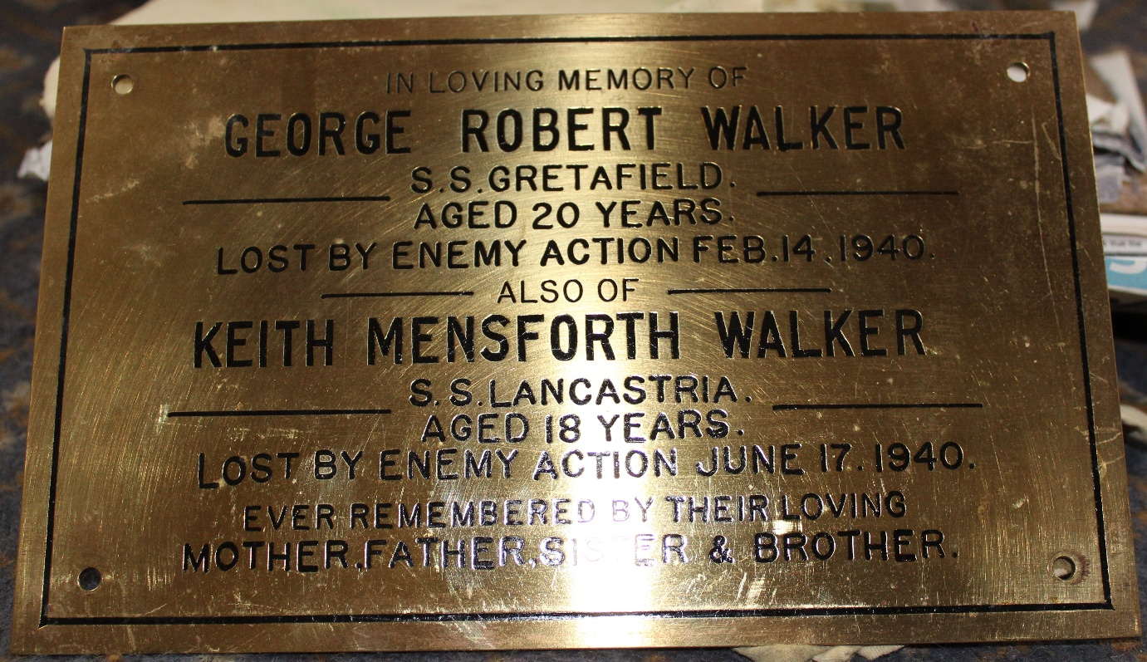
Walker, George Robert, S.S. Gretafield, lost by enemy action 1940 aged 20
also Keith Mensforth Walker, S.S. Lancastria, lost by enemy action 1940 aged 18
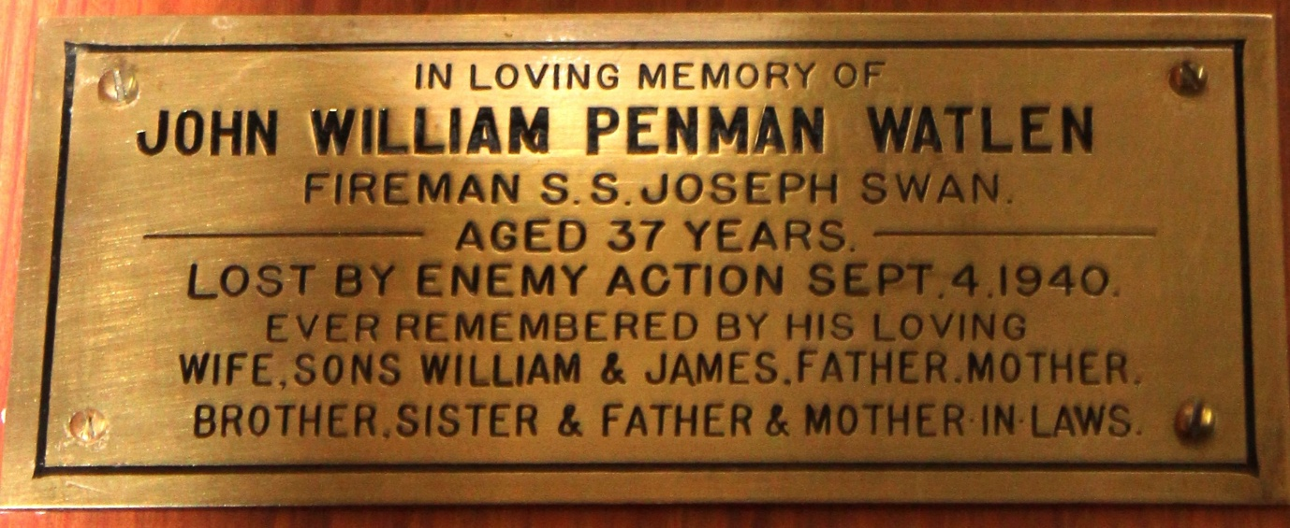
Watlen, Fireman John William Penman, S.S. Joseph Swan, lost by enemy action 1940 aged 37

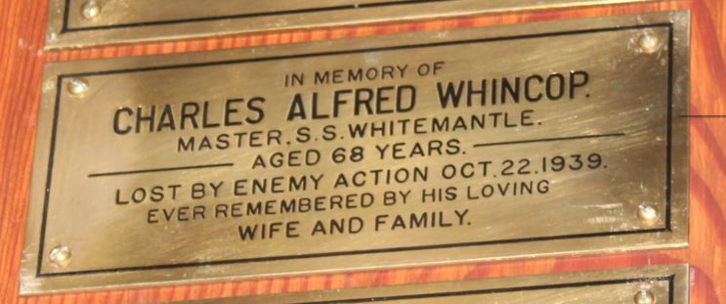
Whincop, Master Charles Alfred, S.S. Whitemantle, lost by enemy action 1939 aged 68

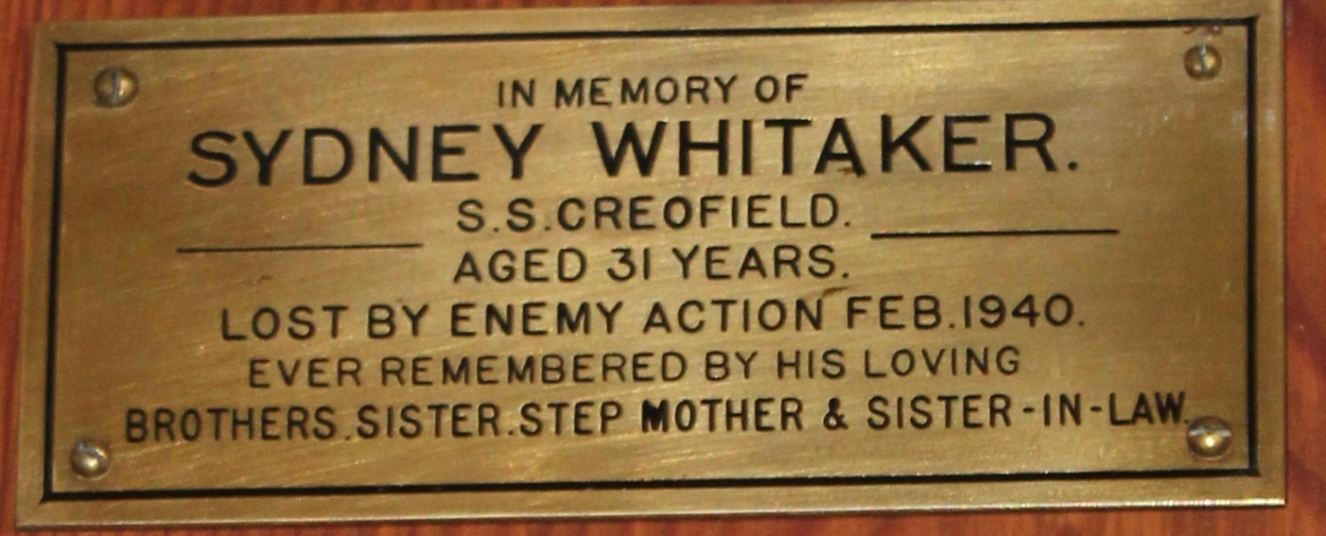
Whitaker, Sydney, S.S. Creofield, lost by enemy action 1940 aged 31

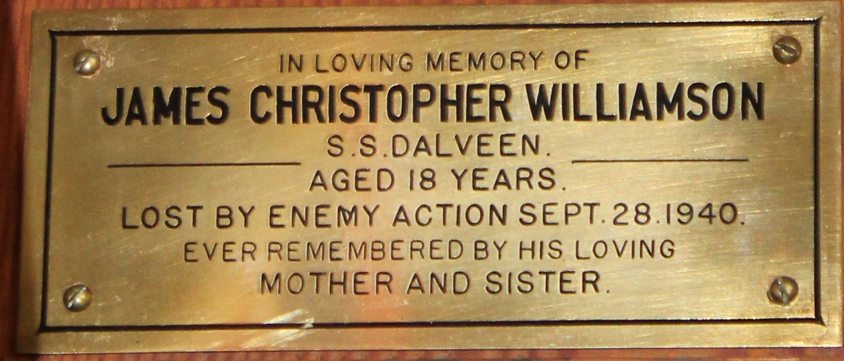
Williamson, James Christopher, S.S. Harpalyce, lost by enemy action 1940 aged 21

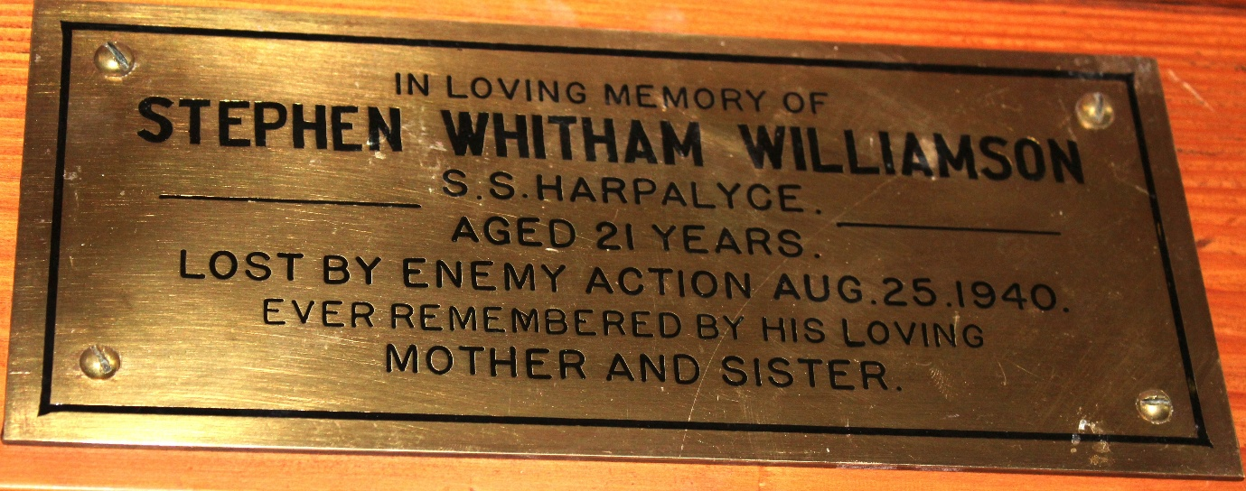
Williamson, Stephen Whitham, S.S. Dalveen, lost by enemy action 1940 aged 18

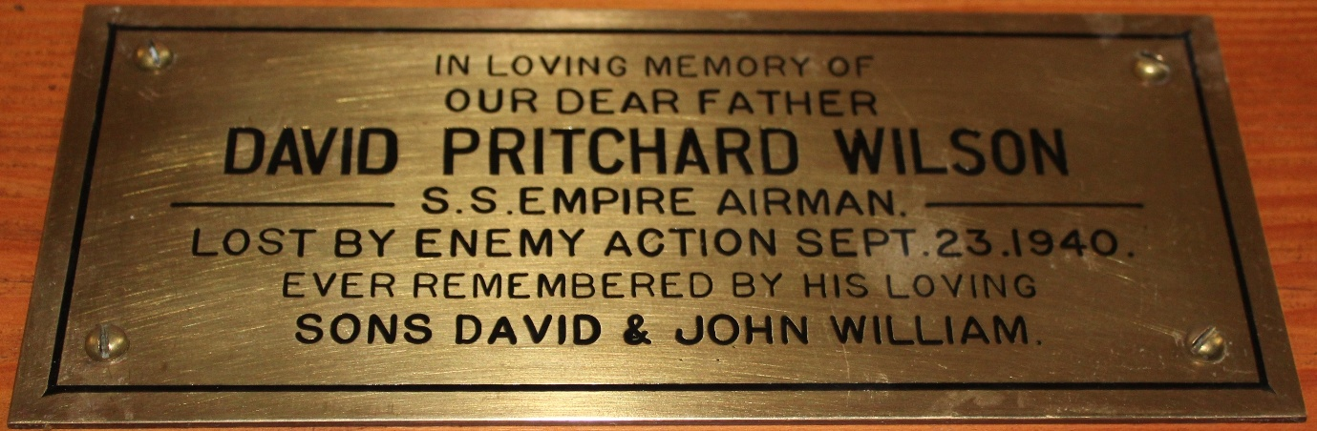
Wilson, David Pritchard, S.S. Empire Airman, lost by enemy action 1940

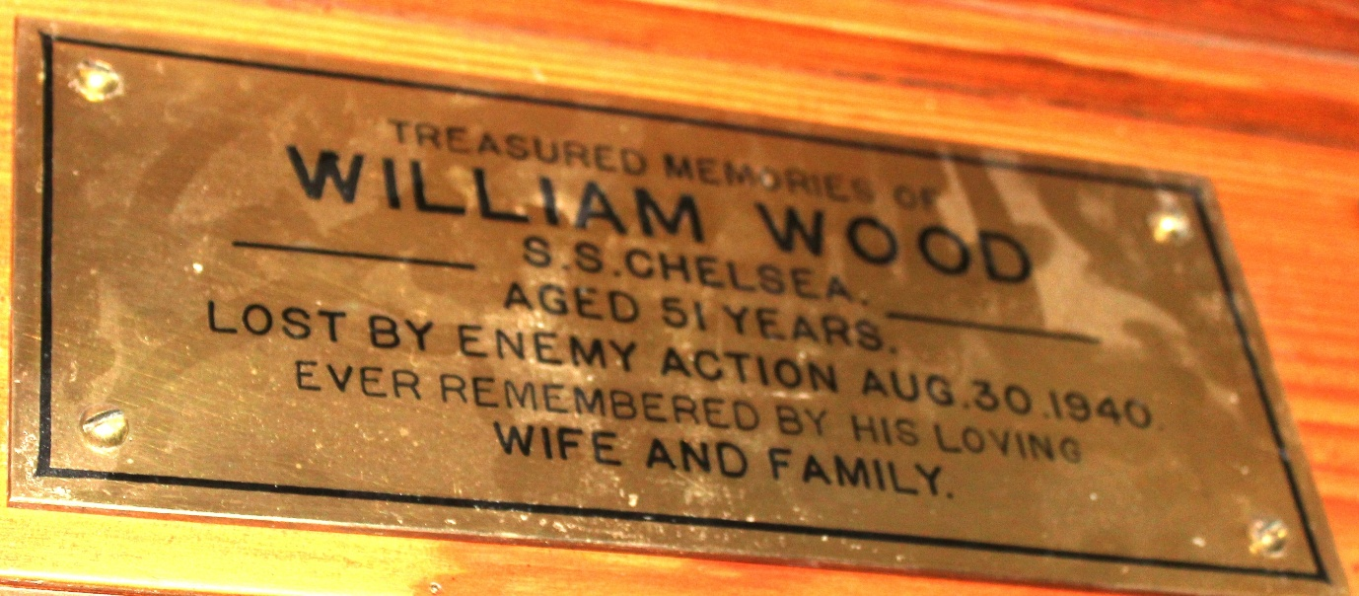
Wood, William, S.S. Chelsea, lost by enemy action 1940 aged 51
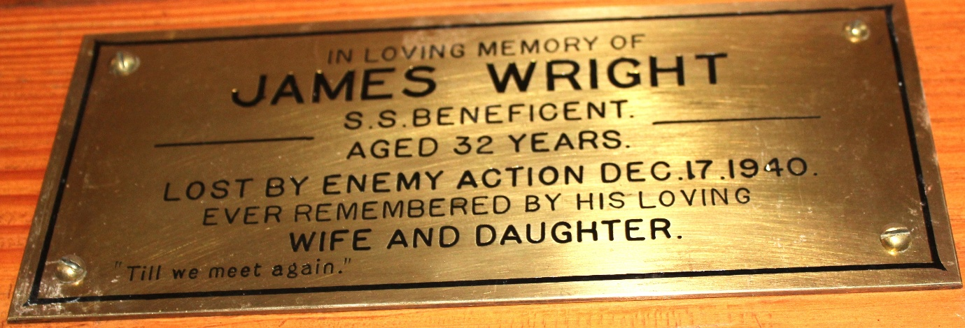
Wright, James, S.S. Beneficent, lost by enemy action 1940 aged 32

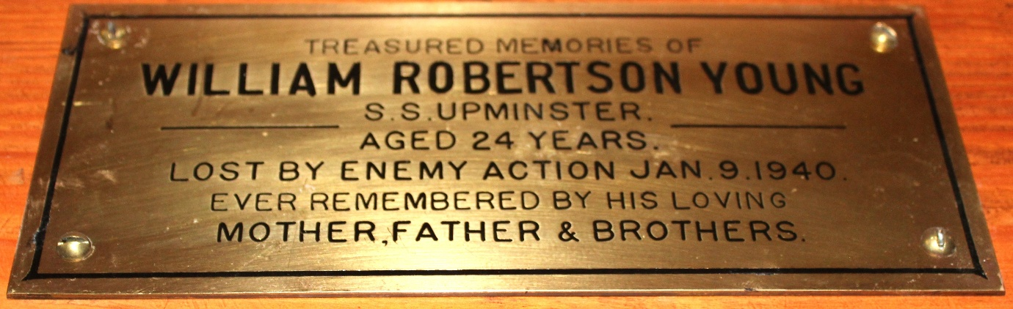
Young, William Robertson, S.S. Upminster, lost by enemy action 1940 aged 24

