

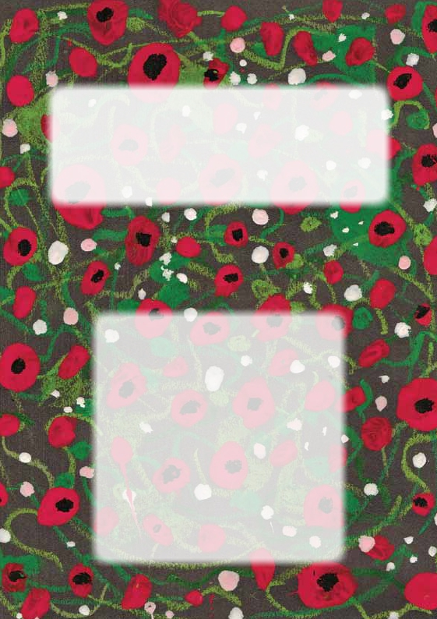
Ellingham
War Memorials

They shall grow not old,
as we that are left grow old:
Age shall not weary them,
nor the years condemn.
At the going down of the sun
and in the morning,
We will remember them.

Dedication
This booklet is dedicated to the men from Ellingham Parish
who died in two World Wars and are remembered by their
fellow parishioners on the War Memorials in Ellingham
Church.
Thanks to Ellingham Community Trust who provided the funding
to allow this booklet to be produced.

Acknowledgements: Much of the information in this booklet
has been obtained from the War Graves Commission, the
Northumberland Gazette, the Berwick Advertiser and the 1901
and 1911 Census reports from Ancestry. Thanks to the staff at
Woodhorn Archives, Alnwick Library and Berwick Archives for
their help.
Thanks also to Olive Johnson, John Mark and Gilly Baker-Cresswell
for sharing photos and memories about family members on the
memorials. To Tom Braidford for his local knowledge. To Jane
Bowen, Janet Ward, Mabon Kinghorn, Jan Gerrard, and Cathy
Dingle for help with research. To Leo Graham, Isla Morton and
Maddie Underwood for the artwork and the children of Years 3
and 4 at Ellingham School for their research into cemeteries.
And to Reverend Brian Hurst for his sermon which started this
whole thing off.
Whilst every effort has been made to ensure the accuracy of this
booklet, if you spot any errors or have more information please
contact me so that amendments can be made if it is reprinted.

Eileen Duncan
Foreword
by
The Reverend Canon Brian Hurst

Every year the names inscribed upon the parish’s war memorials
are read out at our Remembrance Sunday Service. At last year’s
service I hinted in the sermon that it would be good if we could
remember not just the names but something of the stories behind
those commemorated on our memorials.
I suppose my thought was that as we approached the anniversary
of the outbreak of the First World War we should try to remember
those who paid the ultimate sacrifice as individuals – each one
precious in the sight of God and loved by their family, rather than
as an anonymous name.
As we read this booklet the characters behind the names begin to
shine as we hear of familiar family names, well known place names
– both local settlements and townships as well as foreign fields –
along with recognisable and strange sounding occupations.
We realise that each one of these characters left behind them
mothers and fathers, brothers and sisters, wives, girlfriends and
partners who, this side of the grave, never recovered from their
loss. We hear also of a community mourning the loss of its young
(mostly) men.
The parish is immensely grateful that Eileen Duncan rose to the
challenge and has spent time researching the lives and stories
behind the names. In gathering these fragments together into one
place she has created for us and future generations a fitting tribute
and memorial of those who for our tomorrow gave their today.
WWI Memorials
Unlike Commonwealth war graves and monuments which are
tended by the War Graves Commission, war memorials were
erected by local people in memory of their friends and neighbours
who died. Again, unlike the war graves and monuments a
person could be commemorated on more than one memorial.
For example many schools and universities (including the Duke’s
School at Alnwick) have their own war memorials and someone
who was working in one area when he joined the army could be
commemorated on a local memorial and also on one where his
family still lived.
I have found it fascinating tracing the men from Ellingham through
census records, newspaper cuttings and through family memories.
It has also brought home to me the immense suffering, not just
of the men in terrible conditions in the trenches but also of those
left behind waiting for news and both looking forward to, but also
dreading the postman’s call.
Many families had several sons serving in the forces and also
daughters serving as nurses.
The Millar family who lived at Wood Cottage had all four of their
sons serving whilst the Watsons, Ords, Weddells, and Browns all
had three and the Davis’s had three sons in the army and three
daughters who were serving as nurses.
I have tried not only to find out something about these men but
also about the lives they would have led before they joined the
army and how different life was then from now. With no electric,
let alone computers, television, even radio in most homes news
travelled by word of mouth or letter.
Transport was very different and with very few cars many people
still used horses and carts or travelled by bus or train.

Eileen Duncan
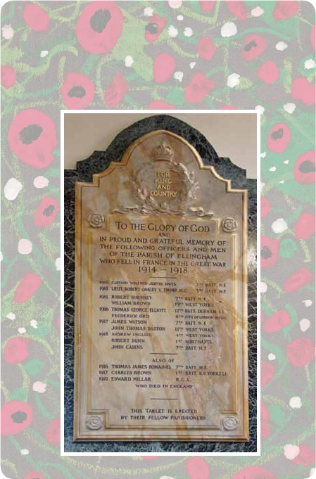
World War I
Memorials
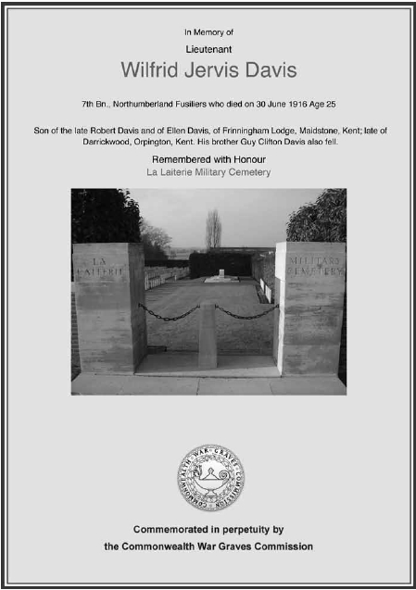

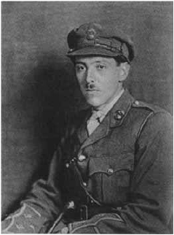
Captain Wilfred Jervis Davis

Wilfred Jervis Davis was born in Epsom, Surrey in 1891, the son of
Dr Robert Davis and his wife Ellen. He had two brothers, Robert
and Guy and three sisters Phyllis, Gwen and Ruth. All three brothers
served in the army whilst the three girls were nurses. In 1911
Wilfred was living at Preston and was a medical student. He joined
the Northumberland Fusiliers and served in France and Flanders as
a lieutenant. He was acting Captain when he was killed on 30th
June 1916 in Belgium and is commemorated at the La Laiterie
Military Cemetery.
His brother Guy was also killed.
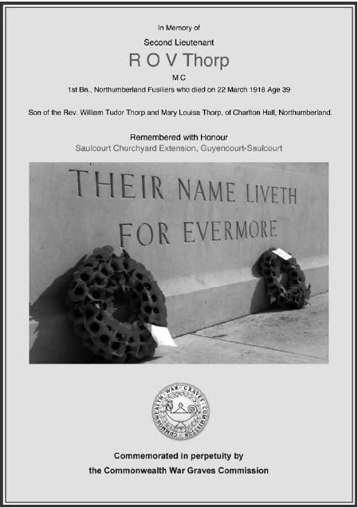

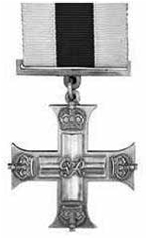
Lieutenant Robert Oakley V. Thorp MC

Robert Oakley Vavasour Thorp was born in Llangarron, Herefordshire
the fourth son of William and Mary Thorp in 1879.
By 1881 he was living with his family at Charlton Hall. He was
educated privately at King`s College, Cambridge. He became
a schoolteacher and taught in Scarborough before moving to
Manchester where he taught French and German. At the outbreak
of the war he joined the Public Schools and University Corps, went
out to the front and served in the trenches in the winter of 1915.
He later obtained a commission in the Northumberland Fusiliers. He
was awarded the Military Cross for conspicuous gallantry in action.
He led a successful raid against the enemy with great courage and
determination, himself killing two of the enemy and capturing a
prisoner. He was later invalided home with trench fever. However
he recovered and returned to his regiment
in 1917. When he returned to the front he
was attached to a trench-mortar battery.
He was killed on 22nd March 1918 during
the battle of the Somme.
He is buried at Saulcourt in France.
There is a memorial to him in Ellingham
Church near the altar. His brother
Collingwood also served in the Army.
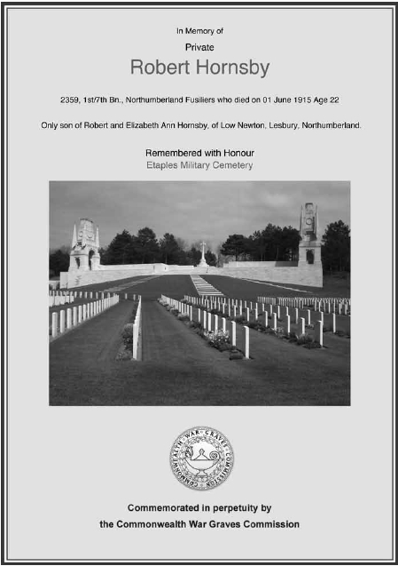

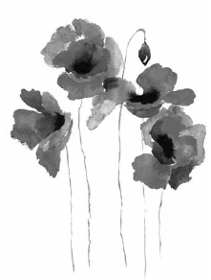
Robert Hornsby

Robert Hornsby was born at Hepple in Northumberland in 1893
the son of Robert and Elizabeth Hornsby.
He had a younger sister Mary.
In 1911 he was living with his mother and sister at High House,
Alnwick and is listed as an assistant shepherd.
As an assistant shepherd Robert would have had at least three
collie dogs, one old, one fully trained and a puppy which was
being trained.
When he joined the Northumberland Fusiliers in 1914 Robert was
living and working at Doxford Farm.
He died of wounds received in battle near Etaples France on 1st
June 1915 aged 22 and is buried there in the Military Cemetery.
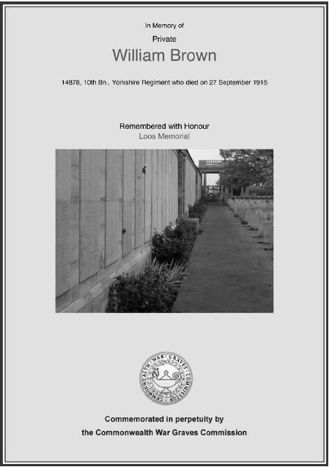

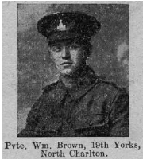
William Brown

William and his twin brother John were born near Whittingham,
the youngest of eight children of James and Margaret Brown.
By 1901 the family were living at number 13 Ellingham Village
which was somewhere between the Pack Horse and Harelaw, so
William would go to school at Ellingham until he was 14.
Sadly his father died in 1904 (when William was 9) and his mother
in 1906. His eldest sister Mary came home to look after the boys.
On leaving school William became an apprentice gardener while
his twin became a telegraph boy. Both of the twins, and their elder
brother Charles enlisted in the army.
William was killed in action at Loos, near Ypres in Belgium on 27th
September 1915.

Report from The Northumberland
Gazette along with the photo:
A North Charlton Hero
We regret to report that Private
William Brown, of North Charlton
was killed in action at Loos on 27th
September. He was in the 19th
Yorkshire Regiment.
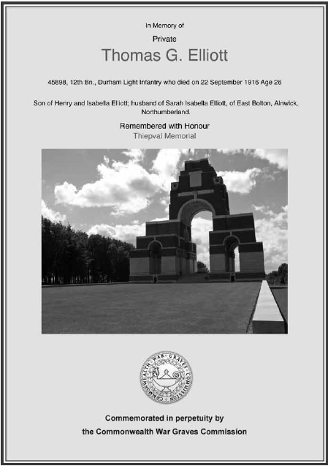

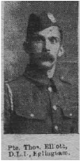
Thomas George Elliott

Thomas George Elliott was born in Lucker in 1890 the son of Henry
and Isabella Elliott. The family moved to Ellingham Lodge when
Thomas was small and he would have attended Ellingham school
before starting work as a drainer in his father’s business.

From The Northumberland Gazette:
Private T G Elliott, who was killed on September 24th was the
youngest son of Mr and Mrs Elliott of Ellingham Lodge. He enlisted
into the NF in August 1915 here at Alnwick. He commenced training
after which he was removed to Warminster and
from thence to France, at the end of January
1916. During the advance on July 1st, Private
Elliott was wounded. He lay for a few weeks in
hospital in France, after which, on recovery from
his wounds, he was transferred to the D.L.I.
(Durham Light Infantry).
In a letter to the deceased’s widow, after expressing
heartfelt sympathy on behalf of himself and other
officers of the battalion, Second Lieutenant Borrell writes:- Your
husband was a very fine and brave soldier, and always did his duty
well and bravely . . . He died a soldier’s death in the thick of the
fighting. Unfortunately a shell burst right on the piece of trench
which your husband and a few of his comrades were occupying
with the result that they were instantly killed.
Private Elliott leaves a widow and one little son.
His brother John also served in the Army.
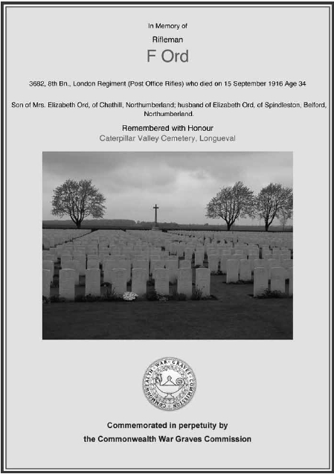

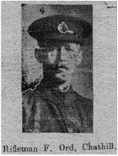
Frederick Ord

Frederick Ord was born at Beadnell, son of Elizabeth Ord and in
1891 was living with his mother, five brothers and two sisters at
Swinhoe. By 1911 he was married to Elizabeth, living at Preston,
working as a postman and had a three year old daughter called
Violet.
As a postman he would start his day by collecting the mail from the
train and sorting it before delivering it either on foot or a bicycle.
He was a rifleman in the City of London Rifles Post Office Division
and was killed in action during the Battle of the Somme on 15th
September 1916, aged 34.
He is buried in the Caterpillar Valley Cemetery, Longueval, France.
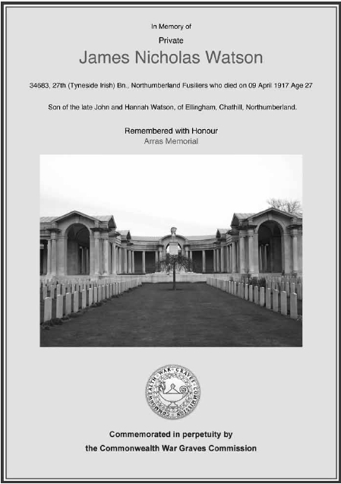

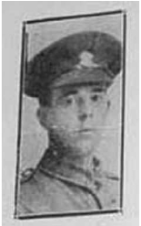
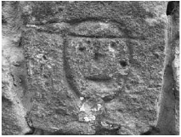
James Nicholas Watson

James Watson was born in 1890 in Gateshead the second son
of John and Hannah Watson (he had three brothers). By 1901
the family was living at Ellingham where his father was Sexton
for twenty two years and the family lived in Vicarage Cottage at
Ellingham.
James joined the Northumberland Fusiliers in August 1915 and
went to France in January 1917. During his embarkation leave
James carved a face on the wall at the Glebe Farmhouse. This can
still be seen today on the roadside near the gate.
He was killed in action near Arras on 9th April 1917 aged 27.
He is commemorated on the Arras Memorial.
His brothers Frank and John also served in the Army during the
conflict.

Carving at the Glebe

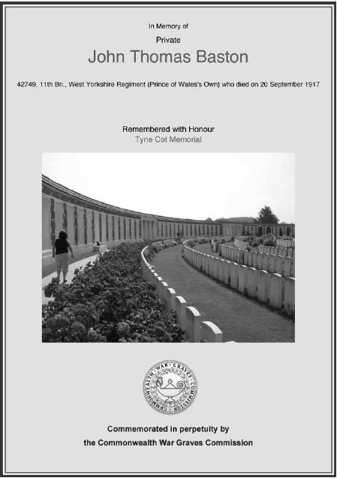

John Thomas Baston

John Thomas Baston was born in 1896 at Gloster Hill near
Warkworth, the son of David and Mary Baston. He had two
brothers and five sisters. By 1911 the family was living at Brockdam
and he was a horseman on the farm. As a horseman he would be
responsible for his two horses, getting up to feed and groom them
at five so that they were ready to work at seven.
He was killed near Ypres in Belgium in September 1917 and is
commemorated on the Tyne Cot memorial.
From The Northumberland Gazette:
Mr and Mrs Baston, Stewards Cottage, Ellingham have been
informed by the War Office that their youngest son Thomas was
killed in France on 20th September. He was 22 years of age and
only joined last April, leaving for France in June. For over 10 years
he was a member of the Parish Church Choir. His platoon officer,
writing to his mother, says: It is with great regret I write to tell you
of the death of your son. I can assure you that he was a man of
priceless worth to my platoon, and as brave a soldier as ever stood
on a battlefield. He died doing his duty for King and Country. I miss
him on every parade and feel his loss greatly. He was always cheery,
and whatever work he had to do he did it well and with a good
will. Much sympathy is felt with the family in their bereavement
as all of them are much respected in the locality where they have
lived so long. Another son is serving in France with a Canadian
Battalion. He joined up in Vancouver City.
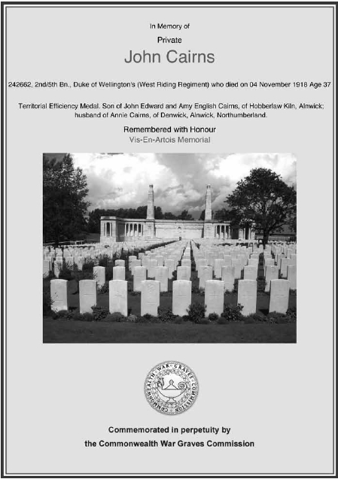

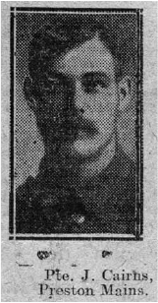
John Cairns

John Cairns was born in Alnwick in
1881 the eldest son of Edward and Ann
Cairns (although listed on the memorial
opposite as Amy, she is listed as Anne E
on Census records) who were farmers.
He had five brothers and a sister.
By 1914 he was married and living at
Preston Lodge. He enlisted at the start
of the war and served over four years
in France and Flanders. He was killed on
4th November 1918 whilst carrying a
stretcher containing a wounded officer.
A letter from his Commanding Officer says that his devotion to
duty as a soldier throughout his long service and willingness to
volunteer as a stretcher bearer were a fine example of all that is
best in the Army. He was serving in the Duke of Wellington’s
(West Riding Regiment) at the time of his death.
He is commemorated on the Vis-En-Artois memorial in France.
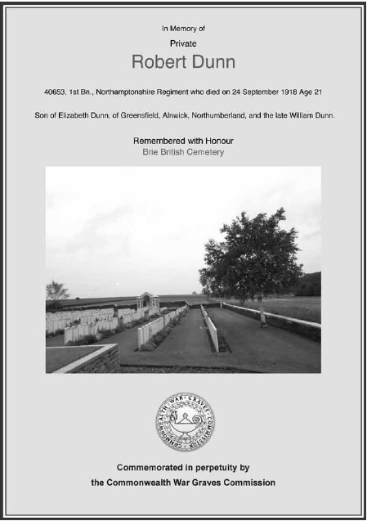

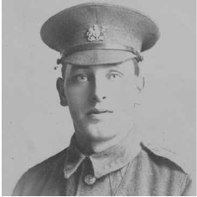
Robert Dunn

Robert Dunn was born at Castle Eden, Co. Durham the second
son of William and Elizabeth Dunn. When his father was killed
in a pit accident at Hordon in 1902 his mother moved to North
Charlton where she took over the running of the post office to
be nearer her family who farmed at East Link Hall. Robert, his
two brothers and one sister went to Ellingham School. On leaving
school Robert started work on his grandfather’s farm and later
joined the Northamptonshire Regiment.
He was killed on 24th September 1918 aged 21.

From The Northumberland Gazette:
Mrs Dunn of East Link Hall has received a telegram stating that her
son Private Robert Dunn of the Northamptons has died in hospital
in France. He was wounded nearly a fortnight ago in the arms and
legs. He was home on leave for the March hirings. He left for France
on 15th and was gassed on
19th. He was back in the
fighting again and sprained
his ankle on 13th July, was
wounded in hospital during
an air raid and rejoined his
battalion on 9th September,
was wounded on 23rd
September and died on 24th.
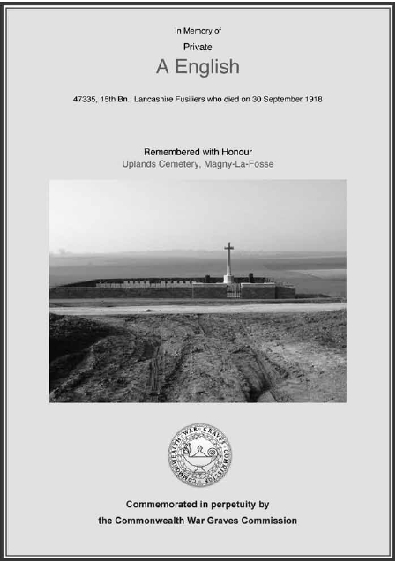

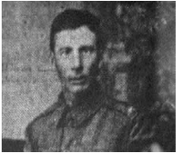
Andrew English

From The Berwick Advertiser:
BELFORD PLANTATION FARM LAD MAKES SUPREME SACRIFICE
We are sorry indeed to state that Mr and Mrs English, Plantation
Farm, Belford, have been informed that their youngest son, Private
Andrew English, Lancashire Fusiliers, has fallen in action in France.
Private English enlisted early in the war, and after undergoing a
course of training was drafted overseas and put in the firing line
and stayed there a long time before anything eventful occurred
to him. Bad luck eventually came his way and he was sent over to
England and after a few months stay here, he returned to France,
and the dear lad has remained there manfully fulfilling his duty in
the Great War until the hour he gave his life for country, home and
loved ones. Practically the whole of our gallant young friend’s life
was spent at North Sunderland, where he was greatly beloved by
all who knew him. We mourn the loss of such a fine young fellow
and sympathise most deeply with the bereaved family.
He died on 30th September 1918 and is commemorated at
Uplands Cemetery, Magney-La-Fosse.

Although I have not been able
to find where he was working,
Andrew English must have been
working on one of the farms at
Ellingham when he enlisted. ED

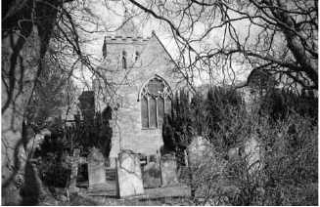
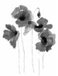
In Memory of
Private
Thomas James Romaines
Northumberland Fusiliers who died 27th October 1916 aged 22
Son of Thomas and Jane Romaines of Wandylaw

Remembered with Honour
Ellingham Churchyard

Commemorated in perpetuity by
the Commonwealth War Graves Commission

Thomas James Romaines

Thomas James Romaines was born at Bowsden Moor in 1894 the
eldest son of Thomas and Jane Romaines. He had two younger
brothers and a sister. By 1915 when he enlisted the family were
living at Wandylaw and he was working on the farm.

This is a copy of the report of his death from The Gazette:
Funeral of Private T Romaines of Wandylaw
On Sunday afternoon last, the remains of ex-Private Thomas
Romaines, Wandylaw, were interred in Ellingham Churchyard. His
sudden death at the early age of 22 gave rise to much sympathy,
and the large numbers present at the funeral testified to the
respect in which the deceased and his parents are held in the
neighbourhood.
The services, both in the church and at the graveside were unusually
impressive. In a brief address, the Vicar alluded to the pathetic
circumstances of the young soldier’s death, of his keenness to serve,
and of his patience. Young Romaines volunteered in June 1915,
and joined 5th NF. A severe chill in spring placed him in hospital,
and a subsequent attack of pneumonia, from the effect of which
he never recovered, precipitated his discharge from the army a few
weeks ago and he died at his father’s house at Wandylaw early on
Friday morning from heart failure.

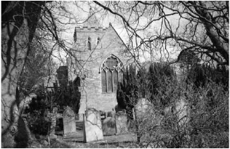
In Memory of
Private
Charles Brown
King’s Own Yorkshire Light Infantry who died
31st December 1917 aged 31
Son of the late James and Margaret Brown of Ellingham

Remembered with Honour
Ellingham Churchyard

Commemorated in perpetuity by
the Commonwealth War Graves Commission

Charles Brown

Charles Brown was born in Ford, the son of James and Margaret
Brown. He had four brothers and two sisters (one of whom was his
twin). His father was a stone mason and by 1901 the family was
living at Ellingham. Sadly his father died in 1904 and his mother
in 1906 so that, by 1911 he is listed on the census as head of
the household and a road man with his eldest sister acting as
housekeeper for him and his two younger brothers who were by
then 16 and working, one as a telegraph boy and the other as an
apprentice gardener. Both of these brothers John and William also
joined the forces.
As a roadman in those days he would be responsible for his stretch
of road (typically about 5 miles). He would have to mend potholes
by breaking up stones to fill them, keep the ditches clear and keep
the grass and hedges cut on the side of the roads. It was a source
of pride for most of these roadmen that ‘their’ stretch was better
than the next stretch. When he enlisted he joined the King’s Own
Yorkshire Light Infantry and saw service in the trenches in France
and Flanders.
Whilst serving he contracted an illness from which he died on 31st
December 1917 aged just 31.
(As well as bullets, shells and shrapnel (often resulting in gangrene)
trench hand, mouth and foot, trench fever, dysentery, typhus and
cholera were common in the soldiers in the trenches)

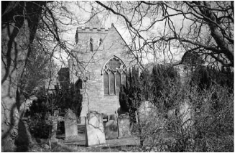
In Memory of
Private
Edward Millar
West Yorkshire Regiment who died 28th June 1919 aged 21
Son of William and Mary Millar of Wood Cottage, Ellingham

Remembered with Honour
Ellingham Churchyard

Commemorated in perpetuity by
the Commonwealth War Graves Commission

Edward Millar

Edward Millar was born at Wood Cottage, Ellingham in 1898, the
youngest son of William and Mary Millar.
He had four older brothers, three of whom also served in the
armed forces.
He went to school at Ellingham and on leaving at 14, instead of
following his father and brothers by becoming a gamekeeper
Edward became an assistant shepherd at East Brizlee in Alnwick
Parks. He joined the Royal Garrison Artillery and fought in France
and Flanders during the war.
He was gassed in March 1918 and on April 5th 1918 was discharged
from the army as no longer physically fit for war service.
He returned home to Ellingham and died 28th June 1919 aged
just 21 having never recovered.
As a trainee shepherd in Alnwick Parks, Edward would have had a
hard life but would have spent most of his time in the open air and
would have had at least three collies to help him in his work. Edward
Millar is also commemorated on the Duke of Northumberland’s
Roll of Honour at Alnwick Castle as he was working for him when
he enlisted.
World War I Cemeteries and Memorials

La Laiterie Military Cemetery
This cemetery is in Heuvelland, West Vlaanderen near to Kemmel
in Belgium which is between Ypres and the Belgium France border.
The cemetery, which was designed by Sir Edwin Lutyens, holds the
graves of 571 identified casualties including that of Captain W J
Davis.

Saulcourt Churchyard Extension
This graveyard is in France near the Somme and contains the graves
of 70 British Officers and men who died near here.
Lieutenant R O V Thorp is buried here.

Etaples Military Cemetery
This cemetery is situated at Etaples near Boulogne on the north
west coast of France. It holds the graves of over 11,500 from both
WW1 and WW2. The number of military buildings in ETAPLES
gave the town a capacity of around 100,000 troops in World War
I and made the area a serious target for German aerial bombing
raids from which the town suffered heavily.
Robert Hornsby is buried here.

Loos Memorial
The Loos Memorial is a World War I memorial located near
Commune of Loos-en-Gohelle in the pas-de-Calais department of
France. 20,610 army men are in this memorial. Built 4th August
1930. William Brown is commemorated here.

Thiepval Memorial
Is in the Somme in France and contains the names of 72,195
soldiers who died in the battle of the Somme and who have no
known grave. Thomas G Elliott is on this memorial.

Caterpillar Valley Cemetery, Longueval
Is in the Somme in France and contains the graves of 1,774 British
servicemen including F Ord.
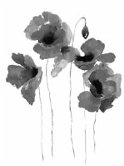
Arras Memorial
Is situated in the Faubourg-d’Amiens Cemetery in France and
contains the names of 34,774 men who have no known grave
including James Watson.

Tyne Cot Memorial
Is in France and is one of four memorials to the missing in Belgium
Flanders which cover the area known as the Ypres Salient. It
contains the names of almost 35,000 officers and men including
John Thomas Baston.
It is the largest memorial to those from the UK who died during
WW1.

Uplands Cemetery Magny-La-Fosse
Is in France and contains the graves of 43 Officers and men who
were killed at the battle of St. Quentin Canal which was fought
between 29th September and 2nd October 1918 including Andrew
English.

Brie British Cemetery
Is in France at the village of Brie which is on the Armiens-St.
Quentin Road. It contains the graves of 409 Commonwealth
soldiers including Robert Dunn.

Vis-En-Artois Memorial
Is situated to the west of the village of Haucourt and about 10
kilometres south east of Arras. It contains
the names of 9,833 servicemen killed
in the area who have no known grave
including John Cairns.

Ellingham Churchyard
Contains the graves of three servicemen
from the area who died as a result of
injuries or illnesses sustained during WW1.
Thomas J Romaines, Charles Brown and
Edward Millar.
WWII Memorials

Unlike Commonwealth War Graves and Monuments which are
tended by the War Graves Commission, War Memorials were
erected by local people in memory of their friends and neighbours
who died in two World Wars. For them this was a way of bringing
their loved ones home.
Again, unlike the War Graves and monuments, a person could be
commemorated on more than one memorial, for example many
schools and universities (including the Duke’s School at Alnwick)
have their own war memorials and someone who was working in
one area when he joined the army could be commemorated on a
local memorial and also on one where his family still lived.
Major Gilfrid Edward Baker-Cresswell is on the War Memorial at
Trinity College, Cambridge where he studied engineering.
Unfortunately I have been unable to find a Roll of Honour for the
men and women from Ellingham who served during the Second
World War.
I feel that I have been very lucky to have traced some family
members of these men who have filled in some of the backgrounds
(census records for that period are not available).
If anyone has any information about any of these men perhaps
they could get in touch with me and this could be included in any
future versions of this booklet.
Eileen Duncan

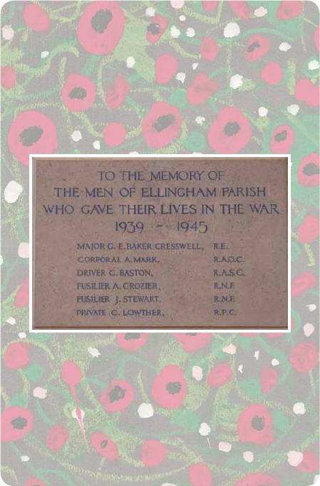
World War II
Memorials
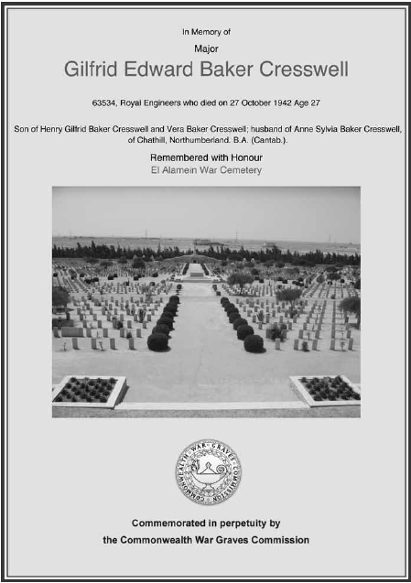

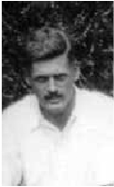
Major Gilfrid Edward Baker-Cresswell

Gilfrid Edward Baker-Cresswell was born in
Edinburgh where his father was working as an
engineer with post office telephones. Gilfrid
moved with his parents, Henry Gilfrid (who
fought in WWI) and Vera to London as a small
boy and attended Westminster School where
he won cups for running, one of which has
now been given to the Pack Horse Leek Club
and is awarded annually for the most points in the baking section.
On leaving school he was commissioned into the Royal Engineers
and was sent by the army to university to study engineering. He
read engineering at Trinity College, Cambridge and completed the
course in two years rather than the usual three.
Gilfrid and Sylvia became engaged in 1938 and plans for the
wedding were accelerated on account of the Munich crisis. Shortly
after the wedding he was posted on garrison duty to Mauritius
(incidentally the island named after the Patron Saint of Ellingham
Church). He was later posted to the Western Desert and was
mentioned in dispatches for bravery before sadly being killed at El
Alamein on 27th October 1942.
He is buried in the cemetery there.
He left a widow Sylvia and two small children, Sally and Gilfrid.

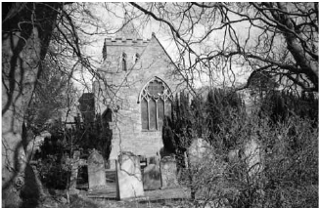
In Memory of
Corporal
Alfred Mark
Royal Ordinance Corps
Died at Foresters’ Cottages, Doxford
Buried at Ancroft

Remembered with Honour

Commemorated in perpetuity on
Ellingham War Memorial

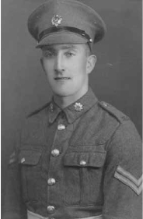
Alfred Mark

Alfred Mark was born at Linden Hall
(near Longhorsley ) on 28th August
1917 and attended South Charlton
School until 1927 when the family
moved to Doxford. He then moved
to Ellingham School. On leaving
school at 14 he started work for
Grieves of Embleton later becoming
a taxi driver for them.
He and his younger brother Robert
moved to the Yair Estate near
Galashiels where they both became chauffeurs. When he joined
the Army in 1939 he became a dispatch rider with the Royal Army
Ordinance Corps.
His younger brother Robert joined the Royal Navy a little later and
then went on to work on cruise liners and is still alive and living in
New Zealand at the time of writing.
Alfie developed TB and spent time in a hospital on the Mount of
Olives, Jerusalem. When he came back to England he spent some
time in a hospital near Hexham. He died in December 1948 at
his parents home at Foresters’ Cottages, Doxford and is buried at
Ancroft.
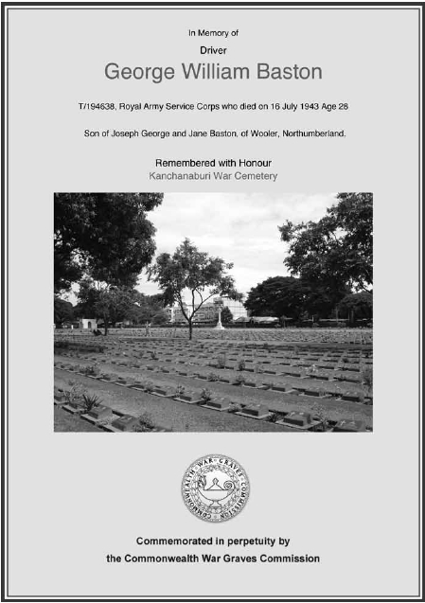

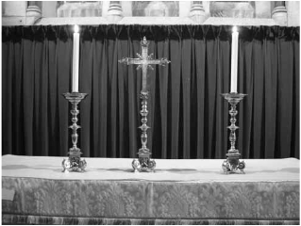
George William Baston

George William Baston lived with his parents, Joseph ( a woodman)
and Jane at Preston. When he joined the Army he joined the Royal
Army Service Corps as a driver. He was captured and worked on
the notorious death railway until his death on 16th July 1943.
This was the railway the Japanese were constructing between
Burma and Siam which was 424 kilometres long and was started
in October 1942 and completed in December 1943.
He is buried in the Kanchanaburi War Cemetery in Thailand.
His father gave the cross and two candlesticks pictured below to
Ellingham Church in his memory.
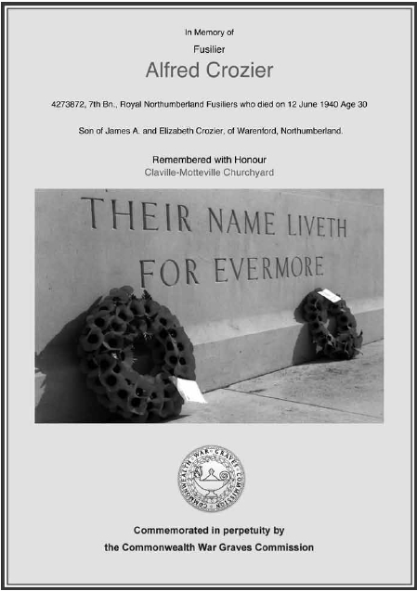

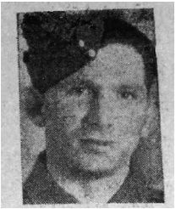
Alfred Crozier

From The Gazette August 30th 1940:
Official notification has been received by Mr and Mrs James Crozier,
Cottage Inn, Warenford that their son, Alfred Crozier, is reported
as missing. He joined the Territorials in 1938, and was attached
to the Royal Northumberland Fusiliers. He was expected home on
leave this month.
In civilian life Alfred was a postman at Chathill for many years, later
being transferred to Alnwick. He was very popular in the district.
He died 12th June 1940 aged 30, and is buried in Claville-Motteville
Churchyard in France.
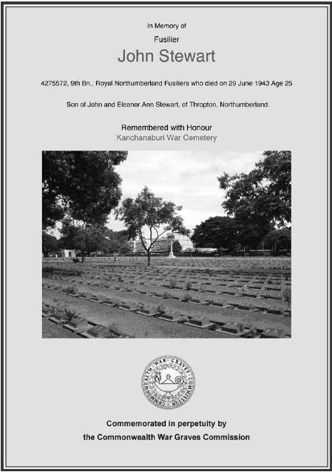

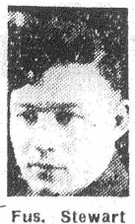
Fusilier John Stewart

John Stewart was born at Thropton, Rothbury in 1918 and the family
was living at Preston Tower when he joined the Northumberland
Fusiliers. He was a prisoner of war in Thailand and would have
worked on the infamous death railway. He died on 29th June 1943
aged just 25 and is buried in the Kanchanaburi War Cemetery in
Thailand. Sadly an entry in the Northumberland Gazette dated 3rd
September 1943 says that Mr and Mrs Stewart of Preston Tower,
formerly of Caistron, Rothbury have received a postcard from their
son John saying that he is a prisoner of war in Japanese hands.
Mr and Mrs Stewart have four sons in the army and a daughter in
law in the WAAFs.
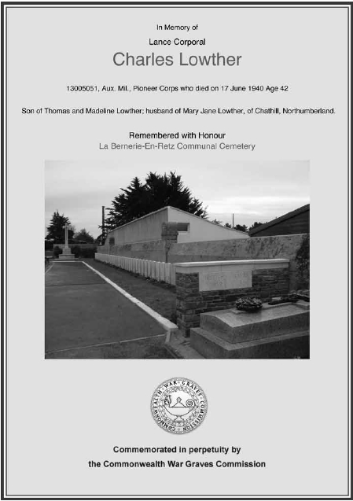

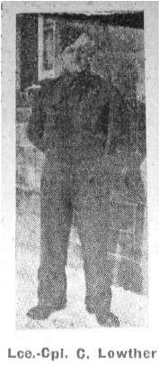
Lance Corporal Charles Lowther

From the Northumberland Gazette:
After having been previously reported as missing, official notification
has been received from the War Office by Mrs C Lowther that her
husband Lance Corporal Charles Lowther, of the Auxilliary Military
Pioneer Corps was killed on active service during fighting in France.
Lance Corporal Lowther, who hailed from Chevington Drift, saw
service in the last war and on the outbreak of the present conflict
offered his services, which were
accepted. His body was discovered
on the shore at St. Nazaire and he
was buried in La Bernier Cemetery
with full military honours. He leaves a
widow, two sons and four daughters.
It is likely that Lance Corporal Lowther
died when the troopship SS Lancastria
was sunk by enemy bombers off St.
Nazaire on 17th June 1940.

(Why Lance Corporal Lowther is
listed as Private Lowther on the War
Memorial is something of a mystery)
World War II Cemeteries

El Alamein War Cemetery
Is situated 130 kilometres west of Alexandria in Egypt on the road
to Mesa Matruh. It contains 6,425 identified casualties.
This is where Major Baker-Cresswell is buried
Kanchanaburi War Cemetery
Is situated 129 kilometres north of Bangkok in Thailand. This
cemetery is along the notorious Burma-Siam railway. During its
construction approximately 13,000 prisoners of war died and were
buried alongside the railway. An estimated 80,000 to 100,000
civilians also died. The railway was started in October 1942,
is 424 kilometres long, and was completed in December 1943.
Kanchanaburi War Cemetery is near the site of the Neike Camp
and contains the names and graves or cremated remains of 5,084
Commonwealth casualties. In May/June 1943 some 300 men died
following a cholera outbreak at the camp, were cremated, and
their ashes buried in two graves in the cemetery. This cemetery
also contains 1,894 Dutch War Graves.
This is where both George Baston and John Stewart are buried.
Claville-Motteville Churchyard
Is situated 19 kilometres north of Rouen in Normandy, France.
There are three war graves in this cemetery including that of Alfred
Crozier.
La Bernirie-En-Retz Communal Cemetery
La Bernirie-En-Retz is a village and seaside resort 48 kilometres
west south west of Nantes in France. The cemetery contains 94
war graves most of whom died when the troop ship SS Lancastria
was sunk off St Nazaire on 17th June 1940.
Lance Corporal Charles Lowther is buried here.

World War I Roll of Honour
The following is a list of officers and men of the Parish of Ellingham
who served in the Navy and Army in the Great European War 1914-1918
*Wilfred J Davis Alexander Manderson
John W Lough Ebenezer Manderson
Charles McDowell Andrew S Millar
George O.M. M’Gonigle *Edward Millar
Collingwood F Thorp John Millar
*Robert O V Thorp William A Millar
Henry G Baker-Cresswell George Milliken
Thomas S Air William Milliken
George Athey Thomas Nesbit
David Baston Edward W Ord
*John Thomas Baston *Frederick Ord
Dudley Bell Thomas Ord
John J Bowden William Ord
*Charles Brown John Renner
John Brown George E Rickleton
*William Brown Foster Robson
John Bruce George Rochester
*John Cairns *Thomas Romaines
James Carse James Scott
James A Chisholm Richard R Scott
Charles W Crozier William Scott
Robert Davidson Frank Simm
John Dick James Tait
Robert J Dick R Frank Thompson
William Dick G Edward Tiffin
John Dixon William L Tiffin
Thomas Donohoe James Tinlin
Christopher Douglas John W Tinlin
*Robert Dunn Frank Watson
John Elliott *James Watson
*Thomas G Elliott John Watson
*Andrew English Edwin Weddell
James Greshon Hubert Weddell
Mark Grey Matthew Weddell
William Hately Henry G Welsh
*Robert Hornsby William Welsh
James Keen John Wilkin
Robert Lillico George Woodcock

* Denotes men who died during the conflict


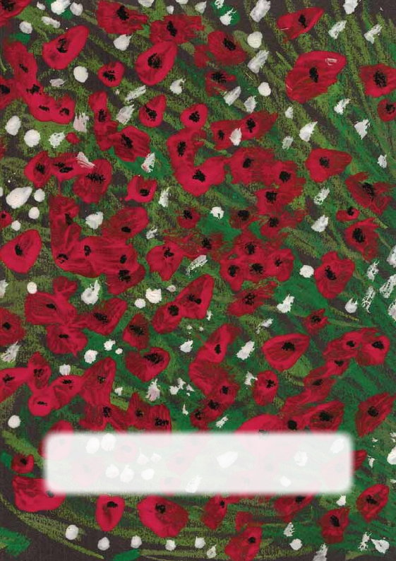
£5.00
All profits from the sale of this booklet will go towards
the upkeep of the War Memorials in Ellingham Church.

Printspot (01289) 309217

