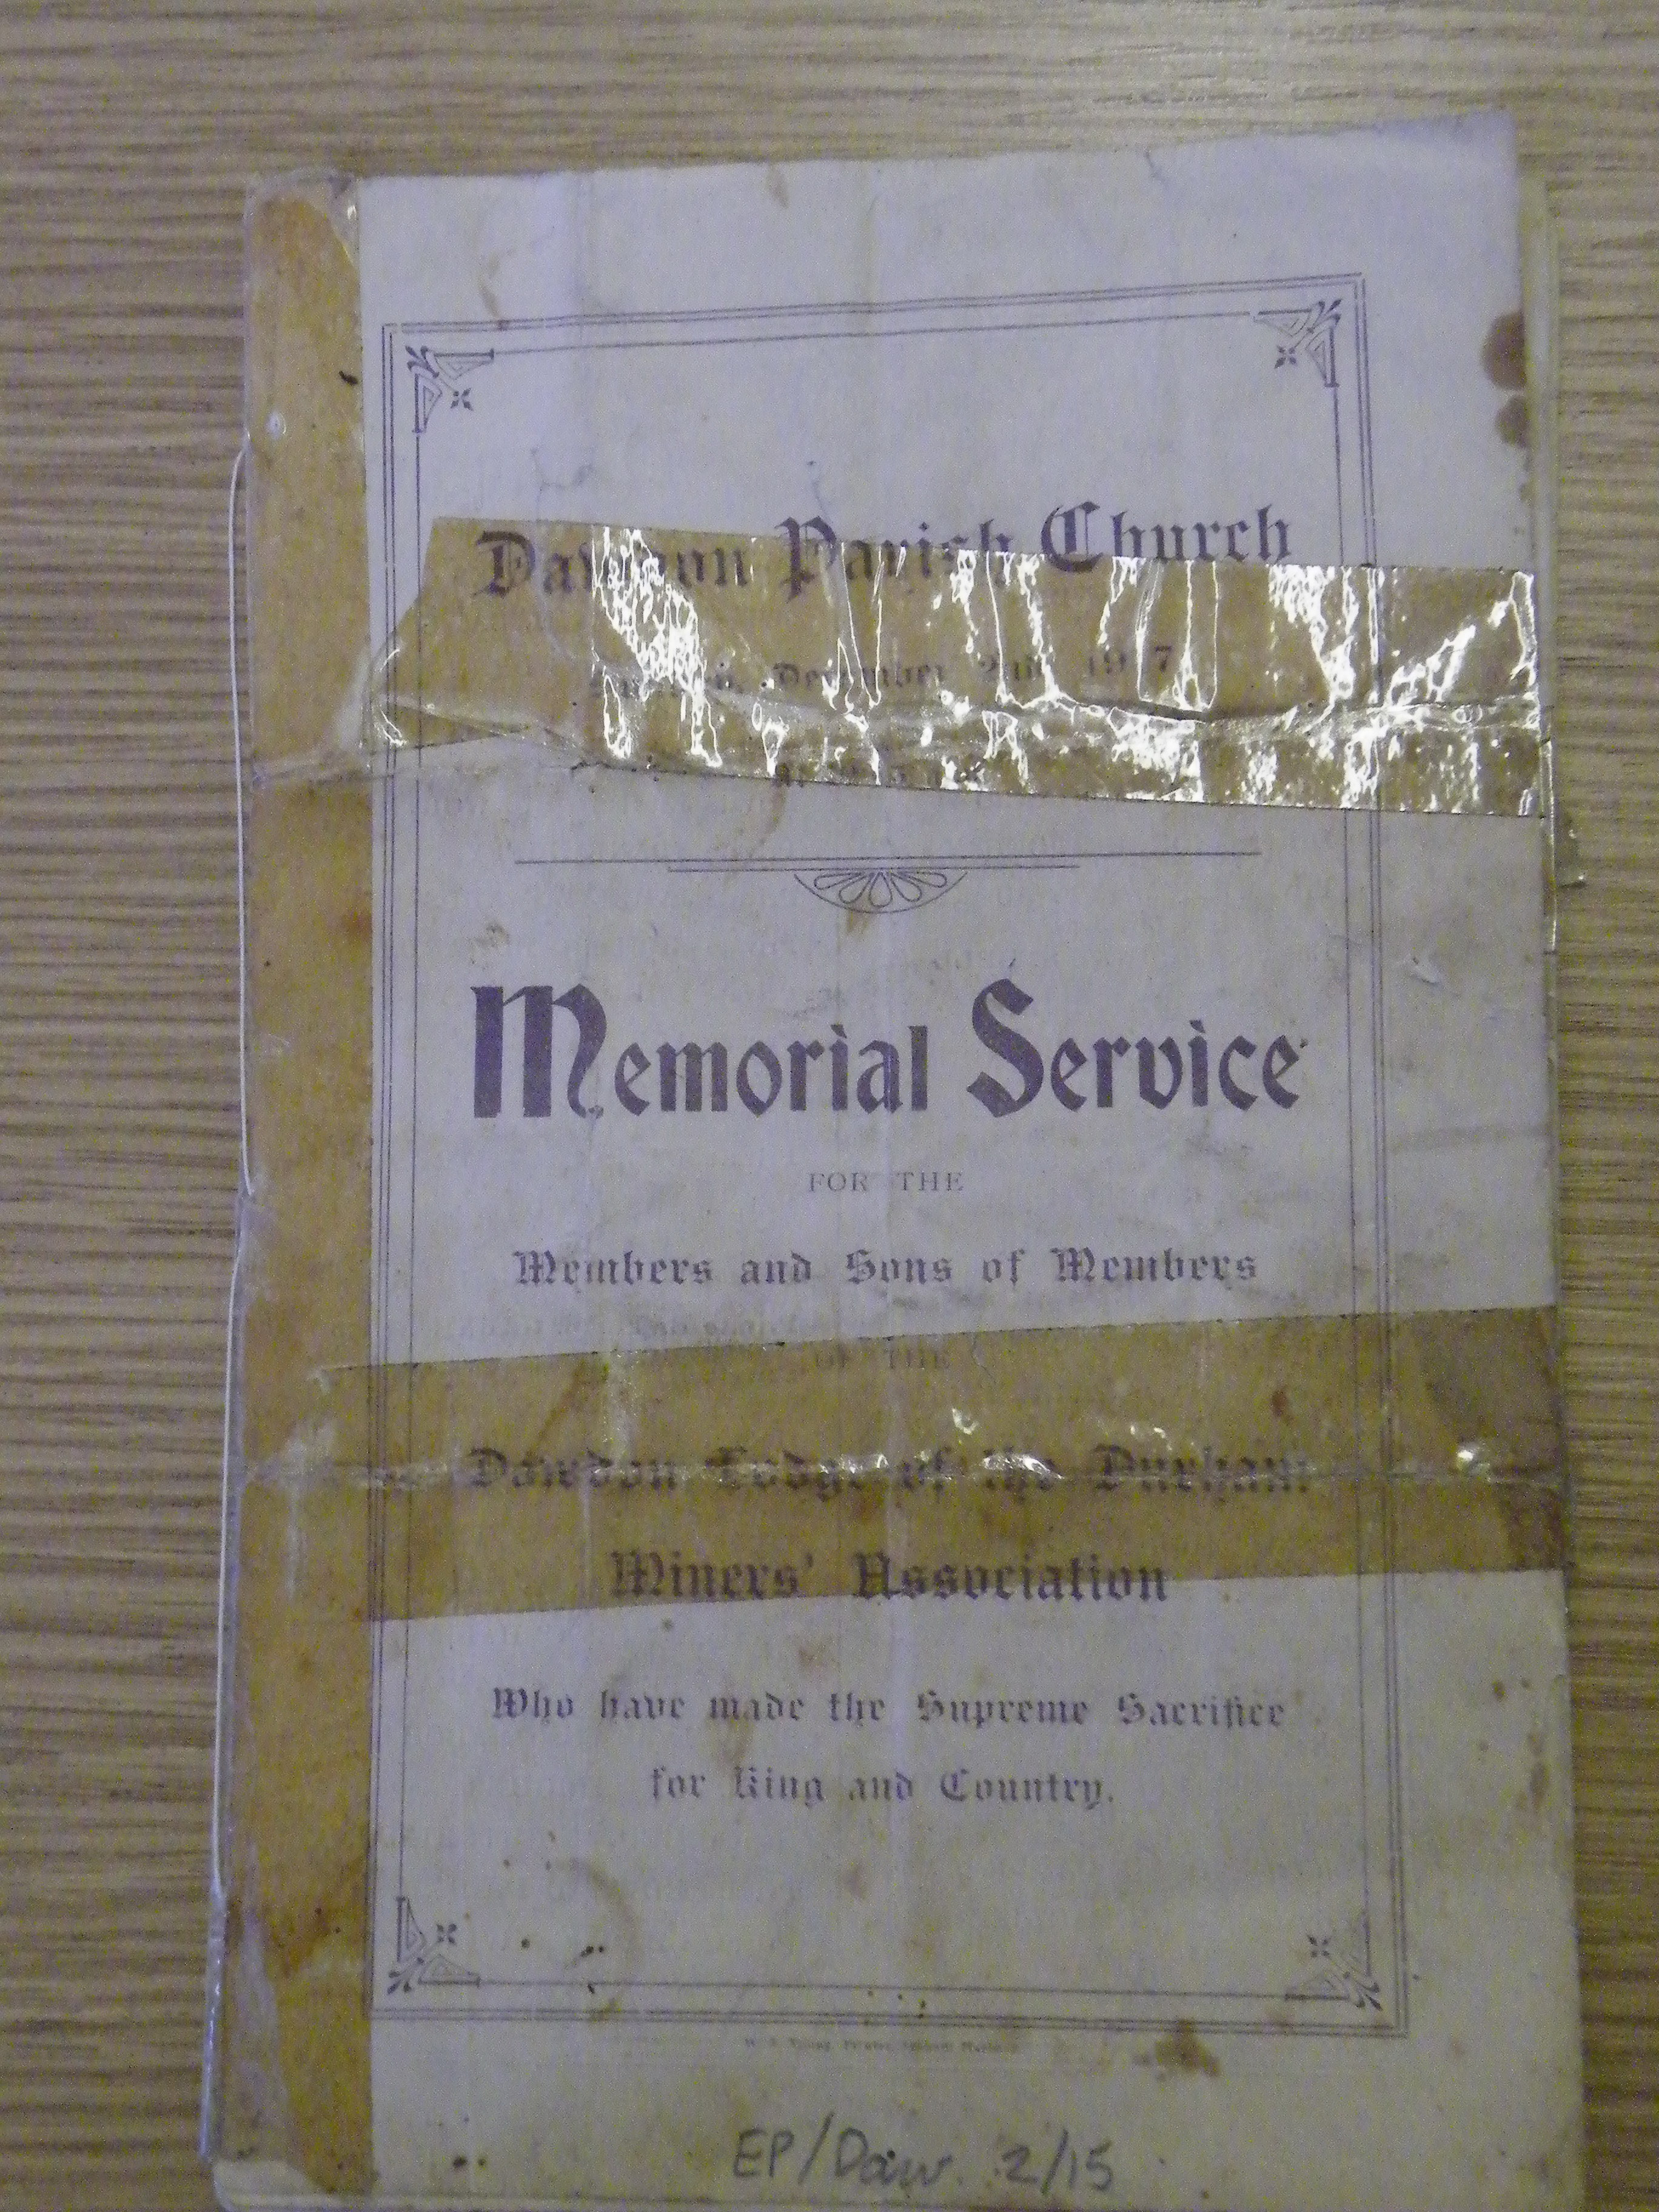

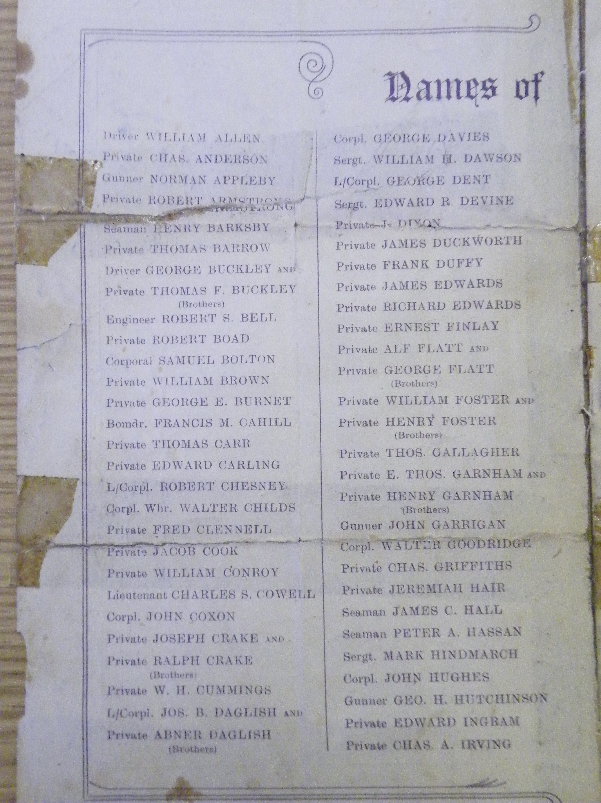

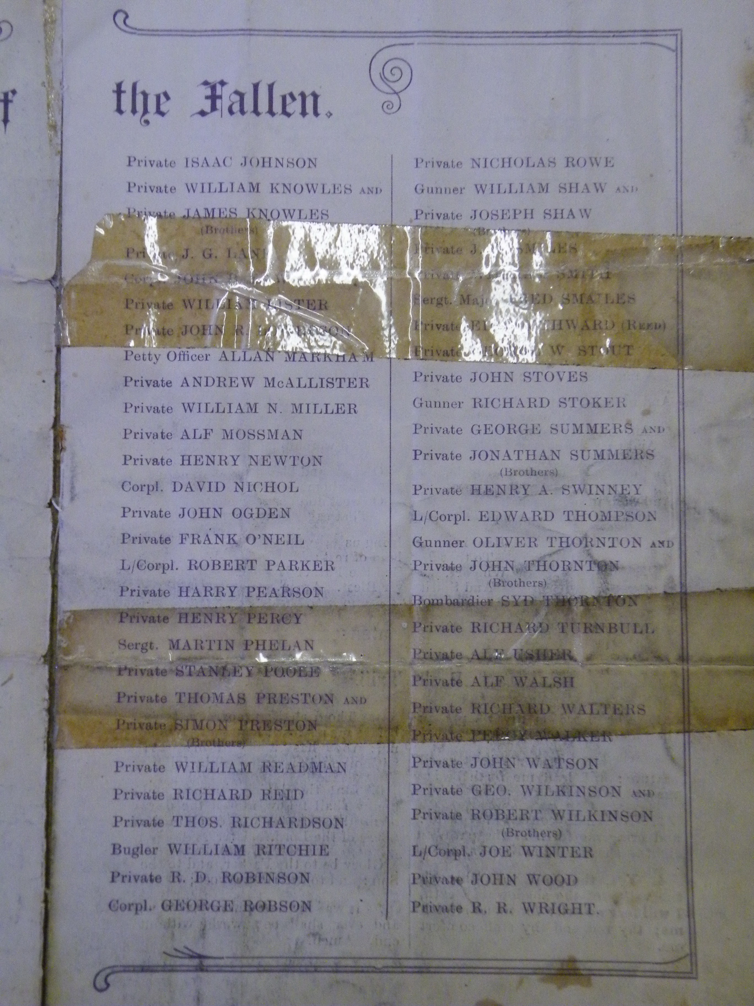

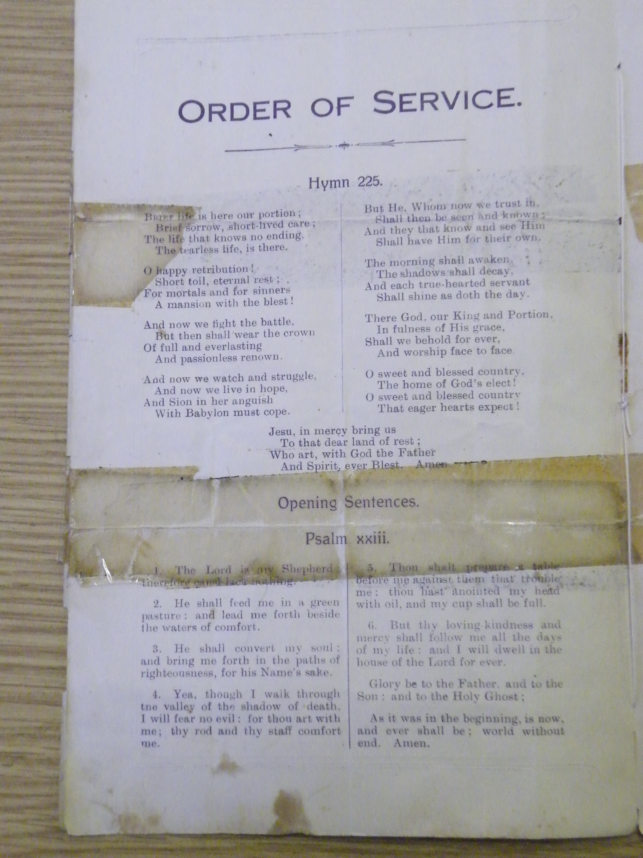

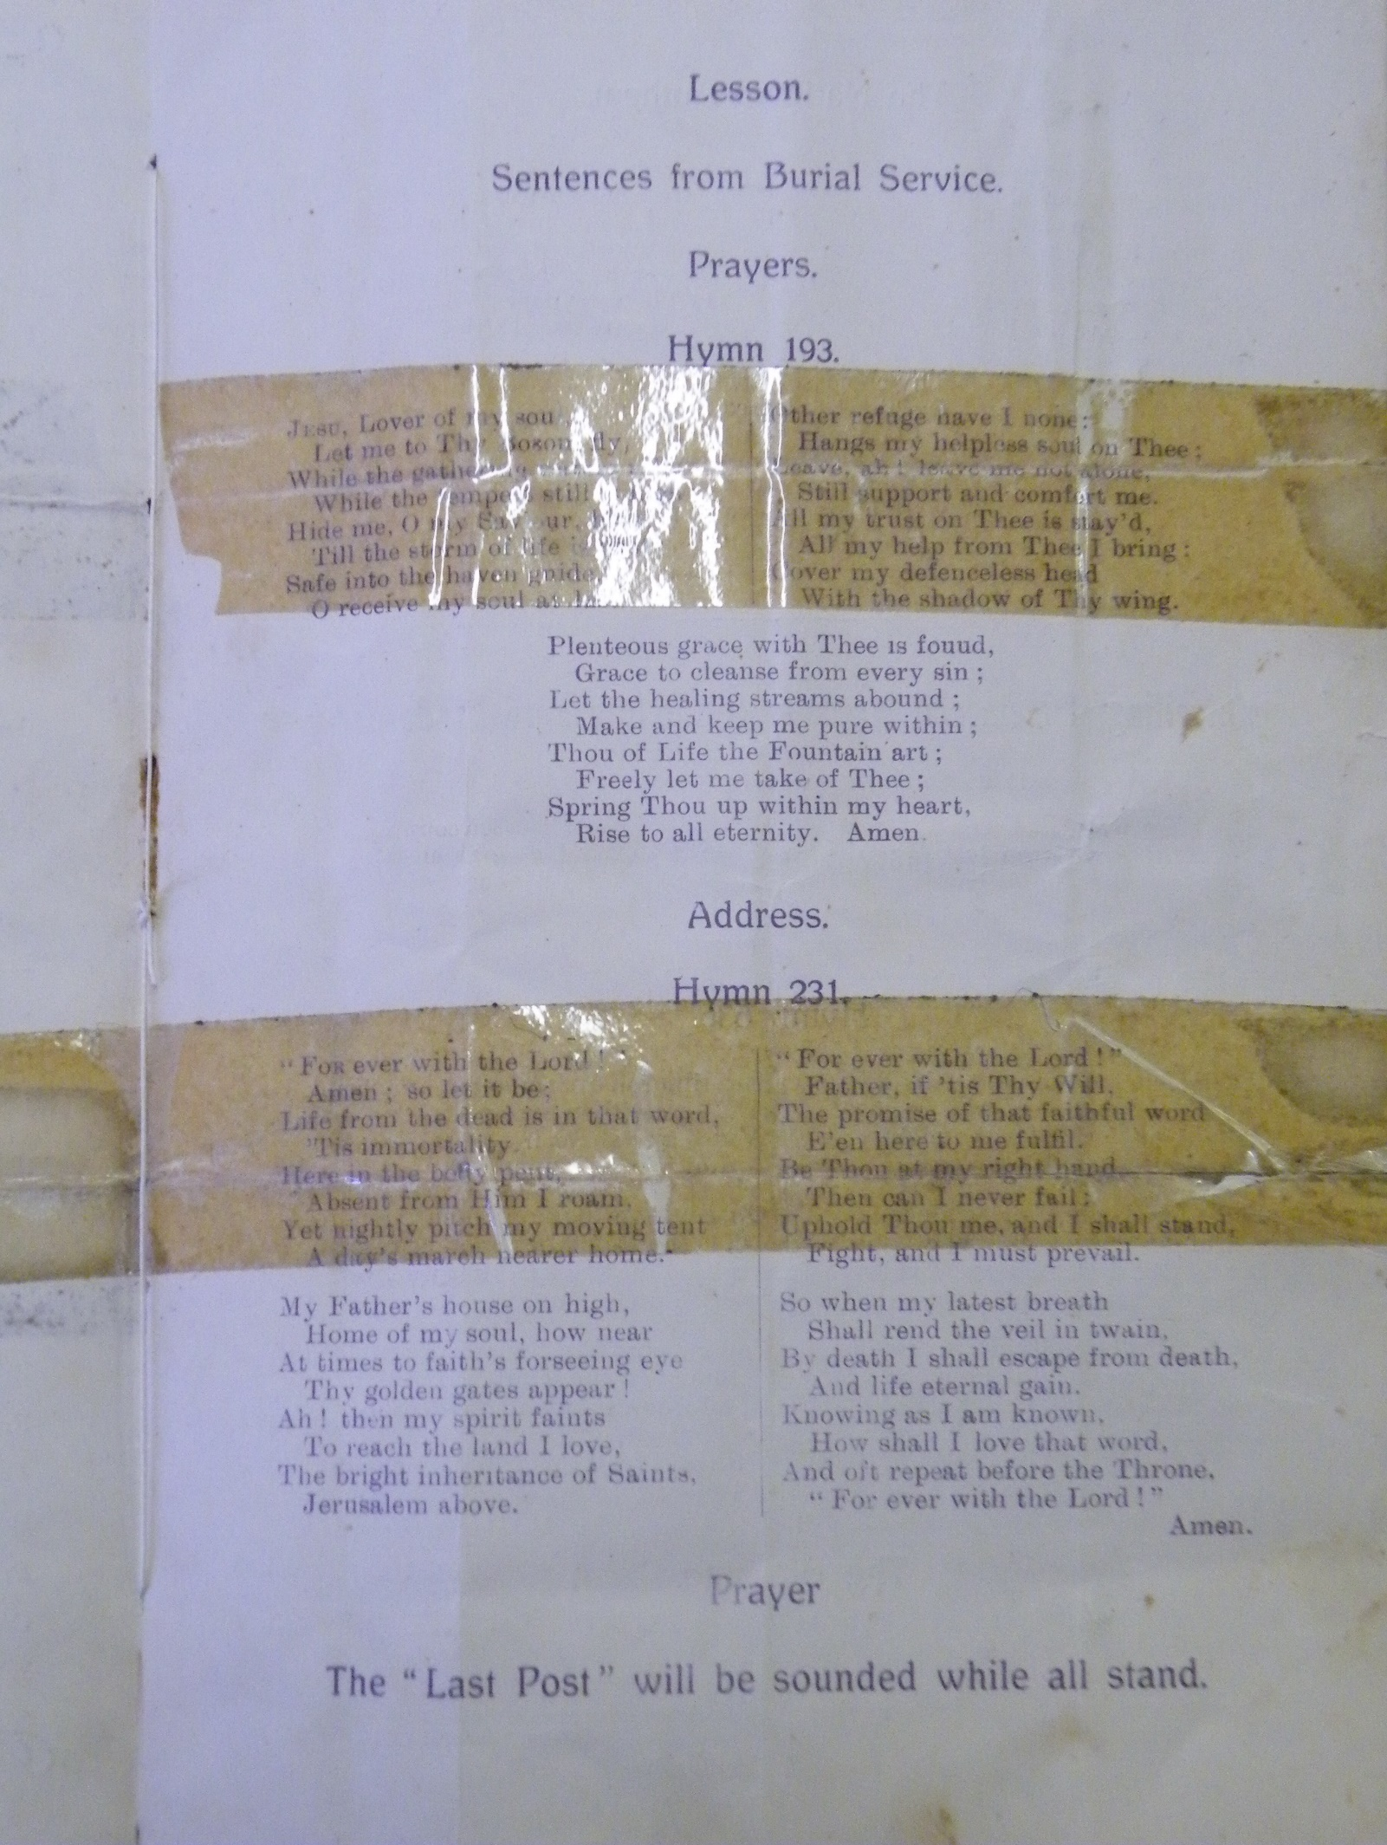
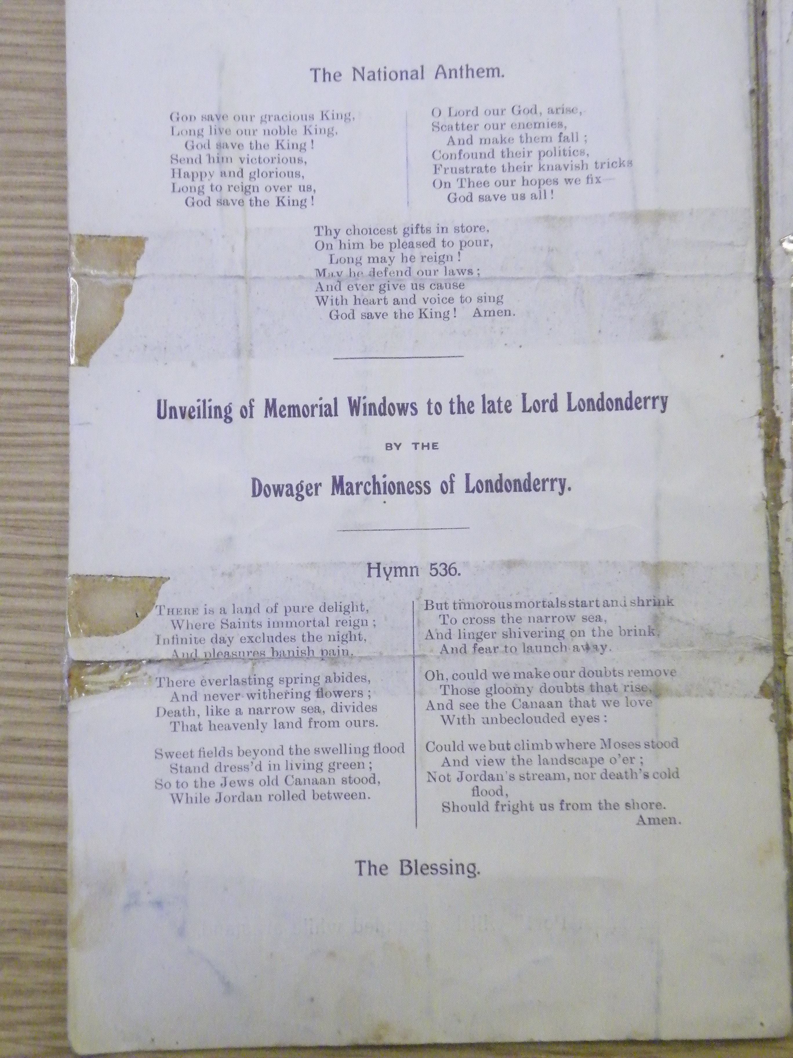
The Story Durham Ref: EP Daw 2/15

Transcript

Names of

Driver William Allen Corpl. George Davies
Private Chas. Anderson Sergt. William H. Dawson
Gunner Norman Appleby L/Corpl. George Dent
Private Robert Armstrong Sergt. Edward R. Devine
Seaman Henry Barksby Private J. Dixon
Private Thomas Barrow Private James Duckworth
Driver George Buckley and Private Frank Duffy
Private Thomas F. Buckley Private James Edwards
(Brothers) Private Richard Edwards
Engineer Robert S. Bell Private Ernest Finlay
Private Robert Boad Private Alf Flatt and
Corporal Samuel Bolton Private George Flatt
Private William Brown (Brothers)
Private George E. Burnet Private William Foster and
Bomdr. Francis M. Cahill Private Henry Foster
Private Thomas Carr (Brothers)
Private Edward Carling Private Thomas Gallagher
L/Corpl. Wht. Walter Childs Private E. Thos. Garnham and
Private Fred Clennell Private Henry Garnham
Private Jacob Cook (Brothers)
Private William Conroy Gunner John Garrigan
Lieutenant Charles S. Cowell Corpl. Walter Goodridge
Corpl. John Coxon Private Chas. Griffiths
Private Joseph Crake and Private Jeremiah Hair
Private Ralph Crake Seaman James C. Hall
(Brothers) Seaman Peter A. Hassan
Private W.H. Cummings Sergt. Mark Hindmarch
L/Corpl. Jos. B. Daglish and Corpl. John Hughes
Private Abner Daglish Gunner Geo. H. Hutchinson
(Brothers) Private Edward Ingram
Private Chas. A. Irving

The Fallen

Third Column Fourth Column
Private Isaac Johnson Private Nicholas Rowe
Private William Knowles and Private William Shaw and
Private James Knowles Private Joseph Shaw
(Brothers) (Brothers)
Private J.G. Lane Private J.R. Smiles
Corpl. John B. Laws Private William Smith
Private William Lister Sergt. Major Fred Smailes
Private John R. Lowerson Private Edward Southward (Reed)
Petty Officer Allan Markham Private George W. Stout
Private Andrew McAllister Private John Stoves
Private Alf Mossman Gunner Richard Stoker
Private Henry Newton Private George Summers and
Corpl. David Nichol Private Jonathan Summers
Private John Ogden (Brothers)
Private Frank O'Neil Private Henry A. Swinney
L/Corpl. Robert Parker L/Corpl. Edward Thompson
Private Harry Pearson Gunner Oliver Thornton and
Private Henry Percy Private John Thornton
Sergt. Martin Phelan (Brothers)
Private Stanley Poole Bombardier Syd Thornton
Private Thomas Preston and Private Richard Turnbull
Private Simon Preston Private Alf Usher
(Brothers) Private Alf Walsh
Private William Readman Private Richard Walters
Private Richard Reid Private Percy Walker
Private Thos. Richardson Private John Watson
Bugler William Ritchie Private Geo. Wilkinson and
Private R.D. Robinson Private Robert Wilkinson
Corpl. George Robson (Brothers)
L/Corpl. Joe Winter
Private John Wood
Private R.R. Wright

