St. Cuthbert's War Memorial Lych Gate.

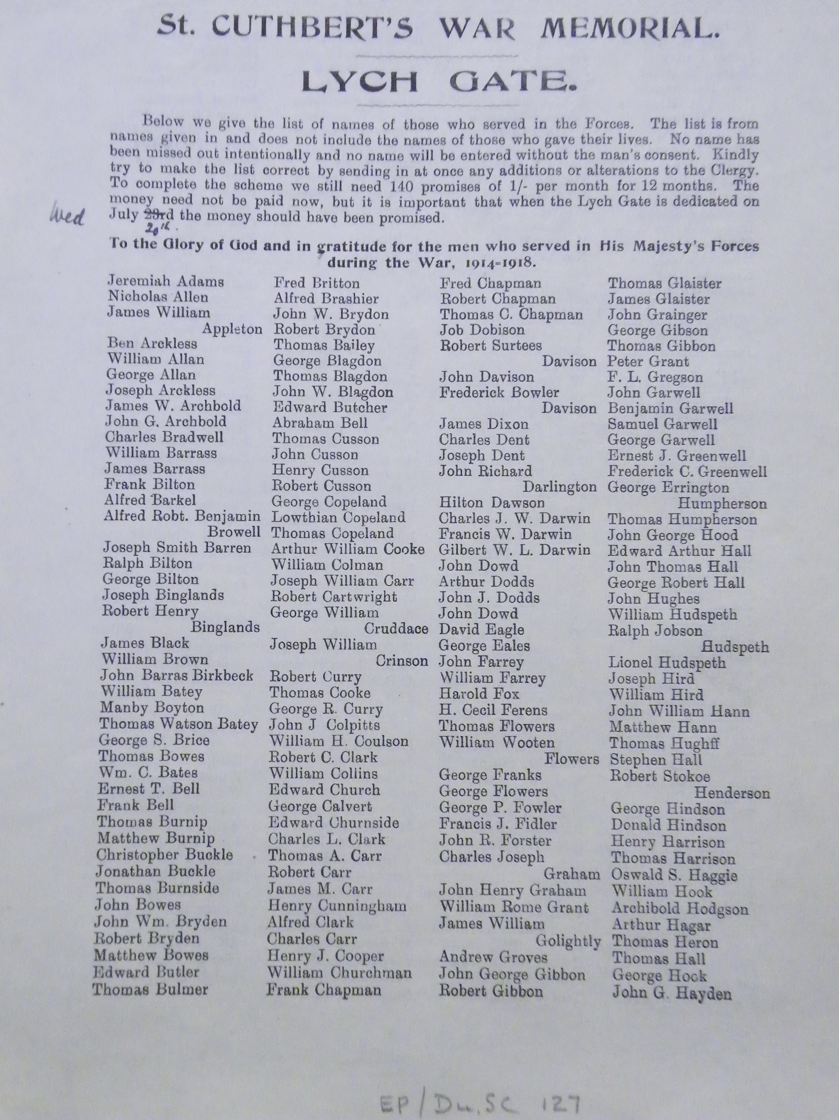

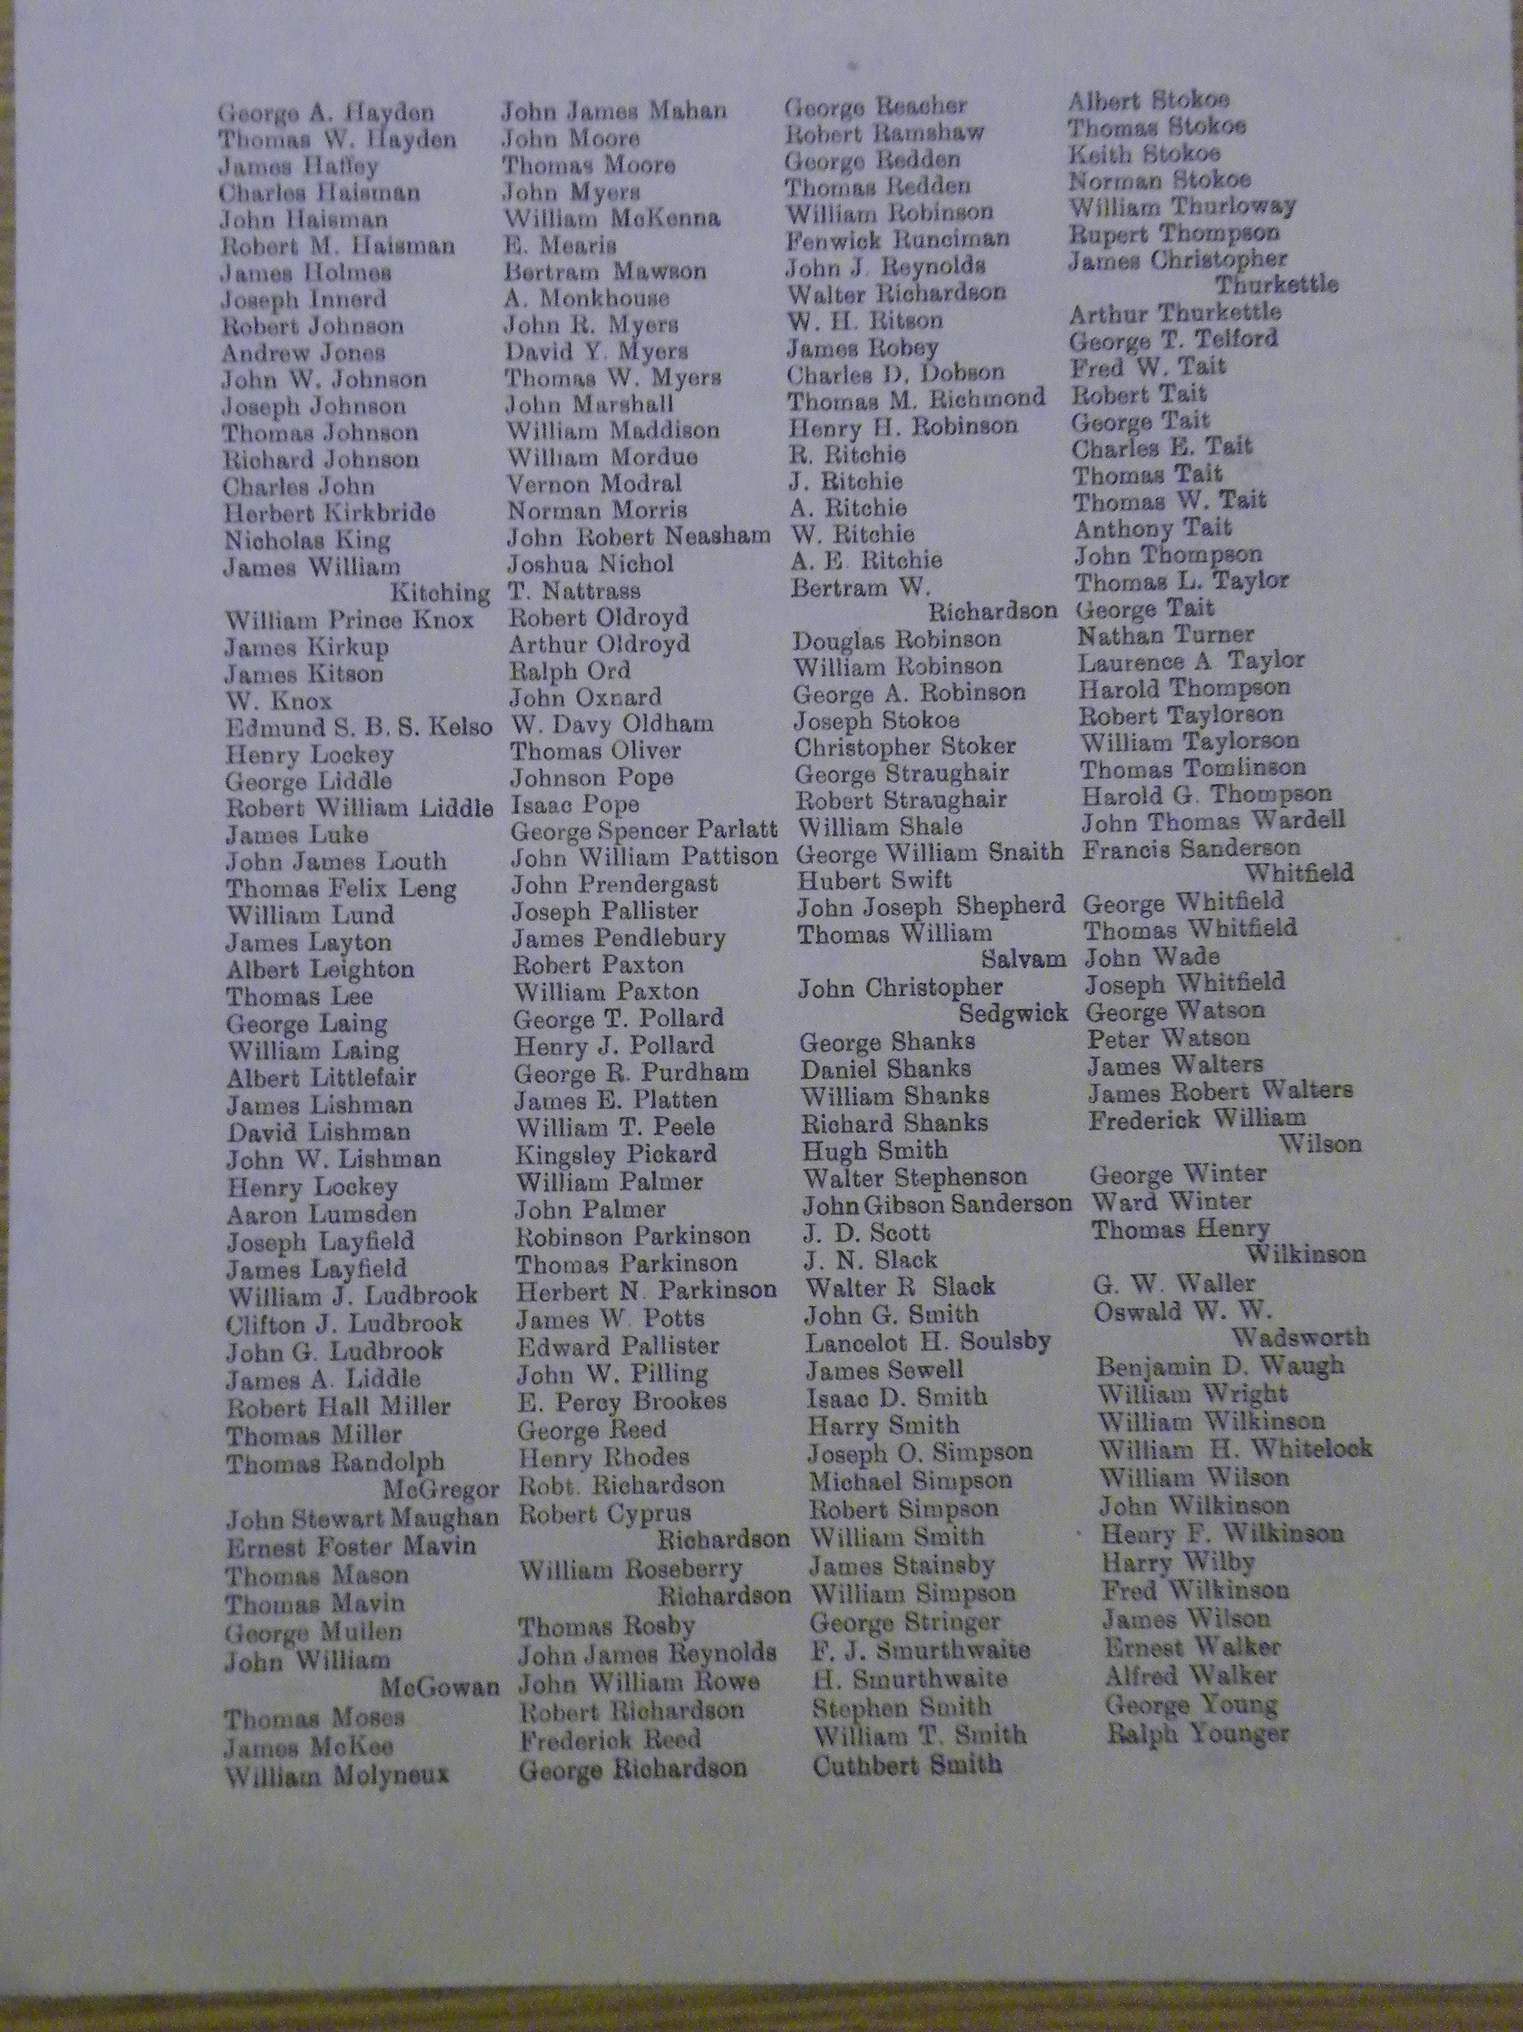
DRO EP/Du.SC.127
Printed list of those who served published by the Clergy of St Cuthbert's Church Durham in 1921

The Lych Gate "bore on one side the names of those who laid down their lives in the war and on the other the names from the parish who served in HM Forces " Newcastle Daily Chronicle 21/07/1921
399 names

The names of those who served was replaced with the names for WW2

St. Cuthbert's War Memorial Lych Gate.
Below we give the list of names of those who served in the Forces. The list is from names given in and does not include the names of those who gave their lives. No name been missed out intentionally and no name will be entered without the man's consent. Kindly try to make the list correct by sending in at once any additions or alterations to the Clergy. To complete the scheme, we still need 140 promises of 1/- per month for 12 months. The money need not be paid now, but it is important that when the Lych Gate is dedicated on July 20th the money should have been promised.

To the Glory of God and in gratitude for the men who served in His Majesty's Forces during the War, 1914-1918.

Jeremiah Adams
Nicholas Allen
James William Appleton
Ben Arckless
William Allan
George Allan
Joseph Arckless
James W. Archbold
John G. Archbold
Charles Bradwell
William Barrass
James Barrass
Frank Bilton
Alfred Barkel
Alfred Robt. Benjamin Browell
Joseph Smith Barren
Ralph Bilton
George Bilton
Joseph Binglands
Robert Henry Binglands
James Black
William Brown
John Barras Birkbeck
William Batey
Manby Boyton
Thomas Watson Batey
George S. Brice
Thomas Bowes
Wm. C. Bates
Ernest T. Bell
Frank Bell
Thomas Burnip
Matthew Burnip
Christopher Buckle
Jonathan Buckle
Thomas Burnside
John Bowes
John Wm. Bryden
Robert Bryden
Matthew Bowes
Edward Butler
Thomas Bulmer
Fred Britton
Alfred Brashier
John W. Brydon
Robert Brydon
Thomas Bailey
George Blagdon
Thomas Blagdon
John W. Blagdon
Edward Butcher
Abraham Bell
Thomas Cusson
John Cusson
Henry Cusson
Robert Cusson
George Copeland
Lowthian Copeland
Thomas Copeland
Arthur William Cooke
William Colman
Joseph William Carr
Robert Cartwright
George William Cruddace
Joseph William Crinson
Robert Curry
Thomas Cooke
George R. Curry
John J. Colpitts
William H. Coulson
Robert C. Clark
William Collins
Edward Church
George Calvert
Edward Churnside
Charles L. Clark
Thomas A. Carr
Robert Carr
James M. Carr
Henry Cunningham
Alfred Clark
Charles Carr
Henry J. Cooper
William Churchman
Frank Chapman
Fred Chapman
Robert Chapman
Thomas C. Chapman
Job Dobison
Robert Surtees Davison
John Davison
Frederick Bowler Davison
James Dixon
Charles Dent
Joseph Dent
John Richard Darlington
Hilton Dawson
Charles J.W. Darwin
Francis W. Darwin
Gilbert W. L. Darwin
John Dowd
Arthur Dodds
John J. Dodds
John Dowd
David Eagle
George Eales
John Farrey
William Farrey
Harold Fox
H. Cecil Ferens
Thomas Flowers
William Wooten Flowers
George Franks
George Flowers
George P. Fowler
Francis J. Fidler
John R. Forster
Charles Joseph Graham
John Henry Graham
William Rome Grant
James William Golightly
Andrew Groves
John George Gibbon
Robert Gibbon
Thomas Glaister
James Glaister
John Grainger
George Gibson
Thomas Gibbon
Peter Grant
F.L. Gregson
John Garwell
Benjamin Garwell
Samuel Garwell
George Garwell
Ernest J. Greenwell
Frederick C. Greenwell
George Errington Humpherson
Thomas Humpherson
John George Hood
Edward Arthur Hall
John Thomas Hall
George Robert Hall
John Hughes
William Hudspeth
Ralph Jobson Hudspeth
Lionel Hudspeth
Joseph Hird
William Hird
John William Hann
Matthew Hann
Thomas Hughff
Stephen Hall
Robert Stokoe Henderson
George Hindson
Donald Hindson
Henry Harrison
Thomas Harrison
Oswald S. Haggie
William Hook
Archibold Hodgson
Arthur Hagar
Thomas Heron
Thomas Hall
George Hock
John G. Hayden
George A. Hayden
Thomas W. Hayden
James Haffey
Charles Haisman
John Haisman
Robert M. Haisman
James Holmes
Joseph Innerd
Robert Johnson
Andrew Jones
John W. Johnson
Joseph Johnson
Thomas Johnson
Richard Johnson
Charles John
Herbert Kirkbride
Nicholas King
James William Kitching
William Prince Knox
James Kirkup
James Kitson
W. Knox
Edmund S.B.S. Kelso
Henry Lockey
George Liddle
Robert William Liddle
James Luke
John James Louth
Thomas felix Leng
William Lund
James Layton
Albert Leighton
Thomas Lee
George Laing
William Laing
Albert Littlefair
James Lishman
David Lishman
John W. Lishman
Henry Lockey
Aaron Lumsden
Joseph Layfield
James Layfield
William J. Ludbrook
Clifton J. Ludbrook
John G. Ludbrook
James A. Liddle
Robert Hall Miller
Thomas Miller
Thomas Randolph McGregor
John Stewart Maughan
Ernest Foster Mavin
Thomas Mason
Thomas Mavin
George Mullen
John William McGowan
Thomas Moses
James McKee
William Molyneux
John James Mahan
John Moore
Thomas Moore
John Myers
William McKenna
E. Mearis
Bertram Mawson
A. Monkhouse
John R. Myers
Donald Y. Myers
John Marshall
William Maddison
William Mordue
Vernon Modral
Norman Morris
John Robert Neasham
Joshua Nichol
T. Nattress
Robert Oldroyd
Arthur Oldroyd
Ralph Ord
John Oxnard
W. Davy Oldham
Thomas Oliver
Johnson Pope
Isaac Pope
George Spencer Parlatt
John William Pattison
John Prendergast
Joseph Pallister
James Pendlebury
Robert Paxton
William Paxton
George T. Pollard
Henry J. Pollard
George R. Purdham
James E. Platten
William T. Peele
Kingsley Pickard
William Palmer
John Palmer
Robinson Parkinson
Thomas Parkinson
Herbert N. Parkinson
James W. Potts
Edward Pallister
John W. Pilling
E. Percy Brookes
George Read
Henry Rhodes
Robt. Richardson
Robert Cyprus Richardson
William Roseberry Richardson
Thomas Rosby
John James Reynolds
John William Rowe
Robert Richardson
Frederick Reed
George Richardson
George Reacher
Robert Ramshaw
George Redden
Thomas Redden
William Robinson
Fenwick Runciman
John J. Reynolds
Walter Richardson
W.H. Ritson
James Robey
Charles D. Dobson
Thomas M. Richmond
Henry H. Robinson
R. Ritchie
J. Ritchie
A. Ritchie
W. Ritchie
A.E. Ritchie
Bertram W. Richardson
Douglas Robinson
William Robinson
George A, Robinson
Joseph Stokoe
Christopher Stoker
George Straughair
Robert Straughair
William Shale
George William Snaith
Hubert Swift
John Joseph Shepherd
Thomas William Salvam
John Christopher Sedgewick
George Shanks
Daniel Shanks
William Shanks
Richard Shanks
Hugh Smith
Walter Stephenson
John Gibson Sanderson
J.D. Scott
J.N. Slack
Walter R. Slack
John G. Smith
Lancelot H. Soulsby
James Sewell
Isaac D. Smith
Harry Smith
Joseph O. Simpson
Michael Simpson
Robert Simpson
William Smith
James Stainsby
William Simpson
George Stringer
F.J. Smurthwaite
H. Smurthwaite
Stephen Smith
William T. Smith
Cuthbert Smith
Albert Stokoe
Thomas Stokoe
Keith Stokoe
Norman Stokoe
William Thurloway
Rupert Thompson
James Christopher Thurkettle
Arthur Thurkettle
George T. Telford
Fred W. Tait
Robert Tait
George Tait
Charles E. Tait
Thomas Tait
Thomas W. Tait
Anthony Tait
John Thompson
Thomas L. Taylor
George Tait
Nathan Turner
Laurence A. Taylor
Harold Thompson
Robert Taylorson
William Taylorson
Thomas Tomlinson
Harold G. Thompson
John Thomas Wardell
Francis Sanderson Whitfield
George Whitfield
Thomas Whitfield
John Wade
Joseph Whitfield
George Watson
Peter Watson
James Walters
James Robert Walters
Frederick William Wilson
George Winter
Ward Winter
Thomas Henry Wilkinson
G.W. Waller
Oswald W.W. Wadsworth
Benjamin D. Waugh
William Wright
William Wilkinson
William H. Whitelock
William Wilson
John Wilkinson
Henry F. Wilkinson
Harry Wilby
Fred Wilkinson
James Wilson
Ernest Walker
Alfred Walker
George Young
Ralph Younger

