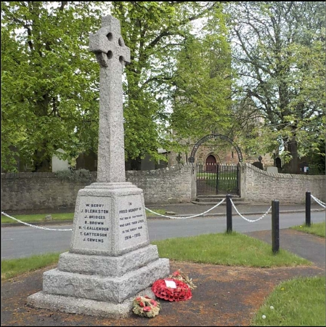
St. Peter’s, Bishopton, County Durham

World Wars One and Two

Casualties

First Edition
Published September 2018

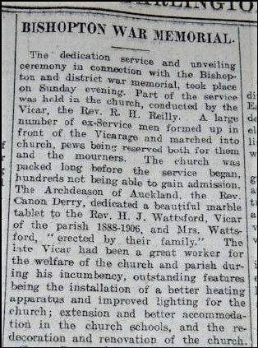
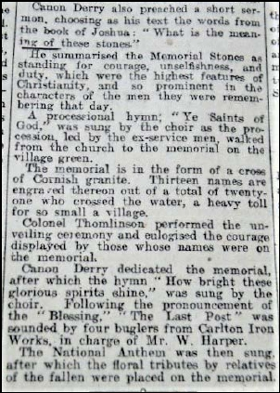
BISHOPTON WAR MEMORIAL

The Memorial was unveiled on the evening of Sunday 12 August 1923 by Col.
Thomlinson and dedicated by Rev. Canon Derry, Archdeacon of Auckland.

On Saturday, 18 August 1923, the Stockton & Darlington Times (North)
published the following report.

(Images courtesy of North East War Memorials Project - www.newmp.org.uk)

-1-

The article records that out of the 21 men “who crossed the water” for the First World
War, 13 had their names engraved on the memorial. In fact there are now 14 names,
the last in the list being J. Cuthbertson whose name is out of alphabetical order and was
presumably added after 1923. A further casualty, Private James Dawson, has been
identified. His name is not inscribed on the Memorial but available records say he was
a resident of “Bishopton, Durham” at the time he enlisted.

In tracing details of the remembered men much information was found online,
including Birth and Death Registration dates, Census Returns, the 1939 Register and UK
Forces Service Records. Websites such as “Ancestry”, “findmypast”, “The Long, Long
Trail” and “Durham at War” were very useful, as also were those of the Commonwealth
War Graves Commission (CWGC), the General Records Office (GRO), local Registry
Offices and the North East War Memorials Project (NEWMP”.

The Memorial inscriptions record only surnames and, with one exception, only one
initial. The absence of Christian names, dates of birth or death and the services and
regiments in which the men fought complicated the task of researching them. Many
WW1 Service Records, an excellent source of information, were destroyed as a result
of bomb damage in WW2, a fact which added to the challenges of research.

Access to Second World War Service Records is limited because it is essentially
restricted to close relatives of the service personnel involved. Generally, the date of
death and place of burial, as held in the CWGC records, is the only information readily
available to the public.

In terms of Census Registration Districts, Bishopton was in Stockton from 1838 to 1895
and then came under Sedgefield from 1896 to 1938 at which point the village
transferred to Durham South Eastern. Extracts from Ordnance Survey maps of
Bishopton Parish and of Bishopton itself can be seen on Pages 27 and 28. The maps
date from the mid 1890’s, the period when many of the men who fought were born.

What follows is a summary of the information retrieved for the 16 men recorded on the
Memorial covering both World Wars, plus two, James Dawson and David Petrie, whose
names are not. It has not been possible to conclusively link the information found for
James W. Cuthbertson to Bishopton nor has it been possible to fully corroborate
information found for James Dawson to Census or other “official” records.

The 14 First World War casualties named on the Memorial should be viewed in the
context of a total population for the Parish of St Peter’s Bishopton in 1911 of 455 souls, of
which 251 were males (of all ages) and 204 females. The breakdown is 349 in
Bishopton, 48 in Newbiggin and 58 in Little Stainton.

-2-

Many of the occupations recorded from Census Returns, for both the casualties and the
members of their families, mention bricklayers, an iron works and a blast furnace.
These men were in all likelihood employed at Carlton Iron Works at Stillington. The
key dates involving brick making and the iron works are:-

1860 manufacture of bricks started at Moor Closes
1865 start of construction of iron works and blast furnaces
1870 works bought by Briggs Bros. North of England Industrial Iron & Coal Co.
Third blast furnace erected. (Operational 1871)
1877 Company changed to Carlton Iron Works Company Limited
1888 40 No. blast furnaces erected
1912 Blacking Mill started in iron works rolling mill building
1920 Dorman Long took over the Iron Works
1922 the Iron Works employed 405 men and boys plus 51 women and girls
1926 formation of North Eastern Iron Refinery Co. Ltd., - start of specialised
refined pig iron
1930 Dorman Long close the works
1931 the village of Carlton Iron Works was renamed Stillington
1935 end of Carlton Iron Company
1937 Slag Works (The Cracker) closed

Details of the 15 First World War casualties, including the uninscribed name of Private
James Dawson, commemorated by the “Bishopton and District War Memorial”, as the
newspaper report describes it, are listed alphabetically in this booklet.

The details of the First World War casualties are followed by those of the two named
Second World War casualties together with David Petrie, who is not named on the
Memorial. He is, however, commemorated in the Churchyard on the gravestone of his
father, Stanley, who was Vicar of St. Peter’s Bishopton from 1945 to 1950.

The badges of the service arms or regiments in which the men served are illustrated on
Page 23 for both wars, as also are the medals awarded in the First World War. The
1914 Star, often called the “Mons Star”, was only awarded for service in France or
Belgium between 5 August 1914 and 22 November 1914. The 1914-15 Star was
awarded for such service between 23 November 1914 and 31 December 1915.

When worn with the British War and Allied Victory Medals the trio of medals was
colloquially referred to as “Pip, Squeak and Wilfred”, named after newspaper cartoon
characters of the time. If a man had no 1914 or 1915 qualifying service he was awarded
only the British War and Allied Victory Medals. When worn as a pair they were
commonly known as “Mutt & Jeff”, named again for cartoon characters of the time.

.

-3-

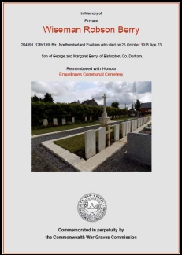
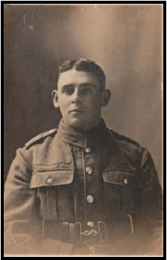
First World War

Private Wiseman Robson BERRY

Service No. 204391
Died 25 October 1918 aged 23
12th/13th Bn. Northumberland Fusiliers
Buried at Erquelinnes Communal Cemetery, Hainaut, Belgium

Wiseman was born in Bishopton, the son of George
Berry, a butcher, and his wife Margaret, the daughter
of Thomas Robson. In 1881, when Margaret and
George married, her father farmed 270 acres at
Stoney Flat Farm. Margaret died aged 37 on 10 April
1900 and George died aged 70 on 25 February 1924.
Their grave is in St Peter’s Churchyard.

Their seventh child, a boy they named Wiseman
Robson, was born in 1893 but he died only 9 months
later on 2 February 1894. In 1895 another son was
born and he was given the same names as his earlier
born brother. He is the man commemorated on the
Memorial.

The 1901 Census shows the family as living at
“Vicarage, Bishopton” with Wiseman having eight
siblings; Mary (19), Thomas (18, a butcher), Charles
(16, an ironmonger), Evelyn (13), John Blench (11,
died 1976 at Wolviston), Elsie (9, died aged 16 on 23
December 1907), Dorothy (4, died aged 21 on 2
November 1918) and Ronald (2). The family also had
a Housemaid, Jane Raine (28).

In 1911 Wiseman was single, and his occupation was
recorded as “engineer”.

Army records show Wiseman died in hospital of
pneumonia as a prisoner of war and was buried by
the Germans. In January 1920 his father received a
payment from the Army of £25-19-3 for money held
by them as part of Wiseman’s effects including a £10
War Gratuity.

-4-

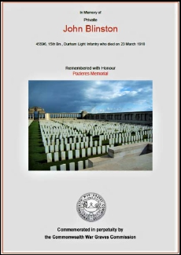
Private John BLINSTON
(Inscribed as “Blenkston” on the Memorial)

Service No. 45596 (Regimental No. 4057)
Died 23 March1918
15th Bn. Durham Light Infantry
Commemorated on the Pozieres Memorial (Panel 69b), Somme, France

No census records have been found of anyone named
“Blenkston” living in Bishopton, nor, in fact,
anywhere in the United Kingdom in 1901 or 1911.
Also, there do not appear to have been any UK births
with that surname since Civil Registration began in
1837. There may, therefore, have been some
misreading of relevant records when the list of names
was being prepared for inscribing.

There is, however, a link to Bishopton in the official
record of “UK, Soldiers Died in the Great War, 1914-
1919”, published by the War Office in 1921, which
includes a John Blinston. It shows he enlisted at
Darlington, giving his birthplace as Ashton-in-
Makerfield, near Wigan, but stating that his residence
at the time was Bishopton.

The 1911 Census shows him living at 4 Alexandra Terrace, Bryn, near Wigan, and that
he was a coal miner aged 28 married in 1906 to Mary Ann (aged 27 – nee Sands) born
at Bryn. Their children were Martha (4 –born 1907 at Bryn), Doris May (2- born 1909 at
Ashton-in-Makerfield) and Edith (born 1911 at Ashton-in-Makerfield). At that time
Blinston was a surname effectively unique to the Wigan and Warrington areas.

As he was a miner it is perhaps not surprising that John moved to the North East but just
why he did so is not known. Perhaps he wished to change his occupation and find
employment in the various ironworks in the area, so he may possibly have worked at
Stillington. Because he moved after 1911 there are no readily searchable records for
him before the date of his enlistment, so his address in Bishopton is unknown.

The 1939 Register shows his wife, Mary Ann, was a widow and a pensioner born in 1883
and living at 313 Bryn Road, Ashton-in-Makerfield. Living with her were daughters
Gladys (born 6 March 1913 employed in an iron foundry) and Emily (born 4 June -
unpaid domestic) along with sons Clifford (born 1917), John (born 1918 employed as a
sorter at UGB Glass Works), Cyril (born 26 October 1920) and Granville (born 23
February 1924 – hand hauler miner), all born at Ashton-in- Makerfield.

-5-

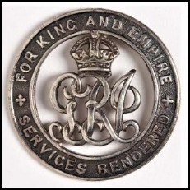
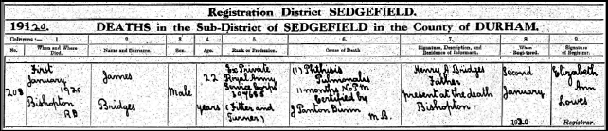
Private James BRIDGES

Service No. M/397685
Died 1 January 1920 aged 22.
Royal Army Service Corps

James was born in 1897 at Carlton Iron Works, which was ecclesiastically renamed
Stillington in 1872.

His father was Henry Albert Bridges, born in Bristol, and in the 1901 Census he was
recorded as a “pig iron worker”. His wife was Ann(e) Elizabeth Jackson (34 – born at
Billingham 1 October 1866) and the family lived at 42 Morrison Street, Carlton Iron
Works. There were six children; Ann (10), Mary (9), Lucy (7), Henry (5), James (3), and
Emma (1), all of whom were born at Carlton Iron Works.

The 1911 Census shows James’ with his family at 83 Parliament Road, Middlesbrough.
His father was aged 46 and gave his occupation as “blast furnace slagger”. The
children recorded were Henry Albert (15 – coppersmith apprentice at a brass
foundry), James (13), Emma (11), and Beatrice (8).

Henry, as head of the family, stated on the Census Return that there had been eight
children born alive and of whom six were still living.

James enlisted on 10 December 1915. He was
discharged on 17 June 1919 as no longer medically fit
but was awarded the Silver War Badge. This was
issued in the United Kingdom and the British Empire
to service personnel honourably discharged due to
wounds or, as in James’ case, to sickness.

James died of tuberculosis in Bishopton on 1 January
1920, aged 22 with his father present, as his death
certificate, which describes him as a “Fitter and
Turner”, shows.

-6-

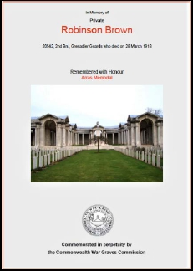
Sadly, despite exhaustive searches of local burial records and Evening Gazette death
notices, James’ grave has not been located.

James’ mother, Anne E. Bridges was recorded in the 1939 Register as living at the High
Street, Bishopton and was described as a “retail cycle accessory – petrol dealer”.

Private Robinson BROWN

Service No. 20542
Died 28 March 1918
2nd Bn. Grenadier Guards
Commemorated at Arras Memorial, Pas de Calais, France
- killed in action in Flanders

Robinson was born at Wolviston in 1878, the son of Robinson and his wife Mary Jane.

In the Census for 1881 the family were still in
Wolviston and Robinson had five siblings; three
brothers and two sisters. In 1901 his marriage to
Frances Drew, born 1879 at Port Clarence, was
registered in Gateshead and in the Census of that
year they were living at 58 Wylam Street, Gateshead.

By the time of the 1911 Census they had been married
for 11 years but had no children and Robinson was
employed as a bricklayer’s labourer. They were
living at Tinkler’s Terrace in Bishopton where they
had two boarders; Ralph Richardson (52 – cartman)
and Thomas Agar (65- farm labourer).

Robinson enlisted at Stockton-on-Tees and Army Records show that his widow,
Frances, eventually received a Gratuity for him of £15-10-00 on 19 November 1919.
From the 1939 Register, by which time she was aged 60, it appears that Frances was the
housekeeper at Black Farm, Portrack Lane, Stockton, which was about three miles from
Port Clarence where she had been born.

-7-

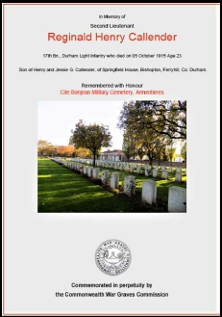
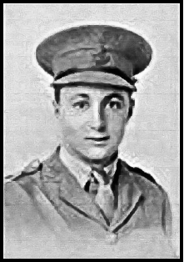
Second Lieutenant Reginald Henry CALLENDER

Died 5 October 1915 aged 23 as a result of a training accident.
17th Bn. Durham Light Infantry
Buried at Cite Bonjean Military Cemetery, Armentieres, France

Reginald was the son of Henry and Jessie Callender of Springfield House, Bishopton,
born there on 31 August 1892. His parents are buried in St Peter’s Churchyard. He is
the only man with two initials on the Memorial – perhaps because he was an officer.

At the time of the 1911 Census his father, a butcher
and cattle dealer, was aged 45 and his mother was 43.
Reginald had 8 siblings; 3 sisters and 5 brothers.

He won a scholarship to Stockton Grammar School,
which he left in 1911. He graduated in history at St.
John’s College, Cambridge in 1914 and then took up a
teaching post at Bromley Boys School in Kent.

Reginald was commissioned as a 2nd Lieutenant on 4
December 1914, joining the 17th Bn. DLI and going to
France on 18 August 1915. On 5 October 1915, after
his men had practiced bomb throwing using bully
beef tins, Reginald was demonstrating a hand
grenade to them when it exploded in his hand, killing
both him and Pte Renforth and injuring several others.

Along with other club members, he is remembered on
a memorial plaque commissioned by Stockton Cricket
Club. The programme for the plaque’s unveiling on
30 June 1920 included the following memoir of him:

“2nd Lieut. R. Callender
After being at Cadet School at Bedford from November
1914 was gazetted in the 17th DLI. He went out to France
in August 1915 and was killed on October 5th of the
same year while lecturing to his men, by the accidental
explosion of a hand-grenade. In addition to being a
very fine cricketer he was a brilliant footballer having
represented Cambridge University in the Inter ‘Varsity
Match; the Corinthians; and Stockton in an Amateur Cup
Final”.

(Courtesy of North East War Memorials Project - www.newmp.org.uk)

-8-

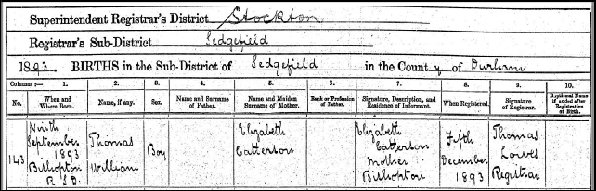
Sergeant Thomas William CATTERSON

Service No. 323054
Died 23 November1918 at Stillington from influenza & pneumonia aged 25.
Durham Light Infantry
Buried in St Peter’s Churchyard

Thomas was born 9 September 1893 at Bishopton. His Birth Certificate shows that his
mother was Elizabeth Catterson, but no details of the father were provided when his
birth was registered on 5 December 1893.

The 1901 Census records that Thomas was aged 7 and living with his grandfather
William Catterson (aged 56 – a tailor). By the 1911 Census, Thomas was a farm labourer
and ploughman living at Gilly Flat Farm, Bishopton. The head of the household at Gilly
Flat was Sarah J. Robson then aged 55 (born in Pickering) living with her daughter,
Florence J. Robson (24 – born in Bishopton, a dairy maid) and Sarah’s sister Eliza Frank
(60 – born in Pickering).

Interestingly, at the time of the 1901 Census a Jane Catterson (aged 15) was shown as a
“nurse domestic” in the Callender household at Springfield House. Jane, as the sister
of his mother, Elizabeth, was Thomas’s aunt, albeit a very young one.

Thomas enlisted at Darlington on 24 July 1915 into the 5th Bn. Durham Light Infantry and
was posted to France in April 1917. In the October of that year Army Medical Records
show he was admitted to hospital after being wounded in an “attack… in the Nieuport
Sector”.
He was suffering from Blepharitis, a severe eye injury resulting from exposure to
Mustard Gas. Another injury was recorded but the Medical Officer’s hand written note
it is not clear enough to decipher, although it too is perhaps related to gas exposure.
Thomas was returned to England in December 1917.

-9-

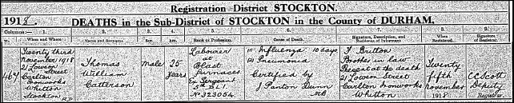
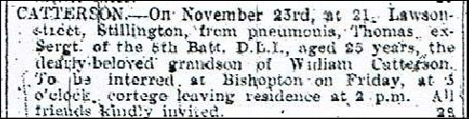
In July 1918 a Medical Board decided that Thomas was not disabled by his injuries, but
that he should be transferred to the Class W Reserve, created in 1916 for soldiers
whose services were thought to be more valuable to the country in civil rather than
military employment. Men in the Class W Reserve were not paid by the Army so, in
view of his experience as a blast furnace worker, Thomas was sent to work on
munitions with Guest, Keen and Nettlefold at their Dowlais Works in Merthyr Tydfil.

It is not known how long Thomas worked at Dowlais but at some point he returned to
live with Annie Britton (nee Catterson) and her family, at 21 Lowson Street, Stillington.
He died there on Saturday 23 November 1918; the cause of his death being recorded as
“(1) Influenza 10 days; (2) Pneumonia”, as seen on the copy of the certificate below.
1918 was the year of the “Spanish Flu” pandemic and Thomas was perhaps more at risk
if he had respiratory problems as a result of the gas attack he had experienced in 1917.

Annie, as the sister of Thomas’ mother, Elizabeth Catterson, was actually Thomas’ aunt
but in her letters to the Army to notify them of Thomas’ death she referred to him as her
“brother”. Similarly, her husband, Fred, who was with Thomas when he died, is
described on the death certificate as Thomas’ “Brother in Law”.

This notice of Thomas’ death was published in the Evening Gazette and he was buried
at St Peter’s, Bishopton at 3-00pm on Friday 29 November 1918. The grave has not yet
been located so no record of its headstone inscription is currently available

.Army Service Records show that Thomas had been “confirmed in rank” as a Sergeant
in July 1917 and that his grandfather, William, received a gratuity of £20 for him, which
was authorised on 21 October 1920.

- 10 -

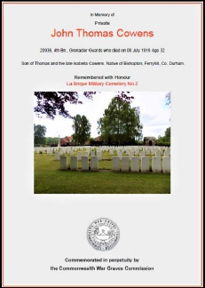
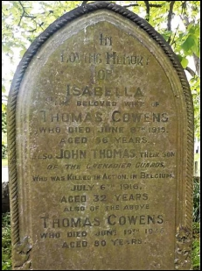
Private John Thomas COWENS

Service No. 20938
Died 6 July 1916 aged 32
4th Bn. Grenadier Guards
Buried at La Brique Military Cemetery No. 2, Belgium

John Thomas’ birth in Jarrow was registered in 1884
but by 1901 the family had moved to Bishopton, when
the Census shows John Thomas was a bricklayer aged
17. In 1911 he was still a bricklayer but employed at
an iron works and was single.

His father, Thomas (56) born in Lesbury,
Northumberland, was a police pensioner and grocer.
He had previously been a police constable in 1881 in
Birtley, then in 1891 at Southwick (Sunderland). John
Thomas’s mother was Isabella (36) nee Gibson, born
at Tanfield, County Durham. His siblings were Lily
(born 1887 - a teacher) and Nora May (born 1891 –
died 1974 - an assistant teacher).

Only two official records of his war service survive:

His entry in “UK Soldiers Died in the Great War,
1914-1919” published by the War Office in 1921
shows that he enlisted in West Hartlepool

His Medal Award Index Card shows he was posted
to France on 15 August 1915 and was therefore
awarded the 1914-1915 Star as well as the British
War Medal 1914-1918 and the Allied Victory
Medal.

In 1920, Thomas’ sister, Lily, who was then living at 16
Newton Avenue, Stockon-on-Tees, chose the wording
“Rest in Peace” for his CWGC headstone at La Brique
Military Cemetery in Belgium.

Thomas is also remembered on the headstone of his parents’ grave at St Peter’s,
Bishopton.

- 11 -

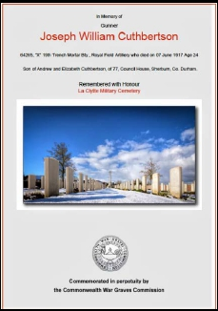
Gunner Joseph William CUTHBERTSON

Service No 64265
Died on 7 June 1917 aged 24 of asphyxia
“X” 19th Trench Mortar Battery Royal Field Artillery
Buried at La Clytte Military Cemetery, Belgium

There appear to be no records of anyone with the
surname Cuthbertson living in Bishopton in the
Census Returns for 1891, 1901 or 1911. In that period
the highest incidence of the surname in England was
in County Durham so it has been very difficult to
identify with certainty just who “J Cuthbertson” was.
However, despite there being no directly traceable
and obvious connection to Bishopton for him, Joseph
seems the most likely person to have been named on
the Memorial.

Joseph was born in 1894, the son of Andrew and
Elizabeth Cuthbertson of 77 Council House, Sherburn,
County Durham. It would seem his name was added
after 1923 as it is out of alphabetical order.

He is also commemorated on the war Memorial at St Laurence Church, Pittington,
County Durham. There is no record of him ever having married.

In the 1901 Census his father, Andrew (40), was a “coal mine hewer” married to
Elizabeth (44). Their children were; John (14) – “bank boy – mine”, Catherine (12) –
“scholar”, Joseph William (7) – “scholar”, Watson Marshall (1). The family was resident
at Whitwell Wood Row, Whitwell House.

By the time of the 1911 Census Joseph described himself as “colliery labourer at bank –
shoving tubs into cage”. His then address was 3 South Street, Sherburn, Durham.

His father, Andrew, chose the inscription on his headstone – “Greater love has no man
than this.” He served initially in the Royal Horse Artillery, and his only overseas service
was in France, after being posted there on 20th July 1915.

- 12 -

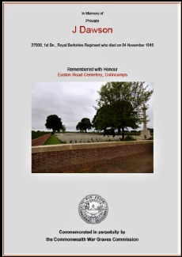
Private James DAWSON

Service No. 27008 (Formerly 140527 of the Royal Field Artillery)
Died 4 November 1916
1st Bn Princess Charlotte of Wales (Royal Berkshire) Regiment
Commemorated at the Euston Road Cemetery, Colincamps, France

The only connection with Bishopton that can be
traced for James Dawson is his entry in “UK, Soldiers
Died in the Great War, 1914-1919”, published by the
War Office in 1921, which shows he enlisted at
Newcastle-upon-Tyne, stating “Bishopton, Durham” as
his place of residence. There are no Census records
available to corroborate this record but available
information traced for a James Dawson born in Hull
and of appropriate age can be summarised as follows.

The 1891 Census shows that he was born in 1883 in
Sculcoates, Hull. His father was William, a tailor born
in 1843 and his mother was Elizabeth E. Dawson,
born in 1845. He was at that time living at Spencer
Street, Hull with his parents and siblings, William
(born 1867), Mary (born 1873), Joshua (born 1875),
Minnie (born 1881) and Harry (born 1881). James himself, (age 8) was recorded as a
“scholar”.

By 1901 James was boarding at 41 Rose Street, Sculcoates, East Riding and his
occupation was given as fish merchant. In the 1911 Census Return shows James as
being married and living at 74 Princes Road, Sculcoates, Hull with his wife Ethel (aged
27), his son George Lawrence (2) and daughter Enid Millicent (0). James’s occupation
was now given as a fish dealer. He employed a domestic servant (Florence Spruit aged
14 who lived with the family.)

- 13 -

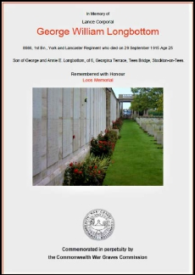
Lance Corporal George William LONGBOTTOM

Service No. 8986
Died 29 September 1915 aged 25
1st Bn. York & Lancaster Regiment
Commemorated on the Loos Memorial, Pas de Calais, France

George was born in Escrick, Yorkshire in 1890, the
eldest son of George and Annie Elizabeth
Longbottom. A year later the 1891 Census records
the family living at Newthorpe, Tadcaster where his
father was a farm labourer.

The 1901 Census shows him living with his parents at
the Blue Bell Inn, Thorpe Audlin, near Hemsworth
(West Riding). His father was aged 43 and gave his
occupation as “horseman on a farm”. His siblings
were Mary (12), Alfred (9), Lilian (1) as well as his
younger brother Leonard (3) – whose own later war
service is described below.

The 1911 Census records the family as living at 4
Georgina Terrace, Tees Bridge, Stockton, which was
in the Bowesfield area adjoining the former Tees Bridge Iron Works.

George is not listed in the 1911 Census Return because by then he was in the Regular
Army, having enlisted on 28th November 1907 in the 1st Bn York & Lancaster Regiment
at Richmond. He was posted to France on 9 September 1914 and was promoted to
Lance Corporal on 13 November 1914.

On 26 September 1914, just over two weeks after going to France, he received a bullet
wound in his right shoulder and was transferred back to England about a week later.
In May 1915 he returned to his unit in France but was later reported as “Missing
believed K in A” on 29 September 1915 during the Battle of Loos. As well as the
commemorative inscription on the Loos Memorial, George is remembered on the
gravestone of his brother, Leonard, at St. Peter’s, Bishopton. Their father and mother,
who died in 1933 and 1939 respectively, are also named on the gravestone.

As a “Regular” in the Army, George went to France with the British Expeditionary
Force soon after war was declared and was therefore one of the “Old Contemptibles”.
He was thus entitled to the award of a 1914 Star, often referred to as the “Mons Star”.
This medal was awarded only to men like George who had served in France or
Belgium in the period between 5 August and 22 November 1914.

- 14 -

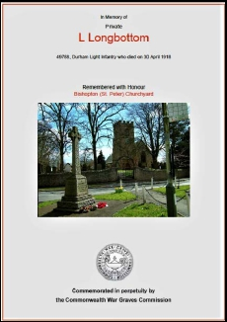
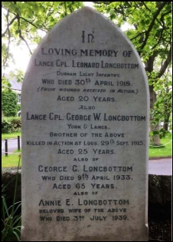
Lance Corporal Leonard LONGBOTTOM

Service No. 49788
Died 30 April 1918 – aged 20
1/6th Bn. Durham Light Infantry
Buried at St Peter’s Churchyard

Leonard was born on 21 September 1897 at
Wentbridge, North Yorkshire and baptised at
Darrington. In the 1911 Census, when the family was
living at 4, Georgina Terrace in Stockton, his siblings
still at home were Lilian May (11), Arthur (9), Clifford
(7) and Thomas E. (5). Leonard’s occupation was
recorded as “cowmans helper”

On 5 October 1914, two weeks after his 17th birthday
and two months after war was declared, Leonard
enlisted in the Territorial Force with 4 years’ service
in the UK. At this time his home address was 3 Adam
Street, Stockon-on-Tees.

His initial Service Number was 2826 in the 5th Bn.
Durham Light Infantry. On 6 February 1918 he was
posted to France but was wounded in action only
seven weeks later on 30 March.

His Medical Case Sheet shows he was admitted to the
3rd Western General Hospital, Cardiff on 25th April
1918 with “severe flesh wounds to the right thigh and
left leg – very septic and suffering from septicaemia”.
He died there on 30 April 1918 but was buried in the
Churchyard at St. Peter’s Bishopton. His brother,
George, and their father and mother, are all
remembered on his gravestone.

Despite being recorded on his Medical Case Sheet as
“LCpl, 6th DLI” when admitted to hospital, Leonard
had previously had numerous and somewhat
confusing changes of rank. He was first promoted to
“Unpaid L/Cpl” on 19 December 1914 and then to “(Act) Cpl” on 27 February1915, but
on 19 October 1916 he “Reverted at own request” to “Pte”.

- 15 -

On 17 May 1917 he was “Appointed (Paid) A/Cpl” but seems to have been once again a
“Pte” when posted to France on 6 February 1918. Other than on the Medical Case
Sheet noted above, his Army Records after his posting to France, and the CWGC
records after his death, all refer to him as a Private. It is possible that he may have
been promoted again “in the field” but there was not time to officially record that
before he was wounded and returned to England.

This confusion about Leonard’s final rank can perhaps be put down to “the fog of war”
or, perhaps more appropriately, “the fog of wartime army bureaucracy”. His
gravestone, however, clearly shows he was known to and remembered by his family as
a Lance Corporal.

Two items in Leonard’s Service Records confirm very clearly that his family were
Bishopton residents by then.

Army Form B. 104-126 dated 31 August 1918 sent to his father from York Infantry
Records when his effects were returned - “1. cigarettes, wallet, letters, photos, cards,
steel mirror in case, purse, disc, pocket book, cap badge, testament, set of False
Teeth, 4 – ½d. stamps” and “2. Muffler. letter”.

A “Statement of Names & Addresses of Relatives Still Living”, dated 20 October 1919,
completed by the family and countersigned by Rev. R.H. Reilly, Vicar of Bishopton.

This showed his brother, Alfred, as living at Guisborough, whilst Arthur, Clifford,
Thomas Edward and Lillian Mary were all still in Bishopton. Mary was by then married
and known as Mary Bellamy, living at 75 Pearson Street, Stockton-on-Tees.

Private James Matthew MELLANBY

Service No. 20426
Died 10 July 1916 aged 26
3rd Bn. Grenadier Guards
Buried at Essex Farm Cemetery, West-Vlaanderen, Belgium

James was born early in 1890, the son of Thomas Malthouse Mellanby and his wife
Susannah. Thomas was born in Stockton and Susannah, generally known as Susan, in
Long Newton. Thomas, died on 8 February 1916 but Susan lived until 1942 and died on
24 September that year. Their grave is in St Peter’s Churchyard.

The 1891 Census Return confirms that the family was living at the Stillington Ox in
Bishopton where Thomas was the “innkeeper”. It was still their home in 1901 but
Thomas had by then changed the description of his occupation to “joiner & innkeeper”.

- 16 -

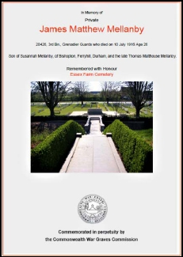
By 1911, with James aged 21, the Census shows he
was living with the family at the Talbot Hotel and gave
his occupation as “general labourer”. His father,
Thomas (55), now described himself as “publican &
joiner” whilst his mother Susan (54) and his sisters
Florence Mary (23) and Lucy Annie (17) were
recorded as “assisting in business”. His brothers
John William (19 – joiner’s apprentice) and Thomas
Henry (14 – school) were there too.

Very little is known about James’ time in the Army
because his main Service Records cannot be found
and must presumably be among those destroyed in
storage by bombing during WW2.

Two items do, however, survive;

His Medal Index Card, showing that he was posthumously awarded the British War
and Allied Victory medals,
His entry in the Register of Soldiers’ Effects, showing that his mother, Susan,
received a Gratuity of £7-0-0 in June 1919.

The cemetery where James is buried was attached to Essex Farm Advance Dressing
Station in the Ypres Salient, beside the Kanal van leper about a mile and a half north of
Ypres itself. Lieutenant Colonel John McCrae, the Canadian surgeon author of “In
Flanders Fields” wrote the poem whilst stationed there in May 1915.

In July 1916 James’ Battalion was in trenches in the Salient near a canal and under
artillery bombardment, so Essex Farm is possibly the place of his death as well as of
his burial and remembrance. Notice of James’ death was published in the Evening
Gazette of 19 July 1916 which recorded that he had been “Killed in Action”.

James’ brother, Thomas Henry, enlisted with the 5th Battalion Durham Light Infantry on
26 July 1915. His Army Records state that he was by trade a “turner & fitter” and so on
1 February 1916 he was transferred on “temporary release” to munition work at Messrs.
Doxford & Sons Ltd. at the Pallion Engineering Works, Sunderland

On 21 April 1916, however, Thomas fractured his tibia and fibula playing football at
Bishopton. He was assessed as being no longer medically fit for War Service by an
Army Medical Board on 11 September 1916 and was discharged on 25 September 1916
with a Half Pay pension for six months. He was eligible for a Silver War Badge but his
Medal Index card shows that he did not apply for it.

- 17 -

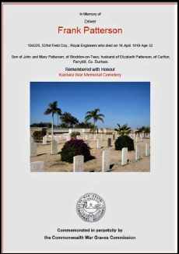
He appears in the 1920 Electoral Register for Bishopton and he married Elizabeth
Freeman of Stockton in June 1930. There seems to be no record of them in the 1939
Register and they may have emigrated, or possibly moved to Scotland where the
Register, which covered only England and Wales, was not taken. In either case,
Thomas himself must have returned because there is a death record for him registered
in Teesside North District in 1971. No death record for Elizabeth has been found.

The 1939 Register shows Susan was still at the Talbot Hotel, assisted by her eldest
daughter, Florence. It also shows that James’ sister, Lucy, had married Percy Levett,
who had been recorded in the 1911 Census as a “journeyman butcher” living in the
Callender household, and they were keepers of the Wheatsheaf Hotel in Ferryhill. His
brother, John, and his wife, Elizabeth, were keepers of the Ship Inn in Stokesley.

Beer, it seems, must have run in the Mellanby children’s blood, unsurprisingly perhaps
given that the middle name of their late father was “Malthouse”.

Driver Frank PATTERSON

Service No. 104225
Died 18 April 1919 aged 32
521st Field Coy. Royal Engineers
Commemorated at the Kantara War Memorial Cemetery, Egypt

Frank was born in 1887 at Long Newton, the son of John and Mary Patterson. John was
born at Bishopton and Mary at Long Newton.

The 1901 Census shows Frank’s family living at Long
Chimney House, Newbiggin where his father was a
farmer aged 39 and his mother was 41. Frank (13),
had three sisters, Mary (16), Annie (15) and Meggy
(12).

By 1911 Frank was employed by the Applegarth
family as a “horseman” at Old Acres Hall in the parish
of Butterwick & Old Acres. The other members of his
family lived at Woodbine Cottage Farm, Newbiggin

In January 1916 Frank married Elizabeth Powell, who
was born in Carlton on 18 April 1892. They had one
child, Doreen Margaret, born 4 July 1918.

- 18 -

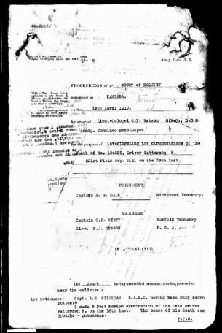
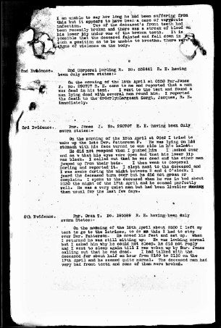
The 1939 Register shows that Frank’s widow, Elizabeth, was still living at Woodbine
Cottage, Newbiggin, where Frank’s family had been living in 1911, as the Census for
that year had recorded. Her daughter, Doreen, and her brother, Henry, both single,
were also living there with her at that time.

Frank enlisted in the 234th Company of the Royal Engineers on a Short Service basis
“For The Duration of the War” on 9 August 1915. He gave his occupation as “Farm
Labourer” and his address as “Whinney Hill, Stockton-on-Tees”. In 1916 he served in
Mesopotamia and in 1918 was posted to Egypt, having spent the intervening period in
England.

On the morning of 18 April 1919 he was found dead in his tent at the 44th British
Stationary Hospital at Kantara in Egypt. As shown below in the extract of its
proceedings, a Court of Enquiry was held the following day. The Court recorded the
formal opinion that Frank had “died of natural causes (acute bronco-pneumonia) and no
blame attaches to anyone”.

(Courtesy of the UK National Archives via Ancestry.com)

After the Court of Enquiry had concluded, Frank was buried in Kantara Military
Cemetery on the same day that it was held. His father was notified of Frank’s death by
telegram on 22 April 1919 and then more fully by an official letter dated 26 May 1919.

- 19 -

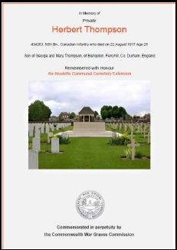
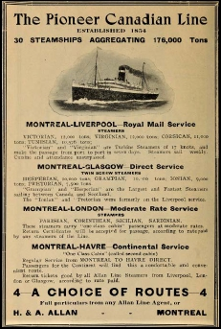
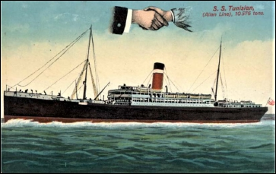
Private Herbert THOMPSON

Service No. 434263
Died 22 August 1917 aged 25
50th Bn. Canadian Infantry (Alberta Regiment)
Buried at the Aix-Noulette Communal Cemetery Extension, Pas de Calais, France

Herbert was born in Bishopton on 18 June 1892, the
son of George and his wife Mary.

The 1901 Census Return shows his father was a
bricklayer, born in Carlton in 1838, and that his
mother (nee Seaton) was born in Sadberge in 1860.
He had five siblings: Annie (24), Alfred (18 –
bricklayer), William Wardell (14), Elenor (16) and
Daisy (12).

In 1911 the family was still in Bishopton and Herbert,
by then 18, was a labourer.

In 1913 Herbert went to Canada, leaving Liverpool on
the S.S. Tunisian and arriving in Quebec on 17 April.
On the passenger list he gave his age as 21 and his
full name as “Geo Herbert Thompson”

- 20 -

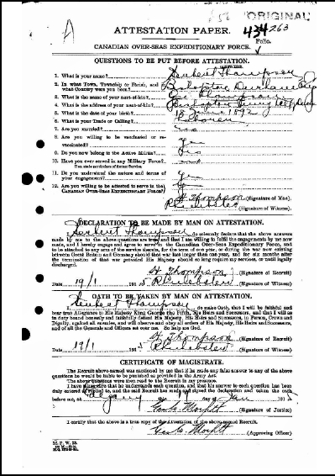
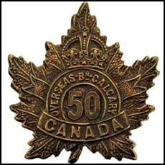
He gave his occupation in England as “blast furnace”, his intended occupation in
Canada as “farming” and his destination as Calgary, Alberta. His religion was given as
“Protestant”.

In Calgary on 19 January 1915, Herbert enlisted in the Canadian Over-Seas
Expeditionary Force. His Attestation Paper gives his place and date of birth as
Bishopton, Durham on 18 June 1892 and his occupation or calling as “labourer”. The
name of his next of kin was given as Geo. Thompson (i.e. His father George).

Herbert joined the 50th
Battalion (Alberta Regiment)
of the Expeditionary Force
and on 27 October 1915 sailed
with them for France. The
Battalion became part of the
10th Brigade of the 4th
Canadian Division, serving in
France and Belgium. By the
start of 1917, the year of
Herbert’s death, the Canadian
Divisions were entrenched
along the Ypres Salient and
became heavily involved in
the battle for Vimy Ridge later
that year.

Apart from such general but still relevant information about the actions of the Canadian
forces of which he was a part, no detailed records of Herbert’s war service have been
found. Only the date of his death and the place of his burial are known.

For his grave headstone Herbert’s mother chose the inscription “He did his duty”.

- 21 -

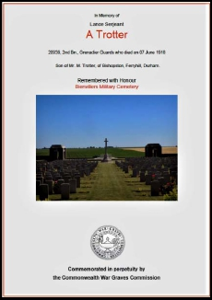
Lance Serjeant Anthony TROTTER

Service No. 20939
Died 7 June 1918
2nd Bn. Grenadier Guards
Buried at Bienvillers Military Cemetery, Pas de Calais, France

Born in Bishopton in the last quarter of 1880, Anthony
was the son of Matthew and his wife Mary.

The 1881 Census records their household as his father
(37), his mother (33) and siblings Ralph (14), William
(8), Mary (6) Henry (5), George (3) and Anthony an
infant with no age given.

By the 1891 Census Ralph had left the household but
Francis (8), Thomas (6), Eliza (3), and Alfred (7
months) had arrived as had a lodger, John Syson (48).
An additional child, Jane (13), was recorded in 1901
but there is no record then of either Thomas or Eliza.
Records suggest, however, that Eliza may have died in
1892.

In the 1911 Census Anthony was aged 30, living with his father Matthew and working as
a labourer at an ironworks. His mother Mary had died before then – records suggest
in 1910. There were four other siblings living in the household; Francis (28), Thomas
(26), Jane (23), Alfred (20) plus Freda Mary (4 – Matthew’s grandchild). Overall
Anthony had 10 siblings but it is not clear who among them may have died by 1911 or
were enumerated in other households.

In the 1939 Register, Anthony’s brother, Thomas, is shown living in High Street,
Bishopton with his wife, Edith, and daughters Mary (born 1923) and Dorothy (born
1925).

Beyond the place of his burial and the date of his death, the records of Anthony’s war
service, as with other men commemorated on the Memorial, are almost non-existent.
His Medal Index card shows that he went to France on 15 October 1915 and was
therefore awarded a 1914-1915 Star in addition to the War Service and Allied Victory
medals. It also records his promotion to Corporal, or Lance Serjeant as known in
Guards Regiments.

- 22 -

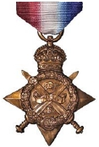
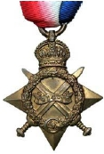
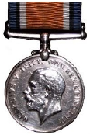
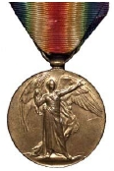
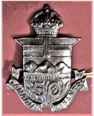
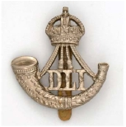
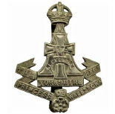
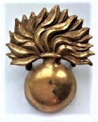
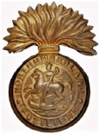
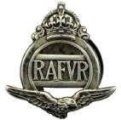
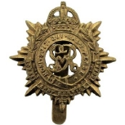
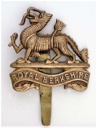
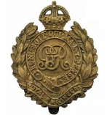
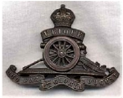
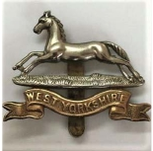
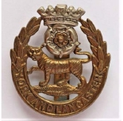
First World War Medals
Service Arm and Regimental Badges For World Wars One and Two

for World Wars One and Two
1914 “Mons” Star 1914-15 Star British War Medal 1914-18 Allied Victory Medal

Canadian Overseas
Expeditionary Force Durham Light Infantry
(Yorkshire Regiment) Grenadier Guards
Green Howards

Northumberland Fusiliers Royal Air Force
Volunteer Reserve Royal Army Service Corps
Princess Charlotte of Wales
(Royal Berkshire)

Royal Engineers Royal Field Artillery West Yorkshire
(Prince of Wales Own) York & Lancaster

- 23 -

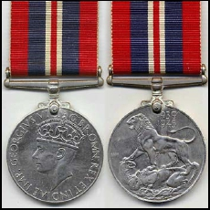
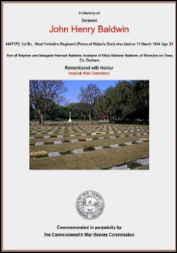
Second World War

As noted in the introduction, there is very little
information publicly available about Service
Personnel in the World War Two and this extends to
the award of individual medals. However, it can
reasonably be assumed that the men named on the
Memorial would have been entitled, albeit
posthumously, to receive the War Medal 1939-45.

This was awarded to all forces personnel serving full
time for 28 days or more between 3 September 1939
and 2 September 1945.

Serjeant John Henry BALDWIN

Service No. 4447172
Died 11 March 1944 aged 33
1st Bn. West Yorkshire Regiment (Prince of Wales Own)
Buried at Imphal War Cemetery, India

John was born on 28 August 1910 and in the 1911
Census his father, Stephen, was recorded age 36,
born in Hetton-le-Hole and married for 11 years,
working as a labourer in the coke ovens. His mother,
Hannah, was 31 and born in Middlesbrough. Their
children were William Stephen (11 – born at
Middlesbrough), Anne Elizabeth (3 – born at
Bishopton), Hannah Mary (2 – born in Spennymoor)
and John Henry himself (infant – born in Bishopton).

In the third quarter of 1939 John married Eliza
Webster Phillips, born 4 June 1918. Later that year,
when the 1939 Register was taken on 29 September
they were living at 3 Chapel Row, Bishopton. Eliza’s
sister, Ivy, also lived with them. Their son, John H
Baldwin, was born in the last quarter of 1940.

- 24 -

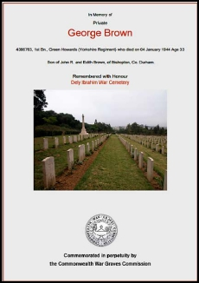
The 1939 Register was designed to record the civilian population and did not include
service personnel unless they happened to be at home on the date the information was
collected. John was already enlisted in the Durham Light Infantry but by chance was
home on leave, as the Register clearly notes.

It is not known when or why John was posted to the 1st Bn. West Yorkshire Regiment
(Prince of Wales Own), the regiment with which he was serving when he died.

Private George BROWN

Service No. 4386763
Died 4 January 1944 aged 33
1st Bn. Green Howards (Yorkshire Regiment)
Buried at Dely Ibrahim War Cemetery, Algeria

George was born circa 1911, the son of John R and Edith Brown of 1 Chapel Row,
Bishopton who had married in 1908.

The 1911 Census shows his father as being 36 years
old, born at Wolviston and he was employed as an
“oiler blowing engine” at an iron works. Edith was
aged 27 and born at Shotton Colliery. They already
had a two year old son named Herbert but, for some
reason unknown, George was not included on the
Census Return.

In the 1939 Register John was a builder’s labourer and
gave his date of birth as 17 November 1875 whilst
Edith gave hers as 6 June 1883. There is no mention of
Herbert or George. This could be because Herbert
had his own home and George had already enlisted in
the Army.

Again, only George’s date of death and burial place can be gleaned from official
records. In Commonwealth War Grave Commission records his father’s name is given
as John R. but in all the Bishopton related records the “R” is not used. However, people
were known in the past to be quite loose about using their names and ages precisely in
records like censuses.

- 25 -

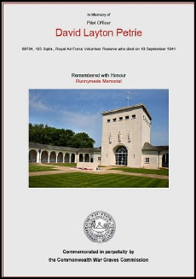
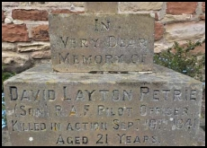
Pilot Officer David Layton PETRIE

Service No. 89794
Died 10 September 1941 – Killed in action aged 21.
Royal Air Force Volunteer Reserve – 103 Squadron
(Part of No 1 Group based at Elsham Wolds, Lincolnshire.)
Commemorated on the Runnymede Memorial, Surrey (Panel 34)

David Layton Petrie was born in the last quarter of
1919 in Sunderland.

His father was Stanley Layton Petrie born on 18
December 1880 at Bromley. Stanley had been the
vicar at St Barnabas, Sunderland (1915 – 1929), Holy
Trinity, Stockton (1929 – 1945) and St Peter’s,
Bishopton (1945 – 1950).

Stanley married Grace Eveline Brown (nee Pratt) who
was the widow of Lieutenant Herbert James Brown of
the 1st/7th Bn. Royal Welsh Fusiliers. Herbert Brown
was killed at Kulweilfeh, Palestine on 6 November
1917 and is buried at Beersheba War Cemetery in
Israel. Stanley and Grace married in March 1919 at St
Martin’s, London.

David’s squadron was based at Elsham Wold, which
opened for operations in the summer of 1941, flying
Wellington and Halifax bombers. After the time of
David’s death 103 Squadron flew Lancaster bombers

David’s father, Stanley, died on 24 January 1950 and
is buried in St Peter’s Churchyard. The pedestal of
his headstone carries an inscription in memory of his
son.

.

- 26 -

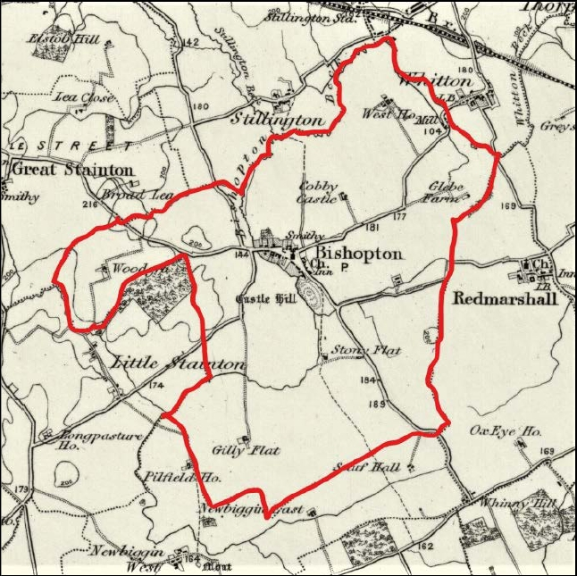
The Parish of St Peter’s Bishopton, County Durham in 1895

Extracted from the Ordnance Survey 1 inch to 1 mile Series – Revised 1895
Reproduced with the permission of the National Library of Scotland

- 27 -

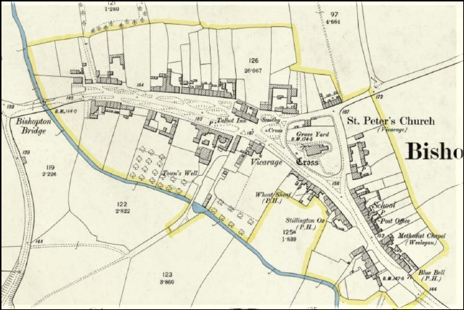
Bishopton Village, County Durham in 1896

Extracted from the Ordnance Survey 25 inch to I mile Series Revised 1896
Reproduced with the permission of the National Library of Scotland

- 28 -

