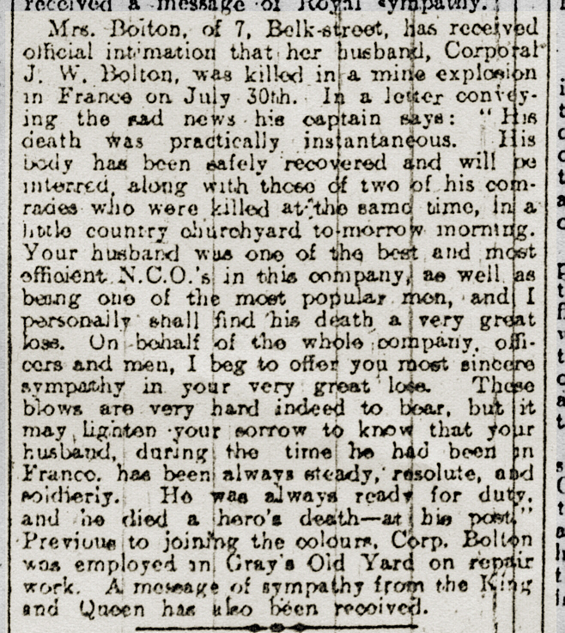

Northern Daily Mail 10 Aug. 1916

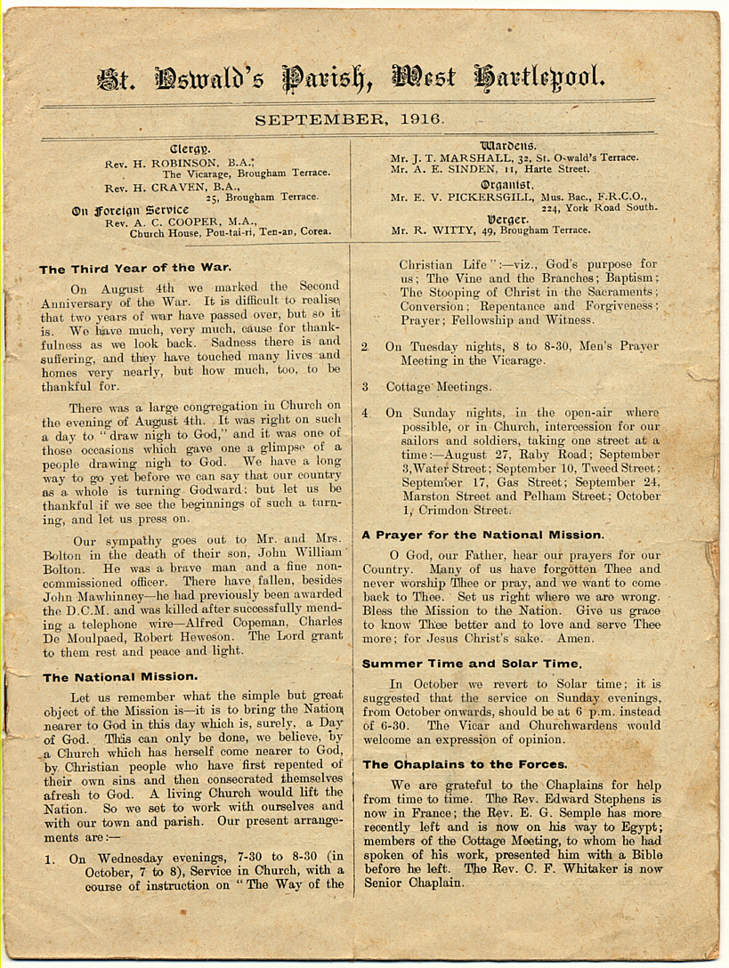

Parish Magazine September 1916

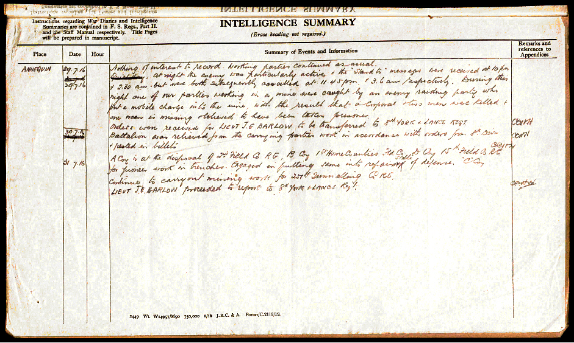

War Diary entry for the incident in which Cpl. Bolton was killed.

